Phishing
Cyber criminals often attempt to acquire valuable information like usernames, passwords, credit cards, social security numbers, etc. You may hear the terms Phishing or Social Engineering when referring to the criminals who will pretend to be someone we trust and use psychological tricks like fear, uncertainty and doubt to lure us to take action like providing information, clicking links or installing software. Emails and phone calls are popular methods of contact.
Here is an example of what a phishing scam in an email message might look like.
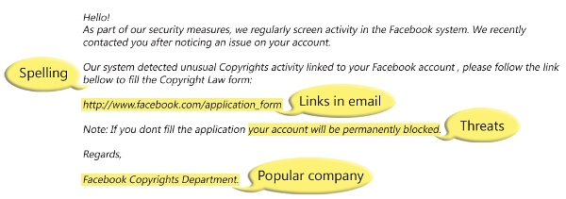
- Web site Security — Verify that website your login is taking security measures to help protect you. The address bar will have https:// then the address and will look like this: 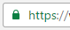
- Threats - Have you ever received a threat that your account would be closed if you didn’t respond to an email message? The email message shown above is an example of the same trick. Cybercriminals often use threats that your security has been compromised.
- Spelling and bad grammar - Cybercriminals are not known for their grammar and spelling. Professional companies or organizations usually have a staff of copy editors that will not allow a mass email like this to go out to its users. If you notice mistakes in an email, it might be a scam.
- Beware of links in email - If you see a link in a suspicious email message, don’t click on it. Rest your mouse (but don’t click) on the link to see if the address matches the link that was typed in the message. In the example below the link reveals the real web address, as shown in the box with the yellow background. The string of cryptic numbers looks nothing like the company’s web address.
