
Sagitta Report Instructions

Required Dictionaries
There are required dictionaries that will need to be added to your system prior to building reports. Click on the “Other” tab at the top of the menu bar in Sagitta. Click on the Maintenance Tab > Miscellaneous > Dictionaries. Add in the dictionaries exactly how they are entered below:
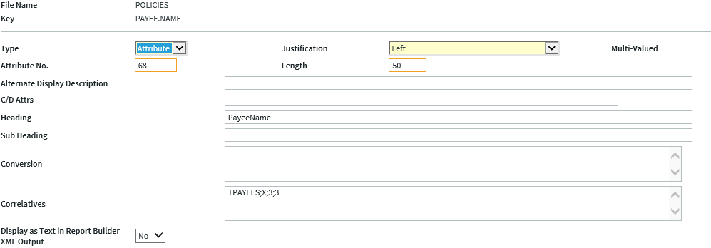
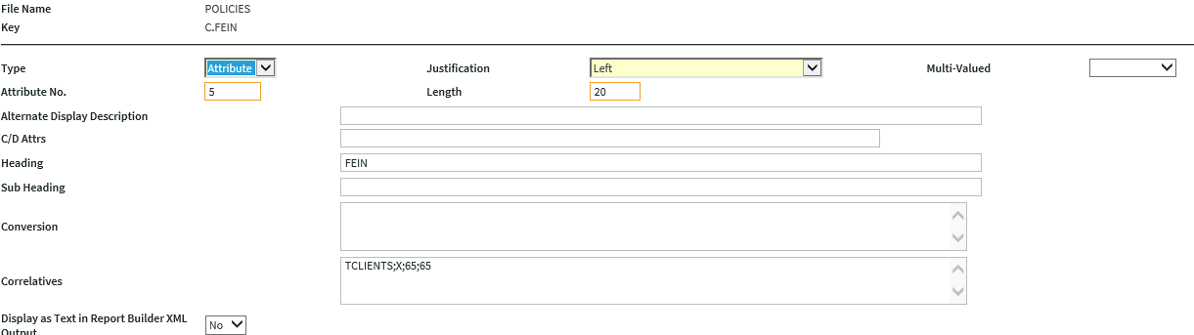
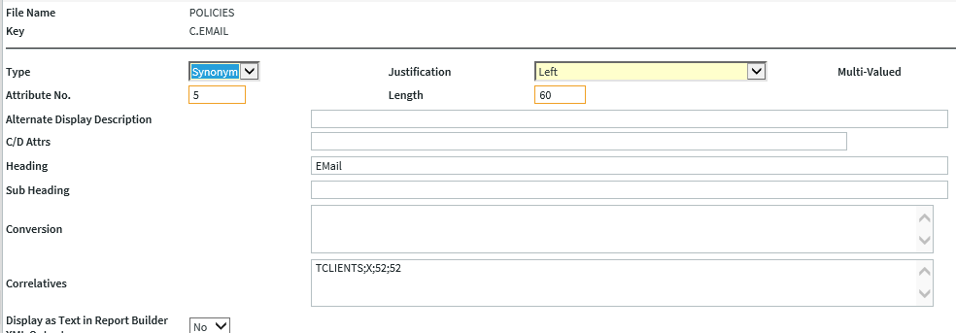
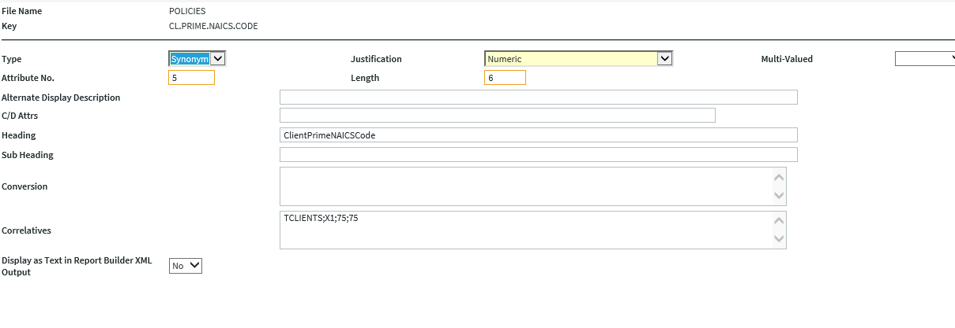
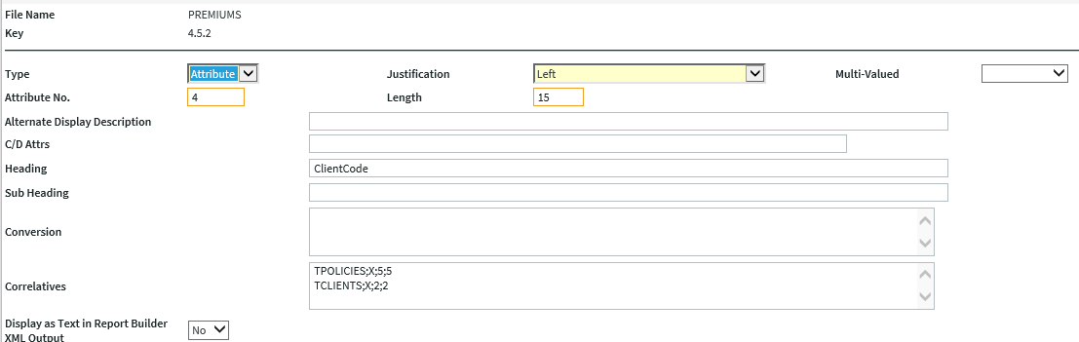
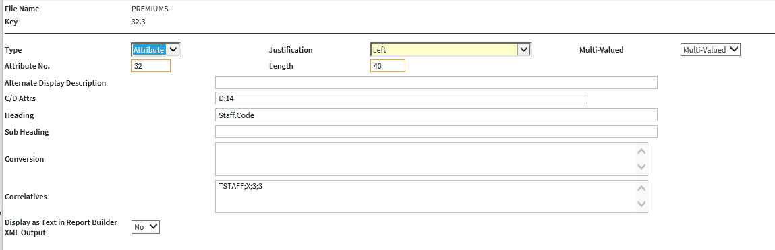
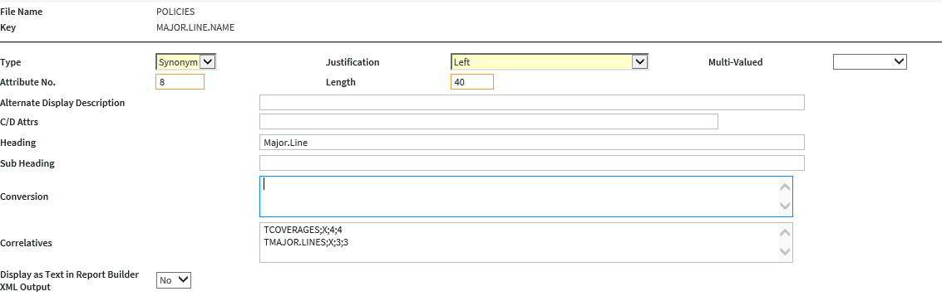
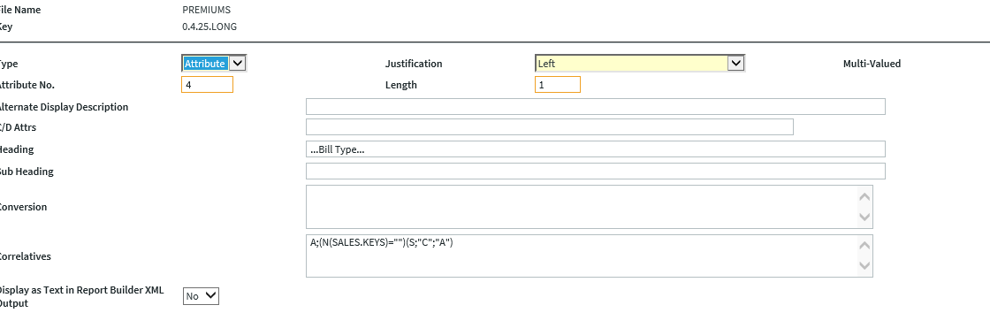
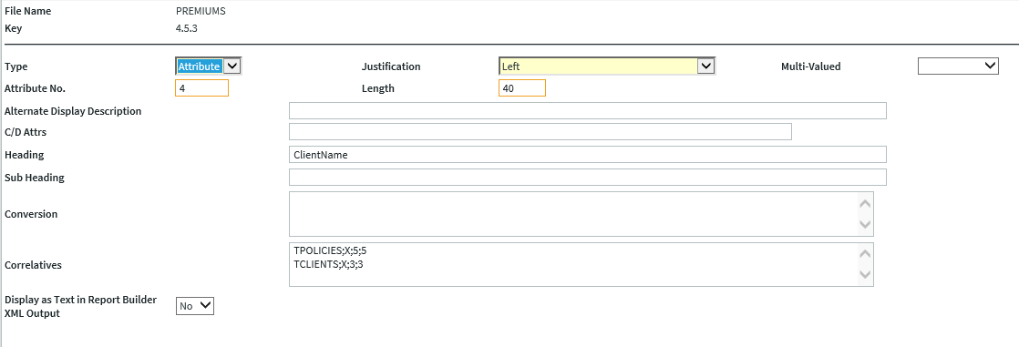
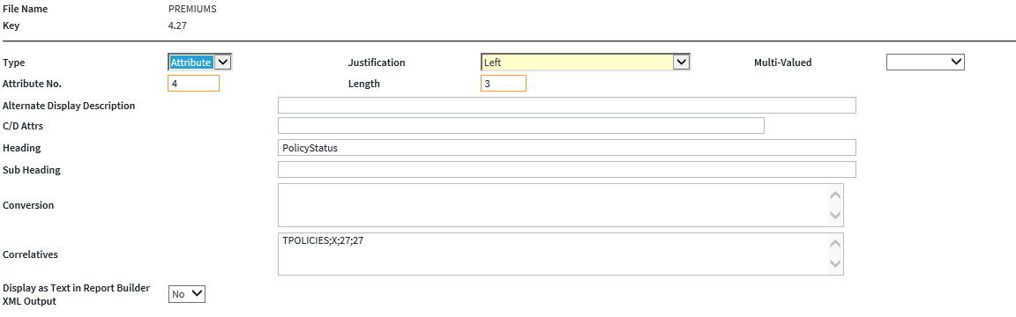
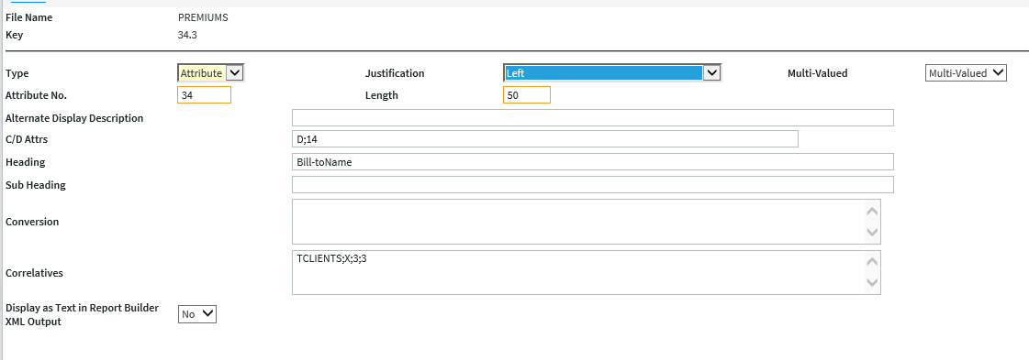
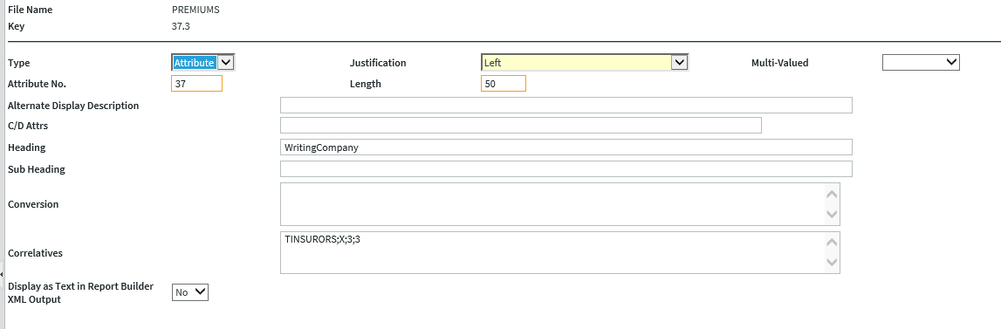
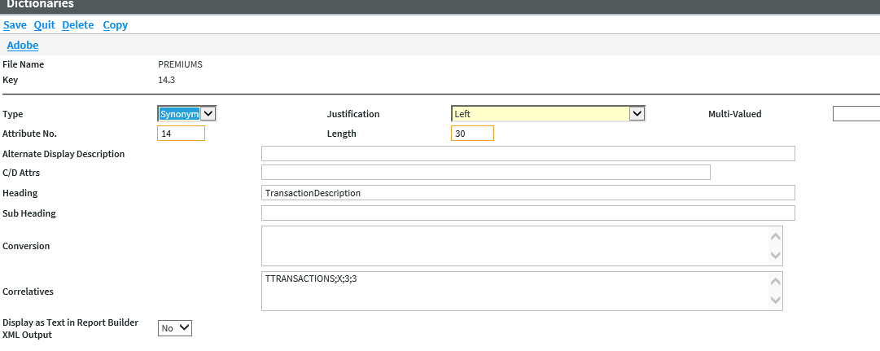
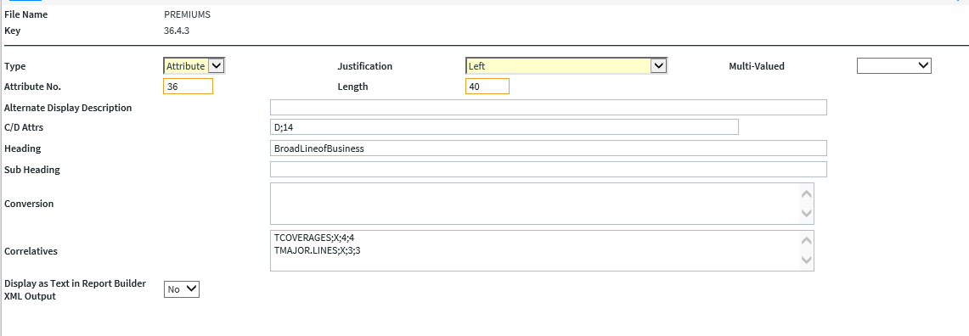
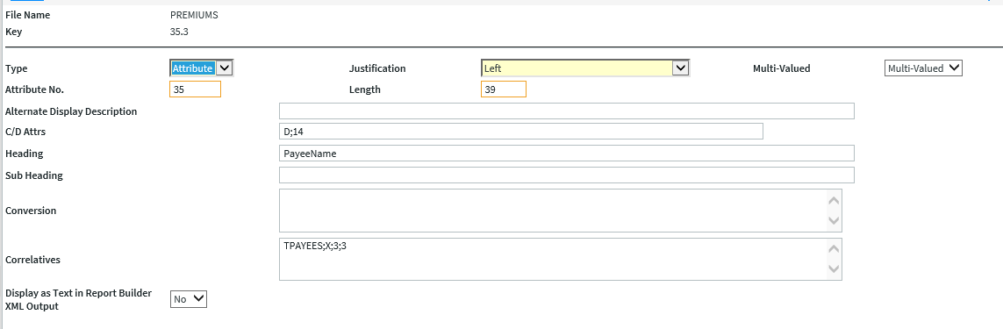
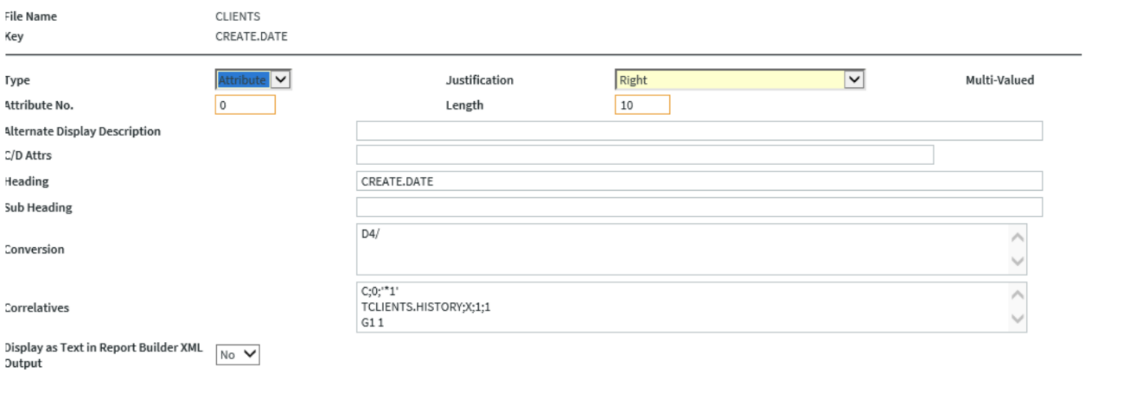
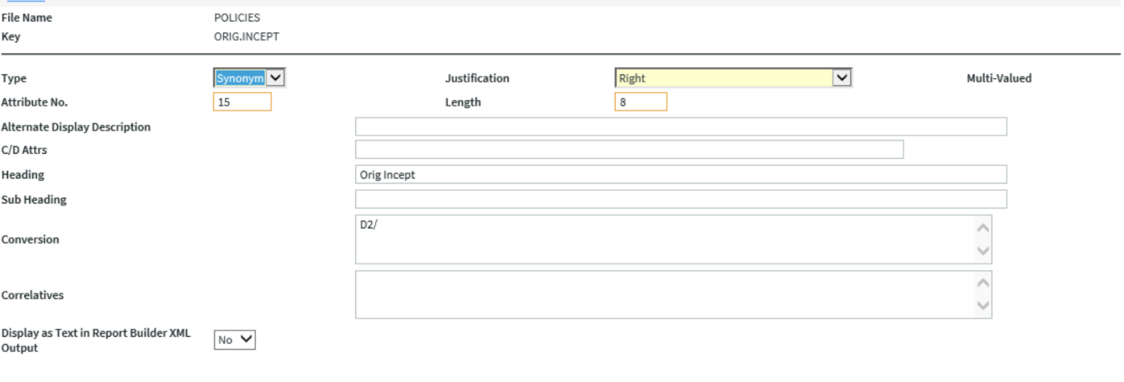
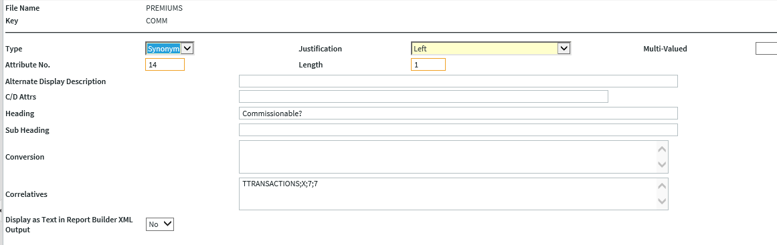
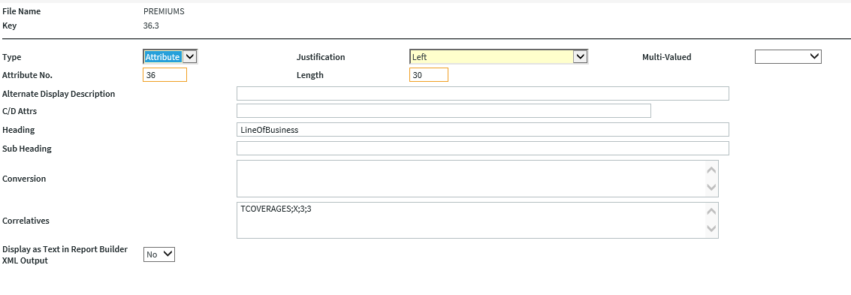
Book of Business
- Click on the Accounting Tab > Production Reports tab > Miscellaneous > Report Builder
- Type in the Report ID: AKPI.BOB
- Copy & Paste the below statement into the Access Statement field:

LIST POLICIES WITH C.N.R """I" CLIENT# COL.HDG
"AccountIdentifier" 5.3 COL.HDG "CustomerName" FMT
60L C.ADDRESS.#1 COL.HDG "Address" FMT 60L C.CITY
COL.HDG "City" C.STATE COL.HDG "State" C.ZIP.CODE
COL.HDG "Zip" C.TELEPHONE.#1 COL.HDG "Phone_#_Business"
C.TELEPHONE.#2 COL.HDG "Phone_#_Residence" C.EMAIL C.FEIN
MAJOR.LINE.NAME COL.HDG "Broad_Line_of_Business" COV
COVERAGE.NAME COL.HDG "Line_of_Business"
POLICY.NUMBER COL.HDG "Policy Number" FMT 25L EFF.DATE CONV "D4/"
CONV "D4/" COL.HDG "Policy_Effective_Date" EXP.DATE
CONV "D4/" FMT "10R" COL.HDG
"Policy_Expiration_Date" WRITTEN.PREMIUM.1 COL.HDG
"Written_Premium" WRITTEN.AGENCY.COMM.1 COL.HDG
"Written_Revenue" EST.PREM.AMT COL.HDG
"Estimated_Premium" EST.COMM.AMT COL.HDG
"Estimated_Revenue" PAYEE.NAME INSUROR.NAME COL.HDG
"Writing_Company" FMT 60L SERVICER.NAME COL.HDG "CSR" FMT
60L POL.PRIME.PROD.NAME COL.HDG "Producer" FMT 40L
POL.SECOND.PROD.NAME COL.HDG "Secondary_Producer"
FMT 40L POL.THIRD.PROD.NAME COL.HDG "Third_Producer" FMT
40L DIV.NAME FMT 60L DEPT COL.HDG "Department" REGION
NEW.REN COL.HDG "New_Ren" POL.SEQ COL.HDG
"Policy_Identifier" CL.PRIME.NAICS.CODE COL.HDG
"PrimaryNAICS" SIC.CODE COL.HDG "SIC.Code" ORIG.INCEPT CREATE.DATE ||

- In the Format/Dest dropdown, choose Excel.
- Click Screen on the Print Options bar.
- Click Yes in response to the prompt Do you want to execute the ACCESS statement?
- If an Excel message pops up asking if you want to Convert file, be sure to select Don’t Convert.
- Name & Save file as an .xlsx format to your computer.

*** The default Book of Business Premium/Commission is set to use Estimated. If you wish to use Written, please reach out to the AgencyKPI Help Desk.

Production Report
- Click on the Reports Tab > Miscellaneous > Report Builder.
- Type in a Report ID: AKPI.PROD
- Copy & Paste the below statement into the Access Statement field:
- Each month going forward, edit the LOE.DATE dates to capture a 12MM (last 12 months) of production.
**For initial load, we recommend loading 12MM and last two fiscal years.

LIST PREMIUMS BY-EXP LOE.DATE GE "01/01/2024" AND LE
"12/31/2024" 34 FMT 20L 34.3 4.5.2 4.5.3 COL.HDG
"CustomerName" FMT 60L 4.5 COL.HDG
"AccountIdentifier" 4 COL.HDG "PolicyIdentifier" 4.2 20 FMT
5L COL.HDG "Producer" PRODUCER.NAME 32 COL.HDG "Servicer"
32.3 COL.HDG "ServicerName" 37 FMT 5L 37.3 REGION
ANY.DIV COL.HDG "Division" DIV.NAME 33 36 36.3 36.4.3
COL.HDG "BroadLineofBusiness" 4.27 14 COL.HDG
"TransactionType" 14.3 COMM 15 16 24 0.4.25.LONG COL.HDG
"BillType" 17 21 22 18 19 35 35.3 COL.HDG
"ParentCompany" 4.11 COL.HDG "EffectiveDate" 4.13
COL.HDG "ExpirationDate" 40 LOE.DATE ||

- In the Format/Dest dropdown, choose Excel.
- Click Screen on the Print Options bar.
- Click Yes in response to the prompt Do you want to execute the ACCESS statement?
- If an Excel message pops up asking if you want to Convert file, be sure to select Don’t Convert.
- Name & Save Excel file .xlsx format to your computer.

Your reports are now ready to load, log into AgencyKPI https://onboarding.agencykpi.com

If you need any assistance, please contact help@agencykpi.com

