How To Share Your Calendar in Outlook

- Click on the Calendar icon – (To Open Calendar View)
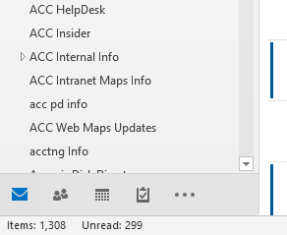

- Click on Share Calendar – (To share this calendar with other people)
Click Share E-mail Calendar
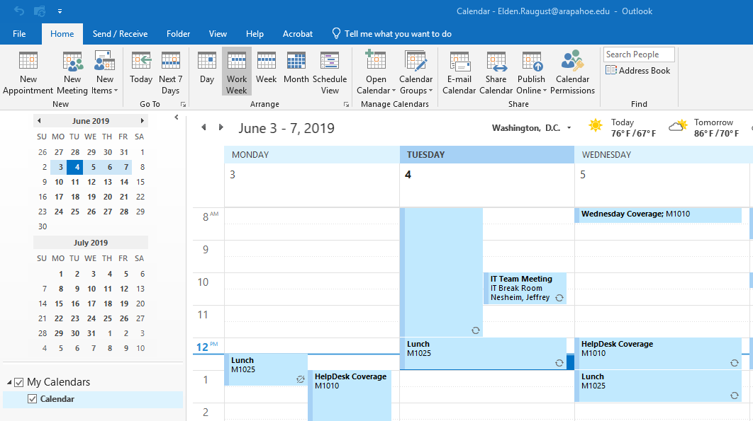

- Enter Email Address or Click ‘To…’ – (Select Recipient inviting to share your calendar)
Select Details Option – (Defaults to ‘Availability only’)
Click Send
Example Below: Elden Inviting Matthew to View Elden’s Calendar Full Details.
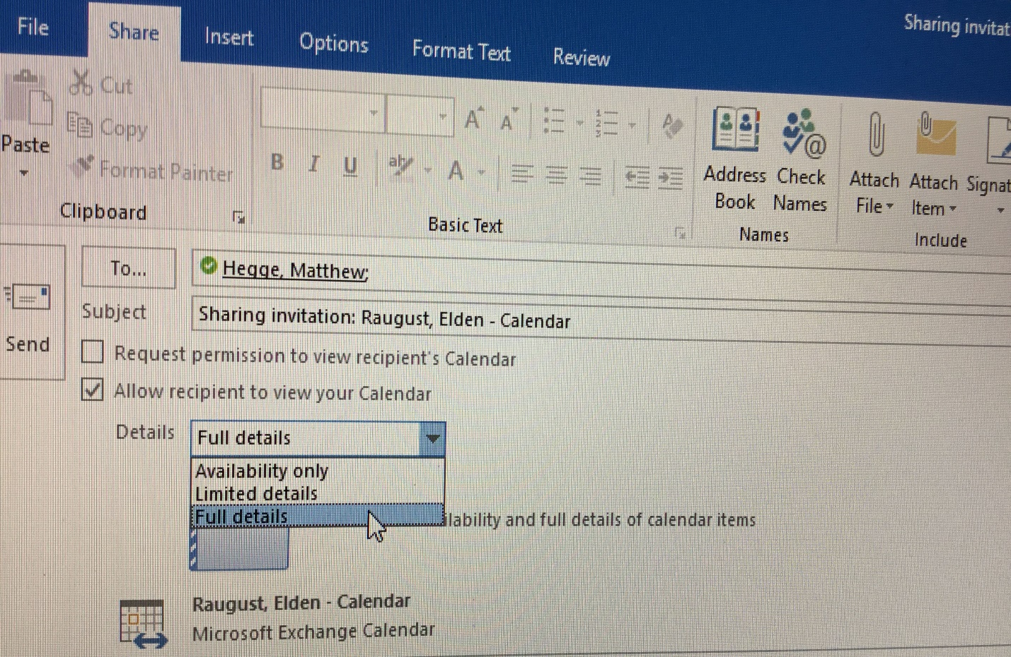

- Recipient will Click Open this Calendar button – (To view the shared calendar)
Example Below: Tia invited Elden to view her calendar ‘Availability only’.
