Standard Classroom Users Guide
This guide has instructions for the use of technology in the classrooms

Classroom Technology User Guide
Nearly all our classrooms have built-in technology.

- A Windows or Mac PC
  - Keyboard and Mouse on a slide out tray.
  - Monitor on an articulating arm
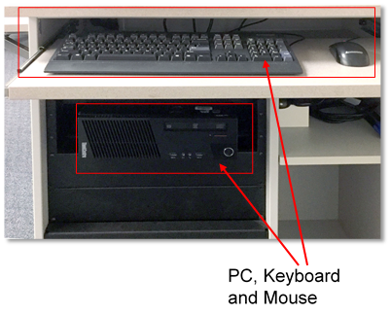

- Document Camera
- Bring Your Own Device (BYOD) Support
  - HDMI Connection
  - VGA connection
  - Audio connection
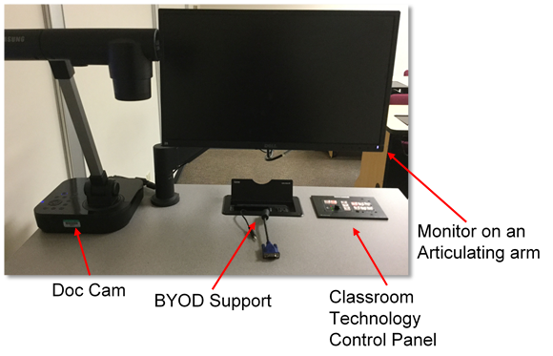

Classroom Technology Control Panel
The Classroom Technology Control Panel gives you control over the many features of the Classroom Technology system.
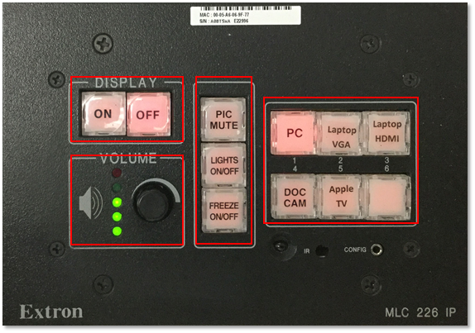
- On - Turns system on
- Off - Turns system off
- Pic Mute - Blanks out the Image (this button may be labeled “AV Mute” in some locations)
- Lights On/Off - Controls the lights above the screen (not used in all rooms)
- Freeze On/Off -Freezes the image on the projector screen
- Volume – Adjusts the volume
- PC - Displays the instructor computer located in the podium
- Laptop VGA - Displays a device connected to the VGA Cable
- Laptop HDMI- Displays a device connected to the HDMI Cable
- Doc Cam - Display from the document camera
- Apple TV – Displays the Apple TV

BYOD- Bring Your Own Device
All rooms with Classroom Technology have connections for BYOD support.
You can connect devices to be displayed on the screen/projector.
The connections are stored in the “Cable Cubby” located on the podium.
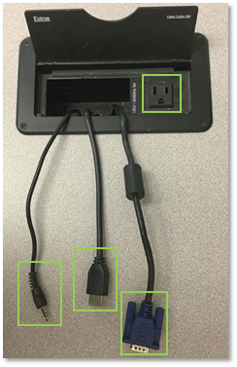
- Electrical Outlet- Can be used for charging
- Stereo Audio Connector- Can be connected to the headphone or line out of a computer or mobile device
- VGA Cable- connects to VGA out on laptop or other similar devices Laptop VGA button on the Classroom Control Panel to display
- HDMI Cable- connects to HDMI out on laptop or similar device Laptop HDMI button on the Classroom Control Panel to display

The Document Camera
The Document Camera can be used to display many different things, such as books, experiments, math problems, or anything else onto the projection screen.
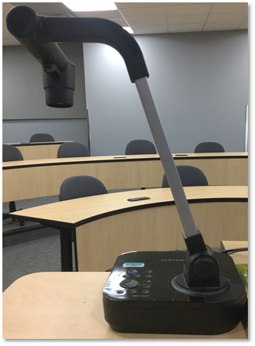
To use the Document Camera, press the “Doc Cam” button on the Classroom Technology Control Panel

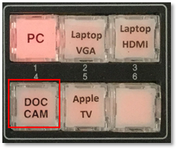

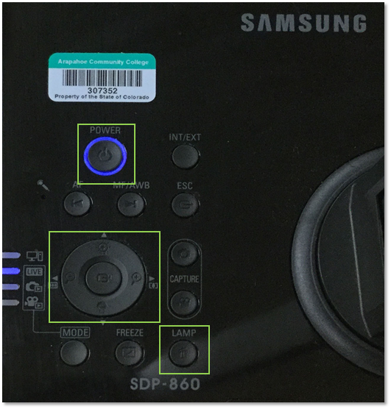
Basic Document Camera Controls:
- Power Button- Toggles the unit on or off
- Adjustment ring- Allows you to adjust the brightness and the zoom
  - Zoom is controlled by pressing Left or right.
  - Brightness is controlled by pressing up or down.
  - The center button is not used

Apple TV
Using Apple TV You can use AirPlay for videos, music, or photos from a variety of locations on your iOS 7 device, including from within the Photos, Videos, Safari, and Music apps.
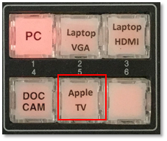
Connecting to the Apple TV in your classroom
- On the Podium, select the Apple TV button from the Classroom Technology Control Panel.
- For more information on using apple TV See Apple TV User Guide

M3750
This room uses a Touch Control Panel similar to the Classroom Technology Control Panel.
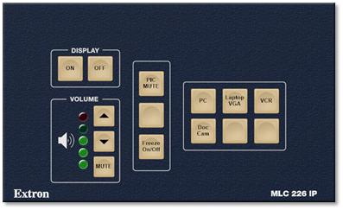
The Control Panel, PC, and DVD/VCR sit inside of a cabinet behind the podium.
- Sometimes the doors will be shut, open it anytime that you need to use the Classroom technology
