How to login to Securly
If you are already connected to internet at home, you will not need to do these following steps 1-3:
- Click on Settings
- Click on Wi-Fi
- Choose your home Wi-Fi and enter the home internet password (with parent permission)

Please note, you have to do the following steps first. If you go to an app first, you won’t be able to connect to it. Remember, Safari first, then you can access apps.

All students will need to do the following:
- Open Safari
- Go to http://www.cnn.com first
- When you try to access another site, this prompt might appear.
- Click continue. It may pop up a few times.
- A Student Login page will open.
- Click the blue bar “Login with Microsoft”
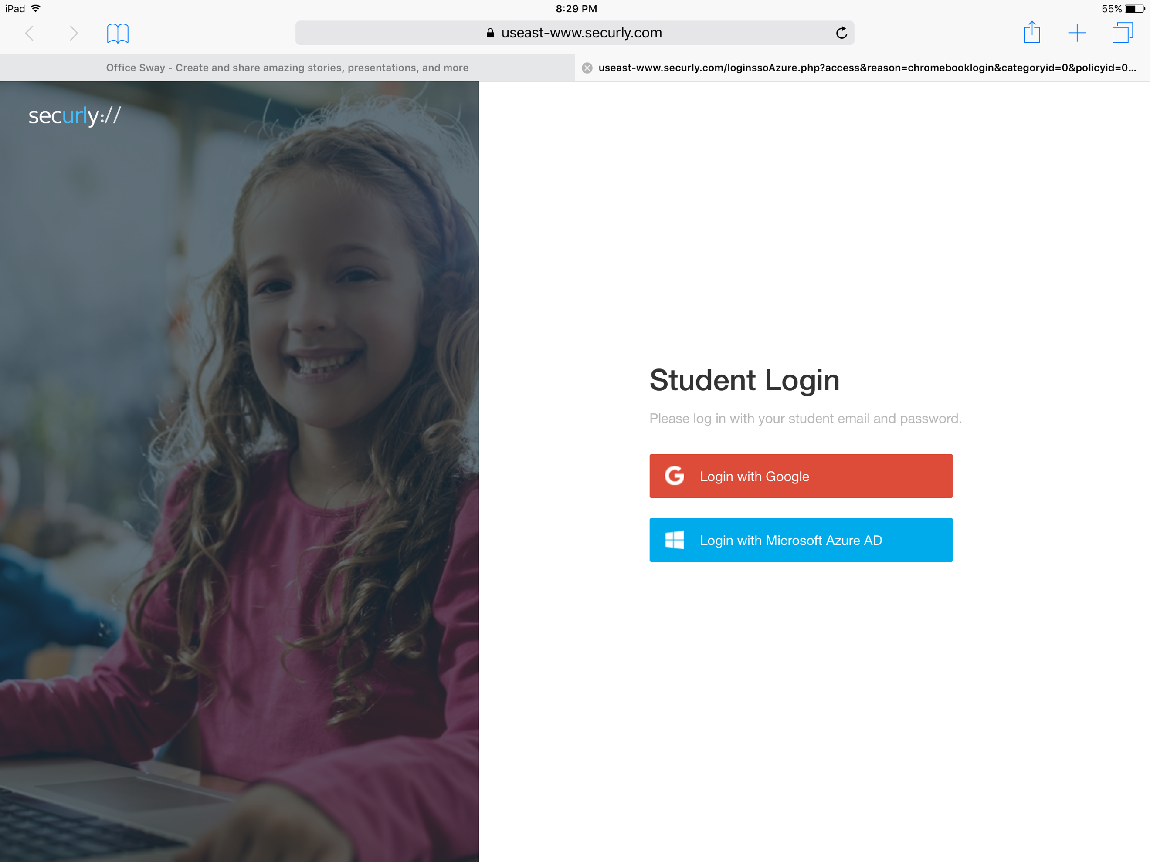
- This should automatically log you in and you can use the internet outside of school.
*If it prompts you to login, use your school email and password. (if you have forgotten your password, please see our ACS iPad Help button on your iPad)

The students will need to sign in each time they change networks while offsite. As long as long as they remain on the same network when not in school they should not need to authenticate again for 8 to 12 hours.

Reminder: You have to do the following steps first. If you go to an app first, you won’t be able to connect to it. Remember, Safari first, then you can access apps.

