Once you are ready to print and have selected the print button.
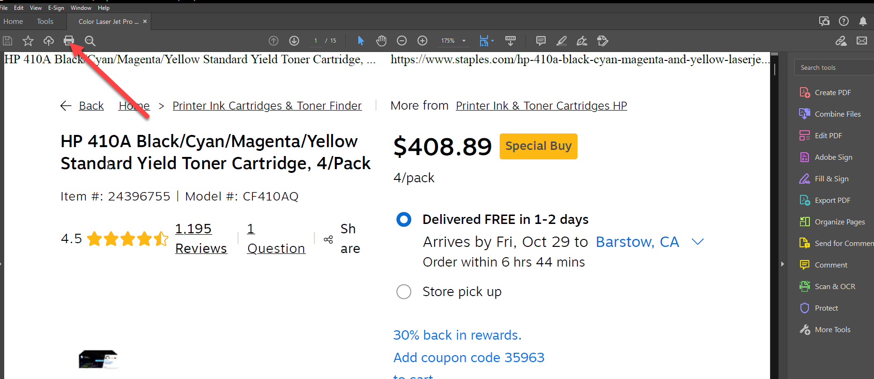

You should see this page, please click PROPERTIES 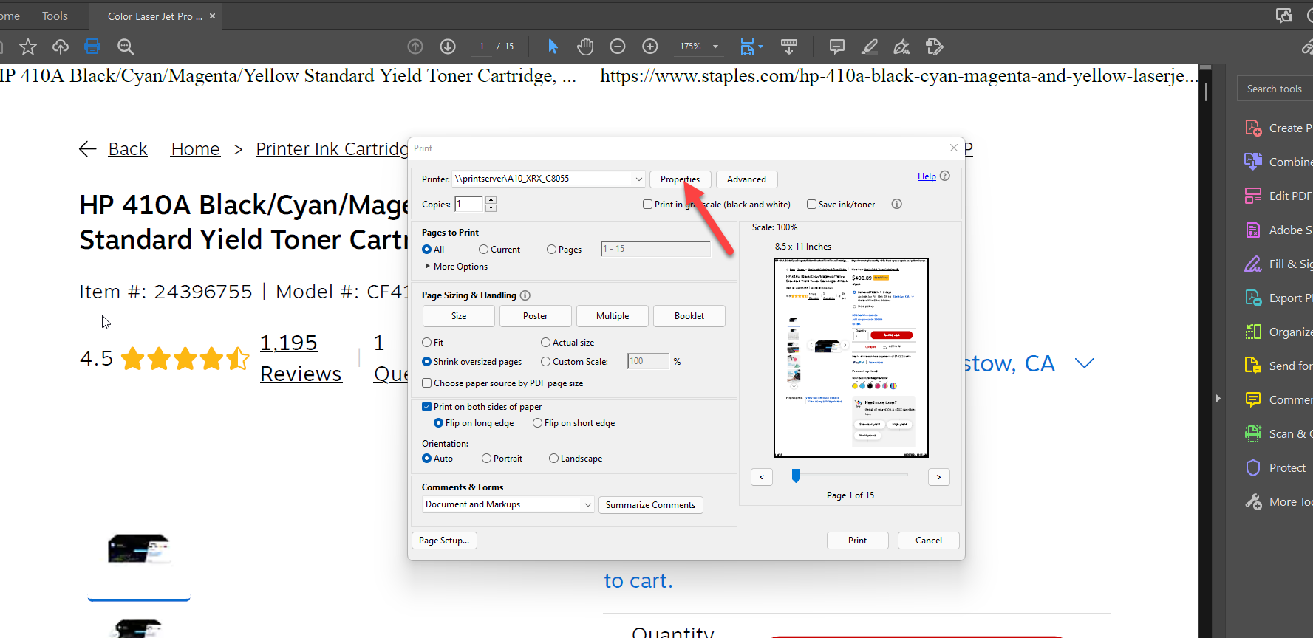
After this next screen will appear, please select the Job Type drop down. 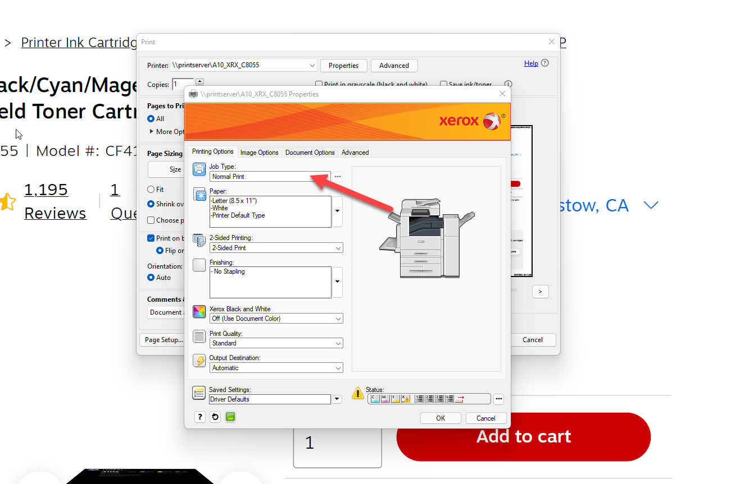

Select Secure print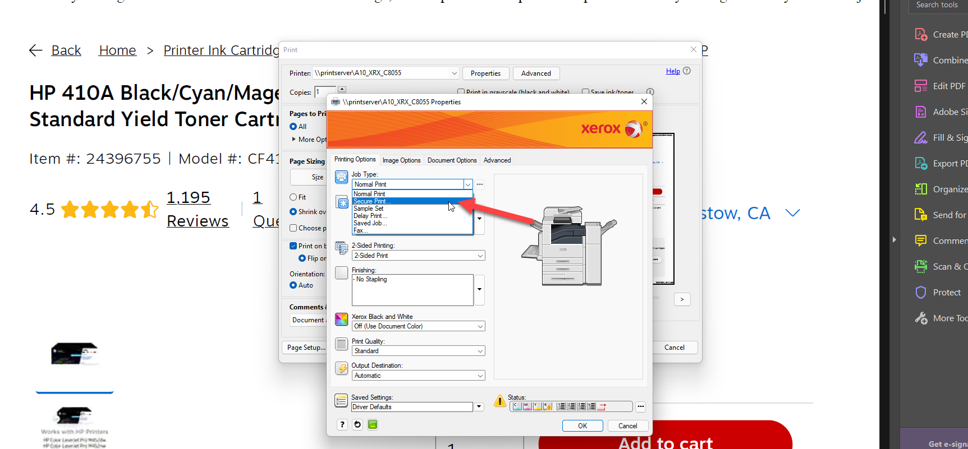

Once Clicked you will be asked to enter a 4 digit code. Remember this code because you will need it to receive you print from the Xerox. 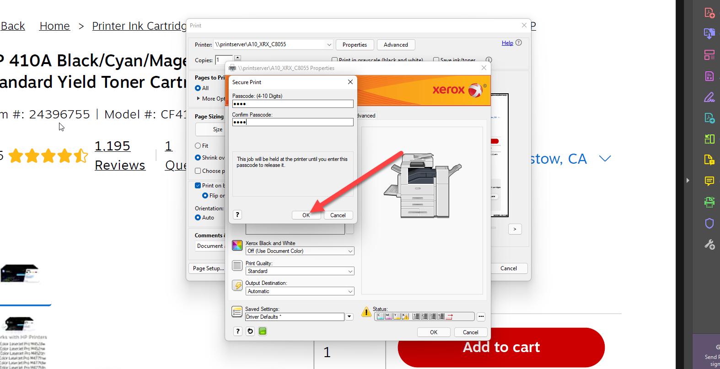

After you code has been entered, click OK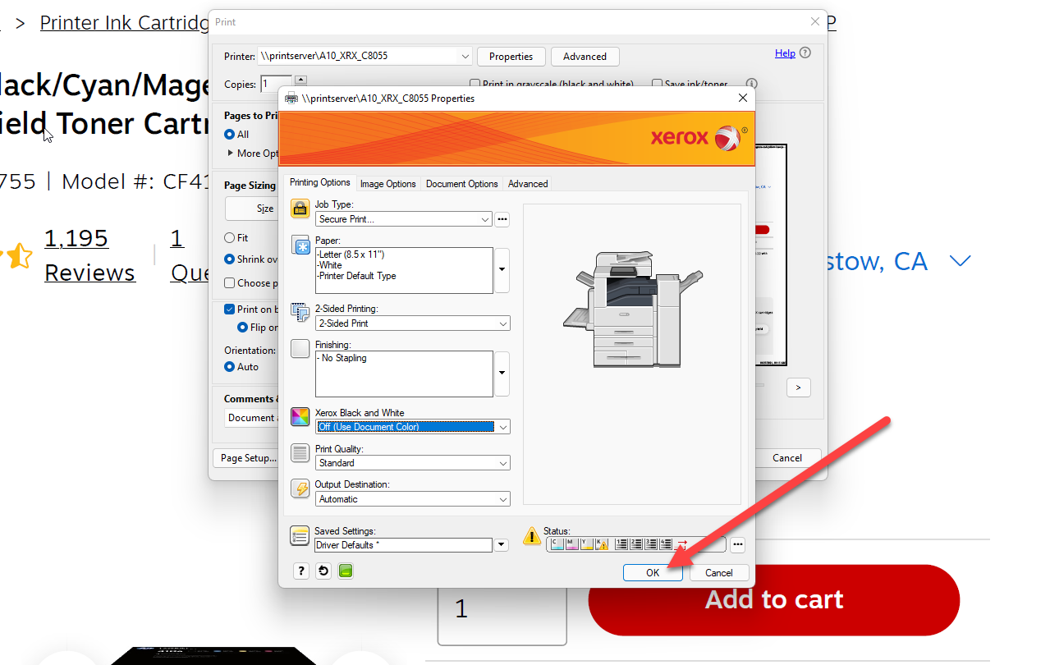

Don’t forget to set the print how you want it (double Sided or other options) and click Print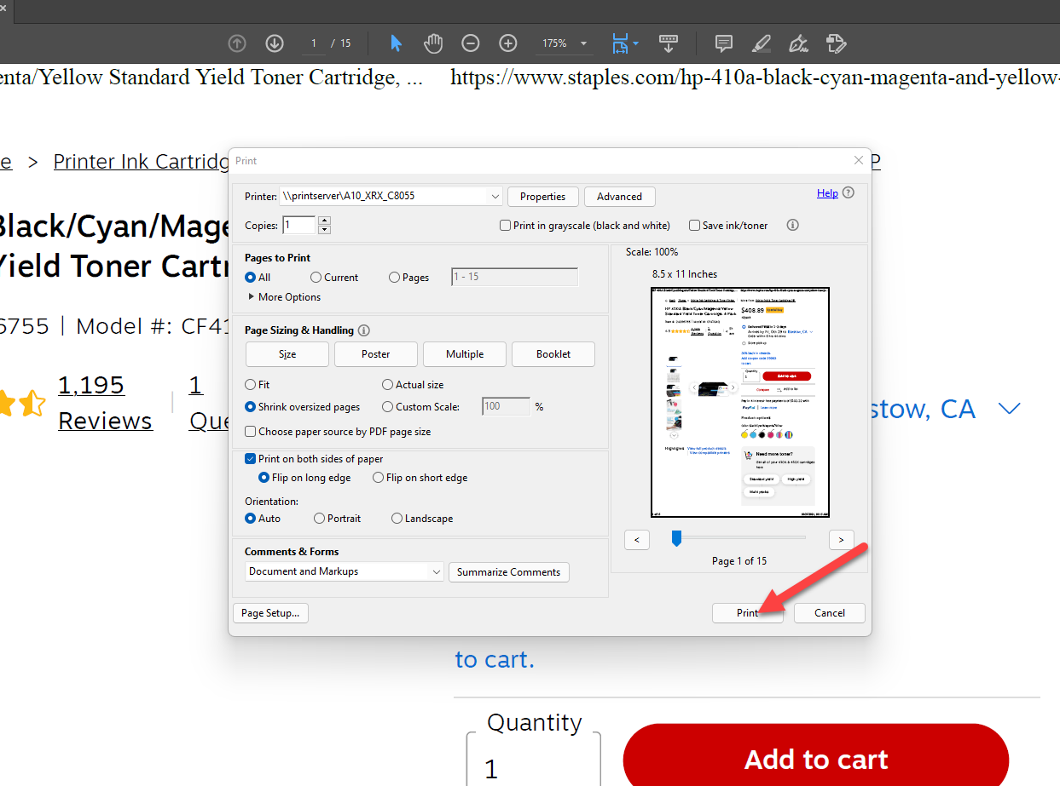
Walk to the Printer you just sent your secure print to and select JOBS. 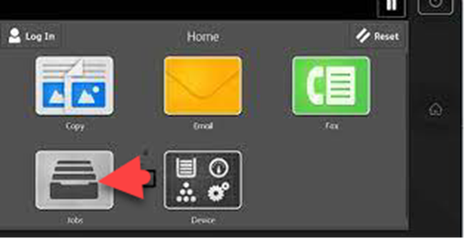
At the top right of the JOBS app you should see SECURE JOBS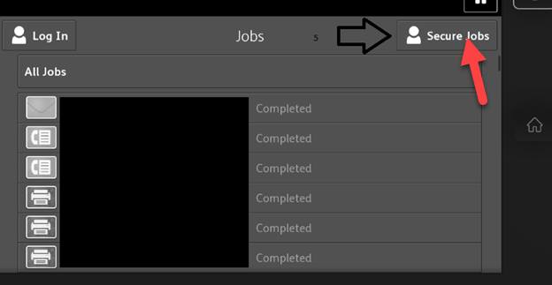

Select your Job, you will be asked to enter the Passcode you made earlier. Your Confidential Print will Begin after. 