

Faculty and Advisor Dashboard
in Banner 9 Self-Service

Overview
Banner 9 Self-Service (SSB9) for Faculty and Advisors allows faculty members to view, update, and print selected information from the Banner Admin database using a new interface. It provides access to the faculty member's schedule, class rosters, class wait lists, registration overrides, curriculum information about their students, and the ability to enter and change grades.
You can access SSB9 for Faculty and Advisors by logging into https://my.catawba.edu/ with your Catawba username and password.

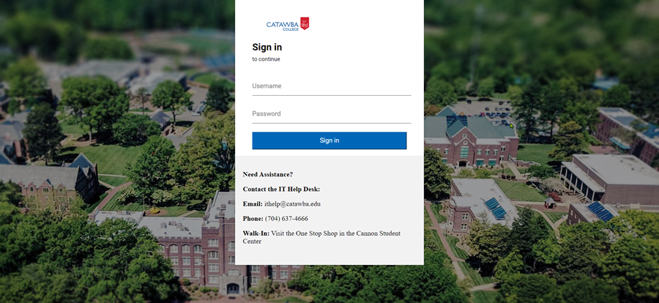

Faculty Dashboard Menu

Faculty Grade Entry
**Note "No Access" under Final or Midterm grade means that the Registrar has not opened grading for faculty for the term.

Class List
The Class List page lets you view, export, and print your class rosters and wait list rosters. It presents a list of your courses optionally filtered by term.
- Leave the value of "All Terms" in the term drop-down list or select a term you taught for from the list. Results may be sorted by any of the results columns by clicking in the column header.
- The Class List page shows course information.
Click on the Course Title or CRN to drill down to tabs for the Class List and Wait List. The default student list is a summary view. To see a detailed view, click the down arrow by "Summary View" at the top right of the list of students.
- Hover over the name of a student on the Class List or Wait List to access their Student card or click on the student name to access their Student Profile page.
- There are buttons in the top right to Export or Print either list. To export a Class List to Spreadsheet
  - Click on the Export link in the top right corner of the Class List page.
  - From the Export Template pop-up window, choose the Excel spreadsheet format you prefer (.xls or .xlsx)
  - Click the Export button.
  - You will find the Excel file in your normal file download area.

Student Week At A Glance
This page displays a week’s actual schedule based on the record created at the point of registration. All of the students’ classes for the selected week are displayed.
Faculty can click a CRN link to display the Class Details dialog showing the class detailed information of that specific class the student is registered for, instead of being directed to the Student Course Detail Schedule page.

Faculty Attendance Tracking
Attendance Tracking is used to track attendance and absence statistics for students by CRN and meeting.
Self-Service pages are available faculty members to enter Attendance Tracking information. Student photos can be displayed for verification of attendance.
Tracking is done at the meeting level for sections. A student’s attendance can be marked as present or absent; meeting cancellations and notified absences can also be recorded. Behind the scenes, the total expected class time, the actual class time present, and the class time absent are saved. Optionally, the student’s total attended hours or last date of attendance or both can be recorded for all meetings within the CRN.
Student Academic Review
Student Academic Review processing allows administrators and faculty members to evaluate a student’s academic performance for a selected term.
Registration Overrides
This page allows a faculty member to perform permits/overrides for students.
**Note: Only the primary instructor can issue registration overrides. Non- primary instructors cannot issue registration overrides.
If the user has not selected a term during the current web session, the Select Term page is displayed first; if a term has been selected, that term is used. Likewise, if the user has not selected a student during the current web session, the Student and Advisee ID Selection page is displayed; if a student is selected, that student is used.
After you choose a value from each of the pull-down lists, click the Submit Changes button.
The top section allows up to three overrides at a time to be entered. The Current Student Overrides section displays the overrides already entered for this student for this term. The information of a student section displays the student’s current schedule for the term.
Advisee List
Use the Advisee Search page to select the term for which you would like to search for a specific advisee to view their student profile information. You may also click View My Advisee Listing to see all advisees assigned to you in the selected term.
Filtering the Advisee List
You can filter data on the advisee listing columns. Each column has a list of defined operators displayed in the Operator field. Use the Delete (-) button or the Clear All button to remove added columns from the filter and the Go button to view the results of the filter.
The filter results display the number of records found and the columns used in the filter. A Column Name X button is displayed for each field included in the filter. You can remove each column, one at a time, and the filtered results are revised for the remaining filters. Use the Remove Filter button to view the original unfiltered results. The filter drop down (triangle) icon is used to display your filter settings so you can review what you selected for your recent filter and modify your choices.
When a filter is in use, it remains active for the session until it is removed, the term is changed, or the user logs out. Any changes to column order and value sorting also remain in effect for the filter. If you go from the Filter Results to the Student Profile page and come back to the Advisee Listing page, the filter remains active.

