

Student Dashboard
in Banner 9 Self-Service

Student Information
Student Information provides a snapshot of a variety of student data. Here you can view personal, curriculum, GPA, advisor, registration and hold information by term.

Unofficial Transcript
The unofficial transcript can be selected by level (undergraduate or graduate) and transcript type (advising or unofficial).
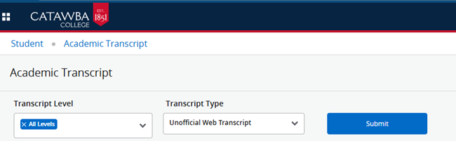

View Grades
To view grades, select the term and level
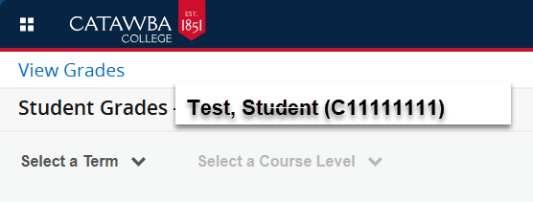
The coursework for the selected term and level will be displayed, allowing you to see your midterm grades, final grades (when posted), and quality points earned for that term.
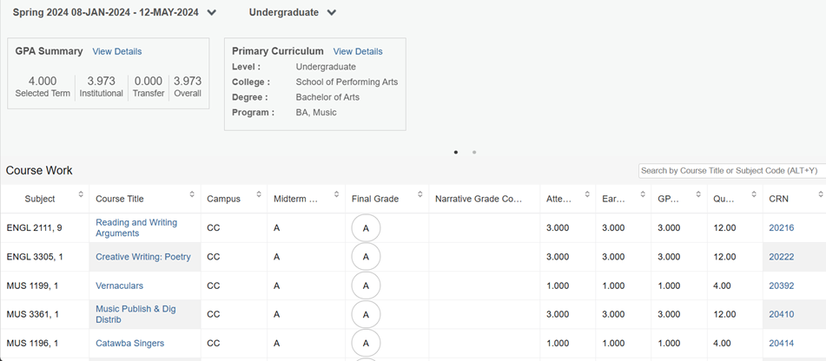

Registration
The Registration Home Page has links to the following:
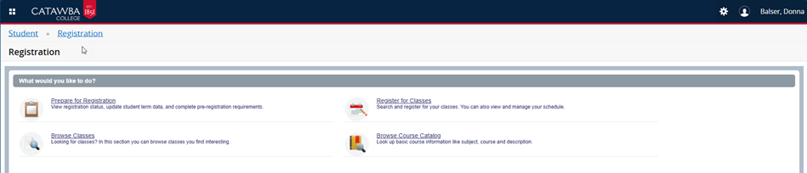

Prepare for Registration
Use this page to check your registration status, as well as information about your Primary
Curriculum, any holds you may have that would prevent registration, and your hours earned.
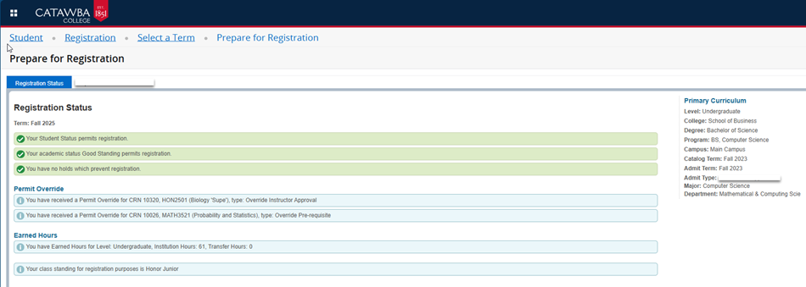
Browse Classes
Use this link to search and browse through class sections for potential registration or research.
First, select the term [1] you want to browse classes for and the click “Continue” [2].

Clicking in the Subject field [3] will open a dropdown where you can choose a subject of a class.
You can also enter the Course Number of a specific class that you’re looking for, or a keyword
related to the class.
Another option is to use the Advanced Search function near the bottom of this section [4] to
search for classes by instructor, schedule, credit hours, and other options.
Once you have entered your search parameters click “Continue” [5] to get your search results.
Register for Classes
To register for a class, you can either enter a CRN, if you know it, or search for a class using a variety of filters.

If you already know the CRNs of the classes you would like to register for, you can enter them in the “Enter CRNs” tab. To add more than one course, press the “+ Add Another CRN” button [1]. Once you are finished entering CRNs, click the “Add to Summary” button [2].

To search for a class in which you would like to register see the Browse Classes section above.
When you find the class you are interested in, you can click on the underlined course title [1] to the left to view more about the course, or you can click on the “Add” button [2] to the right to add the course to your preliminary schedule. The course will then show in the “Enrollment Activity” section to the bottom right of the screen.

Using the Find Classes and Enter CRNs feature only adds classes to your preliminary schedule. Notice in the Enrollment Activity window shown above, the course’s status is listed as “Pending”. This means that you are not yet registered for the course. You will need to click the “Submit” button to finish registering for the course(s). The enrollment status will then change
to “Registered”.
Click on the drop-down menu under “Change Enrollment Status” column next to the class that you would like to drop or remove. This will display then enrollment status options. Select the option that corresponds with the action that you would like to take – either “Withdraw initiated by student” or “Remove”. Then, click the “Submit” button. This will remove the
course from your schedule and drop you from the class.
Degree Works
Degree Works is the University's web-based degree audit tool that allows you to monitor your academic progress toward degree completion.
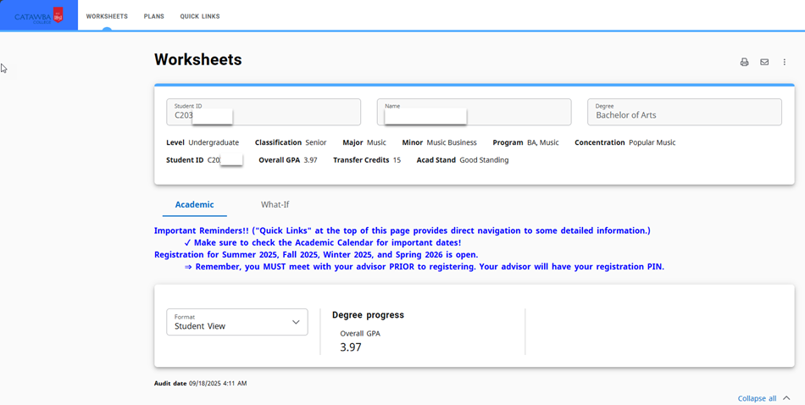

Financial Aid
Financial Aid provides you all relevant information about your financial aid package by the Aid Year.
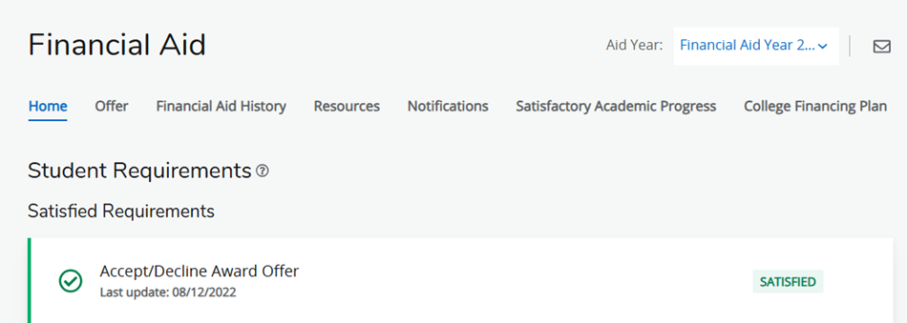

Transcript Request
The Transcript Request provides a link for you to request a transcript from the National Student Clearinghouse. Enter ‘Catawba College’ in the Select School search field and then follow the instructions to order a transcript.
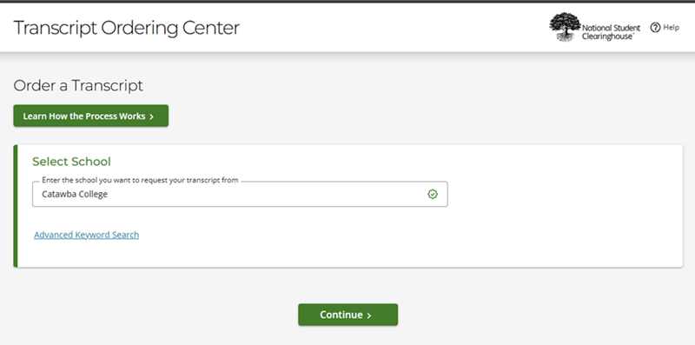
Enrollment Verification
This provides a link to online verification services provided by the National Student Clearinghouse for verification of high school diplomas, college enrollments, and degrees.
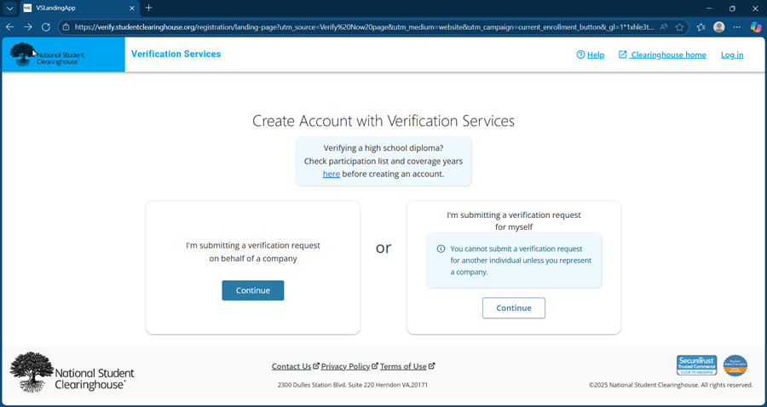

Course Evaluations
Course Evaluation are available at the end of each term for you to provide feedback for each course in which you are enrolled.

