VOICEMAIL & TELEPHONE USER GUIDE

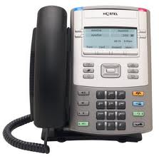

Phone Illustration | Page 1
Voicemail Setup | Page 2
Sample Voicemail Greetings | Page 3
Voicemail Reference Guide | Page 4
Telephone User Guide | Page 6
Prefix Table | Page 7
Time of Day | Page 8

Nortel IP Phone 1120E

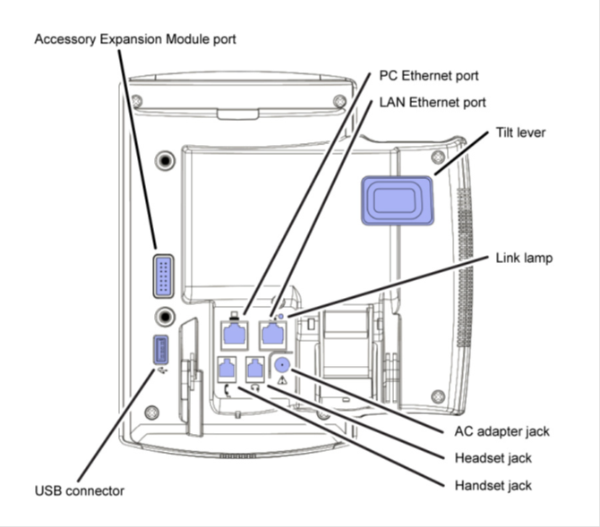

VOICEMAIL SETUP

LOGGING IN Used with all voice mail transactions

- Dial 314-953-5200 OR Press MESSAGE key on the classroom phone Or Dial 35200 internally.
- Enter your 5 digit mailbox number followed by the # sign.
- Enter default password of 724665 (SCHOOL) followed by the # sign.
- At this point the system will prompt you to change your password.

CHANGING YOUR PASSWORD As a first time user to this mailbox you will be forced to change
your password. Your new password will remain until you choose to change it.
You cannot use:
-consecutive numbers (ex: 12345)
-repeat numbers (ex: 55555)
-your telephone extension.

- Enter new Password (6 to 16 digits) follow by the # sign.
- Enter new Password again, followed by the # sign.

Note: If you login incorrectly 3 times per session, your mailbox will be locked until a system administrator resets your mailbox! If this happens, call the Help Desk at 35099.

RECORDING YOUR GREETING- What callers will hear

- Log into the voicemail system (see above)
- Dial 4
- The system will tell you that you have no greeting and will use the standard greeting
- To record a personal greeting, press 6 and follow the prompts.

SAMPLE VOICEMAIL GREETINGS

It is sometimes hard to know what to say for a mailbox greeting. You can use any message that you feel is appropriate for the caller to hear. The following greetings are only suggestions and should serve only as starting point, when you develop your own. It is a good idea to write your greeting down before you pick up the phone to make the recording.

“Hello, you have reached [your name], 3rd grade teacher at McNair Elementary”…

“I’m on the phone or away from my desk at the present time. If you need to speak to someone immediately, please dial __________ (ext number) for assistance or you may leave your name, phone number and a brief message and I will call you back as soon as possible.”

“Today is Monday, July 28 and I will be in a meeting most of the morning but I will be in the office in the afternoon. If need assistance immediately, please call extension __________ (ext number) and __________________ (person’s name) will be able to assist you.”

“I am attending a (meeting, class, or conference) and will be back in the office on _______________ (date). You may dial __________ (ext number) for assistance or leave your name, phone number and a brief message and I will return your call when I return.”

If you need assistance with using voice mail or if you have questions, please call the Help Desk at extension 35099.

VOICEMAIL REFERENCE GUIDE

First Time Login Only
- Change your security code from the default (SCHOOL or 724665)
Security codes: 6-16 digits
- Record your personal greeting

To Access the Voice Mail System
- Call the System (within the District dial 35200; outside the District dial 953-5200)
- Enter your mailbox number followed by #
- Enter your security code followed by #

To Listen to Messages:
- 5 to listen to the first/next message
- 15 to listen to the last/previous message
- 192 to listen to saved messages from the new message queue
- 191 to listen to new messages from the saved message queue

To Forward A Message:
- Listen to entire message
- Press 13 to forward message
- Record your comments
- Press # to end comments
- Enter address(es) of person(s) you want to forward message to (up to 10)
- Press # to end addressing
- Press # to forward the message

To Exit Mailbox:
- 9 to initiate exit
- * to continue using your mailbox
- 0 to exit and dial an extension
- 9 to end session

Options While Listening to Message
- 3 to delete the message (*To delete the message you must press 9 TWICE before hanging up.)
- 7 to save the message
- * to pause/resume
- 2 to back up 4 seconds
- 22 to back up to beginning of message
- 4 to skip ahead 4 seconds
- 8 to hear date/time message was left

Reply to a Message:
- Listen to entire message
- Press 17 to reply
- Record your reply
- Press #
- If system tells you “Reply address unknown”, enter mailbox number
- Press # to end addressing
- Press # to send reply

To Send a Message:
- Access your mailbox
- Press 6 to record your message
- Record your message
- Press * to end recording
- Press # to accept recording
- Enter address(es) up to 10
- Individual Mailboxes
- Personal Distribution List
- System Distribution List
- Press * to cancel previous address
- Press ** to erase the message
- Press # after entering addresses
- Press # to send the message

Personal Greeting
- Access your mailbox
- Press 4 to access greeting, press
- 5 to listen to greeting
- 6 to record new greeting, press # to end recording and turn on greeting
- # to leave greeting unchanged

Helpful Hint:
When listening to a mailbox greeting, press * to bypass the greeting and go straight to recording.

Custom Options:
- Press 16 to initiate Custom Options
  - 2 to set Security Code
    - Enter 6-16 digit code
    - Press #
    - Re-enter code to confirm
    - Press # to ready
  - 8 to record name for mailbox
TELEPHONE USER GUIDE

Auto Dial
- To Program or Update
  - Without lifting handset…press Auto Dial key…dial number to be programmed…press Auto Dial key again.
- To Use
  - Lift handset…hear dial tone…press Auto Dial key (number is automatically dialed.)

Call Forward
- To Activate
  - Without lifting handset…press Forward key…dial number where calls are to be forwarded…press Forward key again.
- To Cancel
  - Press Forward key.
- To Reinstate to same number
  - Press Forward key twice.

Call Pickup
- To answer a ringing call in your own Call Pickup group
  - Lift handset…press Call Pickup key

Call Processing
- To call another extension
  - Lift handset…wait for dial tone…dial five digit extension number
- To call outside system
  - Lift handset…wait for dial tone…dial 9 and the number you wish to call

Call Transfer
- To Transfer a call…press transfer key (the call is placed on hold and you hear dial tone)…dial the number…press transfer either when you hear ringing, or announce caller in privacy.

Callers List
- To see who has called you
- Press Directory key then Press Callers List
- It will show the name if available the press Center button to the right to see the number

Conference Call
- While on a call…press Conference key (the other party is on hold, you hear dial tone)…dial the number to add to the call…press Conference key again to add all parties…repeat for additional parties.

Corporate Directory
- Press Directory then Press Corporate Directory
- Enter Last name followed by First

Hands free
- To use
  - Press Hands free instead of lifting handset
  - Press Goodbye to end your call.
- To mute a Hands free Call
  - Press Mute…replace the handset.

Last Number Redial
- To use
  - Lift handset…press extension key one time (number is automatically dialed) or without lifting handset…press extension key to get dial tone…press extension key again…number is automatically dialed.

Message Waiting
- Message indicator light is on …press Msg/Inbox key or dial voice mail number 35200
- Enter mailbox number or just hit #
- Enter password followed by #
- Press 5 to retrieve message from voice mail.

Park
- Call Park allows a call to be stored temporarily, then to be retrieved from any other extension. Calls are parked on the System Park Extensions.

To Park a call
- Press PARK key…system park extension will appear in your display…press park again.

To retrieve a parked call
- From any extension, dial the system park number.

Redial List
- To see your last twenty numbers you dialed
- Press Directory Key then with the Center Button scroll down to press Redial List

Voicemail Access
- Dial extension 35200 or from outside the system, dial 953-5200

Volume Controls (ringer, handset, buzzer)
- Press Services Key Then press Telephone Options
- Then choose the option you wish to adjust.

Prefix | Phone Extensions beginning with:
43 | 84XXX
65 | 33XXX  38XXX
95 | 34XXX  35XXX  37XXX
TIME OF DAY

Time of Day refers to the silencing of phones in instructional areas during instructional time. Phone calls during instructional time will go directly to voice mail. Phones will ring before and after school hours. The following are the times during the day when phones will not ring in the classroom:

High School 7:15am-2:30pm

Middle School 8:00am-3:15pm

Elementary School 8:45am-4:00pm

Early Childhood Centers 8:30am-3:30pm

