How to obtain Oracle requisitioner access

Oracle Requisitioner training must be completed in Learning Connections Curriculum before access can be requested.
Navigate to Hertz SharePoint site: https://hertz.sharepoint.com
Select My HR, Global Learning, from the right side of the page

Select Learning, select Learning Connections.

Log on with your employee number and password set up when newly hired.
If you do not have a username/password, contact IT at ITServicedesk@hertz.com
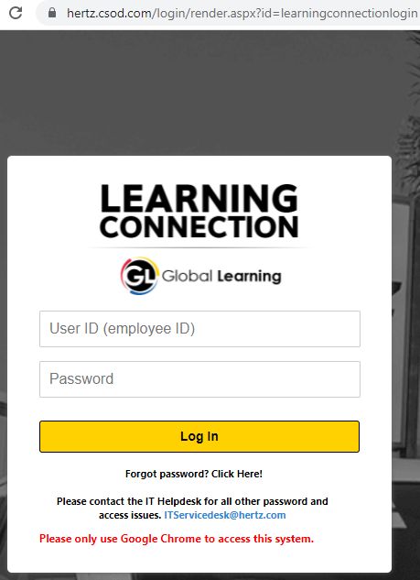
Once you are logged in, use the search bar on the top right corner to locate the required class
Oracle Requisitioner 102 - Oracle Cloud Requisitioner

From selection, double click on the picture icon depending on the Language requirement.
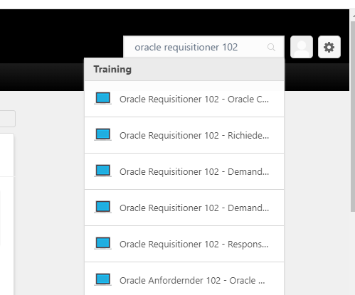
Select Request and follow the prompts. If there is a note you have already complete the training you may need to take the Oracle refresher training, search for refresher training.
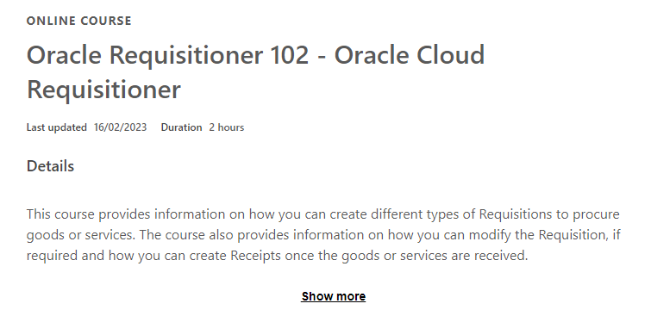
Upon finishing the course, save the Certificate of Completion:
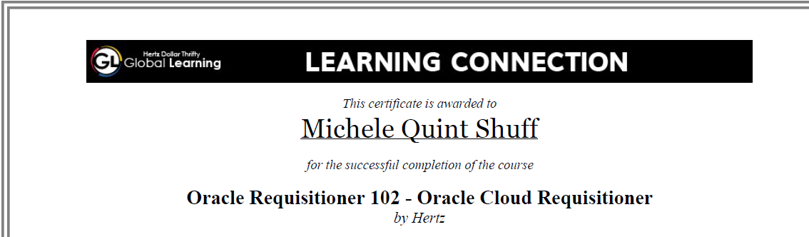
It must be attached/uploaded to the Saviynt Oracle access request.
Follow the steps below to submit your access request.
Saviynt Log On

Ensure you are logged into the Hertz network

https://myapps.microsoft.com (using your hz########@hertz.net username and password) to access Saviynt. There you will see a page of tiles for each Hertz application:

Go to MY apps My Apps (microsoft.com)
Note: If you logged onto the Hertz network, Saviynt will automatically log in. Hertz network is typically email: hz########@hertz.net username and password (single sign on PW)
Click on Saviynt
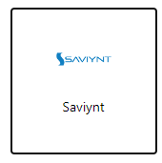
Click on Request New Access
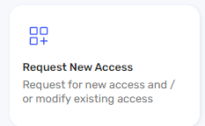

Search for Oracle ERP
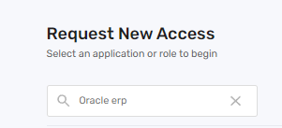

Click the Oracle ERP tile
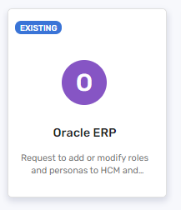
Click on Modify Existing Account
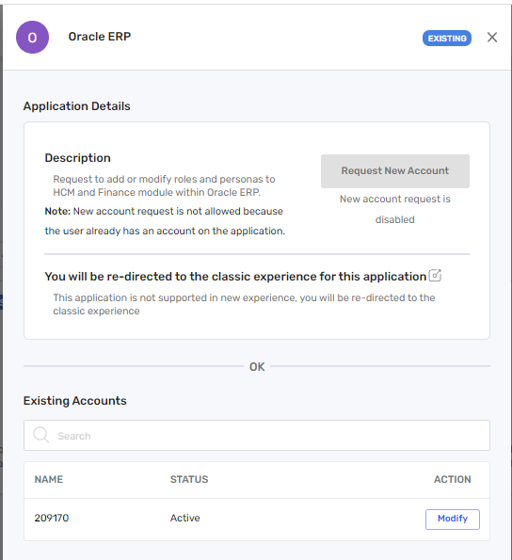

Click this icon


Click Yes
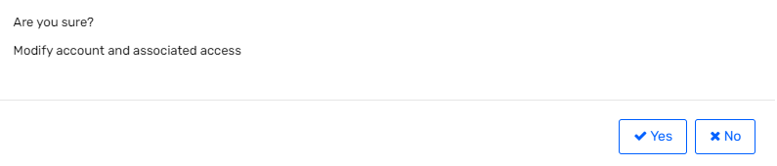

Click Checkout

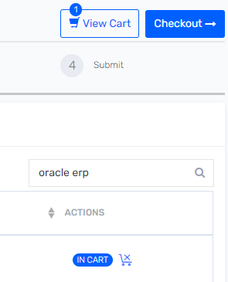
Click Close
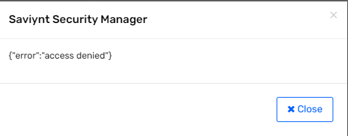

Select either Finance Persona Access or Finance Individual Roles
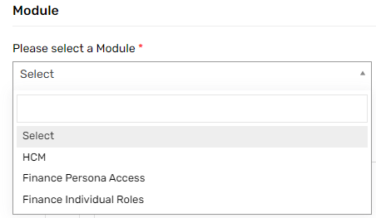
Finance Persona Access:
This will allow you to select a single persona that has many different sub-roles that are included with a single persona such as PO Requisitioner, PO Inquiry, AP Inquiry etc. The name of each persona will give you a high-level overview of what the roles are included as well as which business units are included in that persona.
All new request to have access to create requisitions, process receipts, view the PO and invoices, search for “HTZ Procurement requester XX_XXXX_XXXX
Ensure you pick the business unit where you will be ordering examples: US, CA, NA=US &CA, UK, DE, FR etc.
Next look for Fleet, Non-Fleet, or both type roles to review what access is provided hover over the “i” icon
Example for US access to non-fleet ordering select: HTZ Procurement requester-US Non-Fleet_Persona
Note: after you select the Finance Persona Access, look below for an open search bar, type in HTZ-PROCUREMENT REQUESTER_ as example to see various Business units and non Fleet Fleet
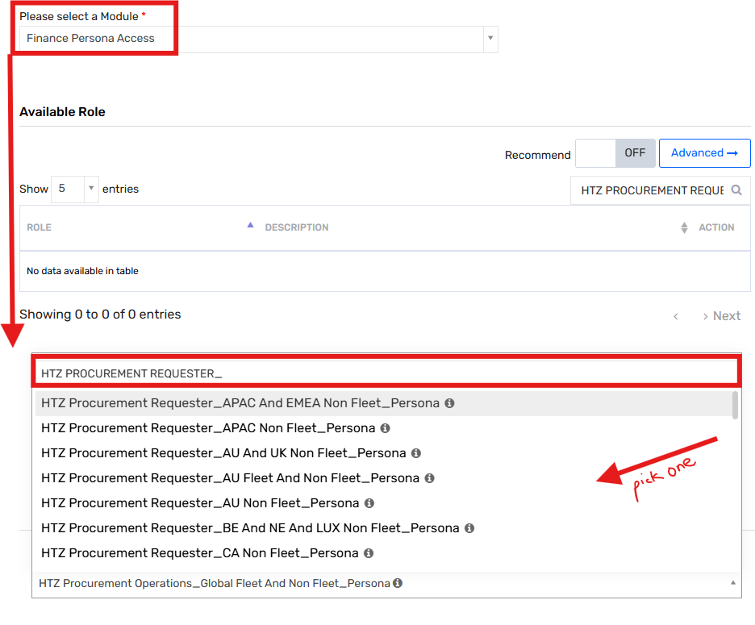​
​
Finance Individual Roles:
Selecting an individual role will allow you to request a single job role, this is helpful if you already have a persona assigned to you, but you need an added role added.
Example: if you selected Finance Persona Access, available role is blank, but the selected Role on the right shows a list of job functions. You already have a Person assigned.
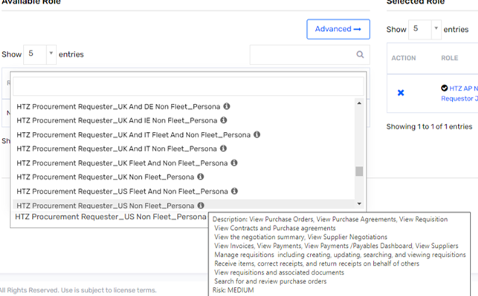
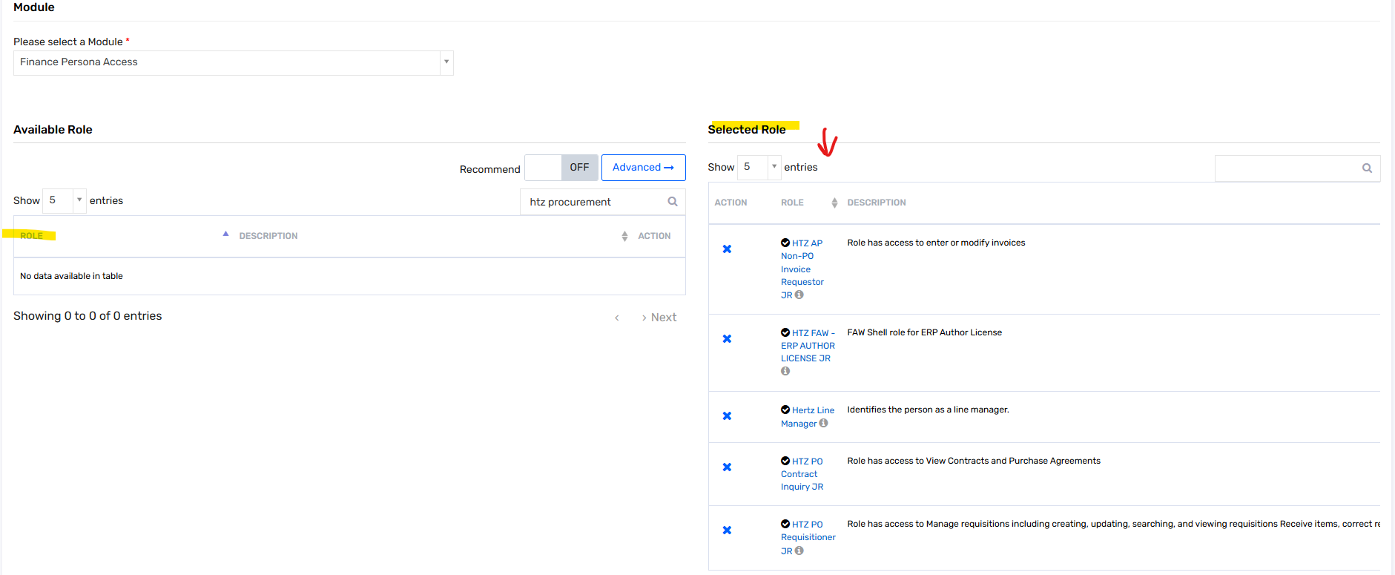

You already have a persona assigned but need to add a role, select Finance Individual roles.
Example you need access to add purchase requisitioners, choose HTZ PO Requisitioner JR
Example of how to search, once role is found, select + sign, role moves from left to right.
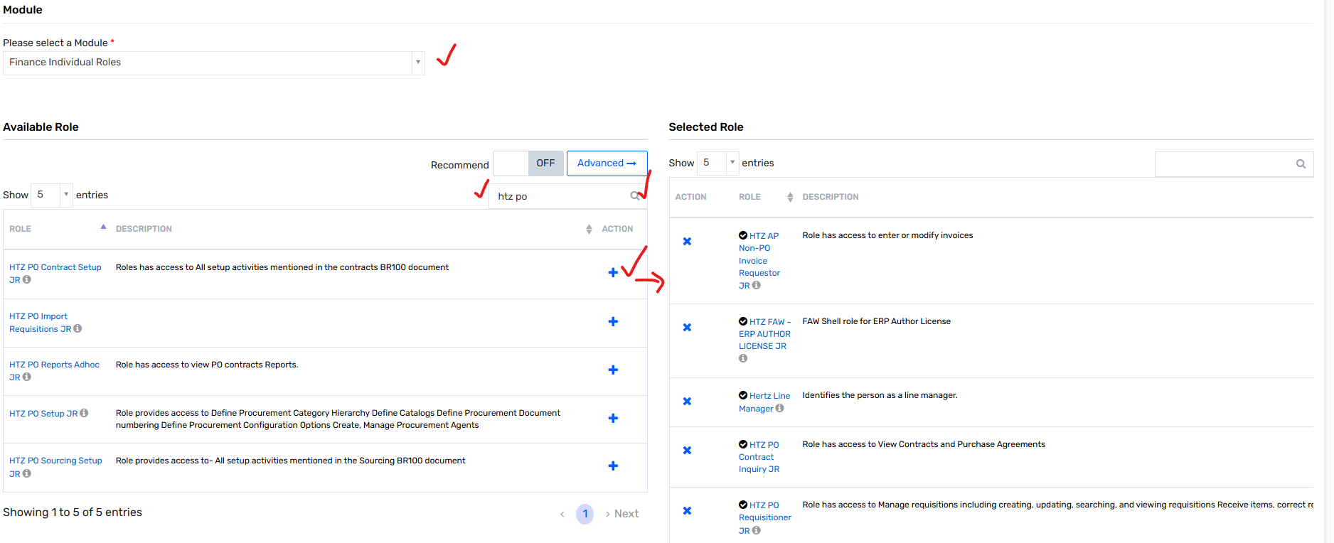
Once you are done requesting the access or choosing the persona, click the Next button.


Enter the justification for the access in the comments field.
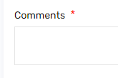

Click Submit

A Saviynt Request number will be generated, and the request will be routed to your immediate supervisor for approval. Depending on the Persona and or roles(s), there may be other approvers based on what type of access is being asked. Once the request is fully approved, the access should be granted within a few hours.

For a copy of this guide, click on the below attachment.

