Create Requisitions from Smart Form: Multipurpose Requisition Creation form
- On the Oracle Cloud homepage, Select Procurement.
- Click Purchase Requisitions (New)
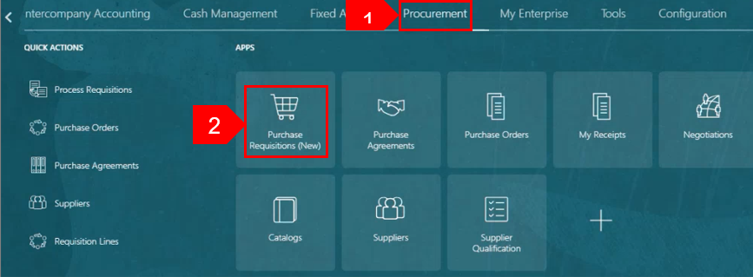

- Select the Preferences tab.
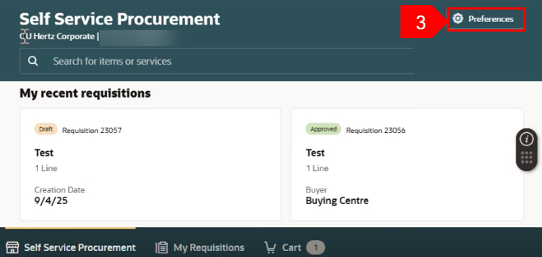

- Select the relevant BU from the Requisitioning BU dropdown menu, if needed.
- Select Update.
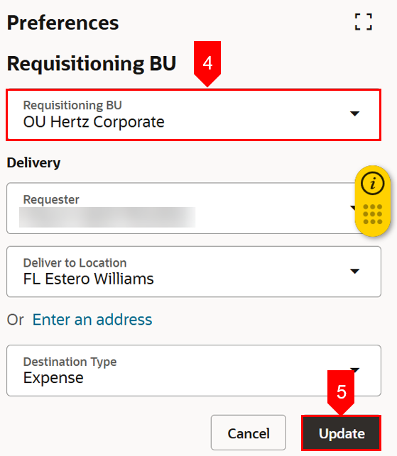

- Select Self-Service Procurement.
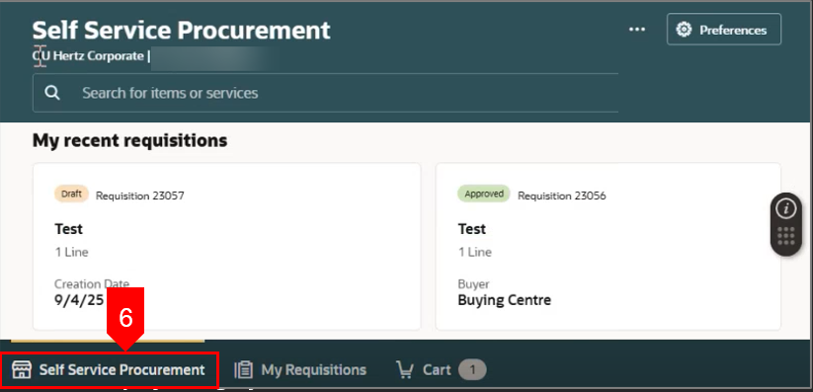
- Select Shop by Category
- Select Browse All.
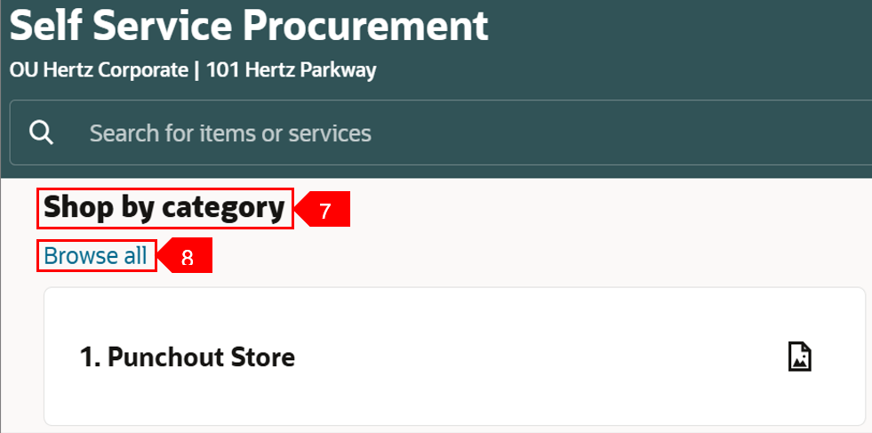

- To use the Multipurpose Creation form, select the other file
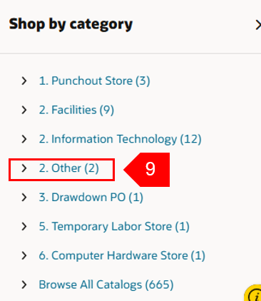

- In Corporate BU the form must be selected, in all other BUs the form will open form the Other file.
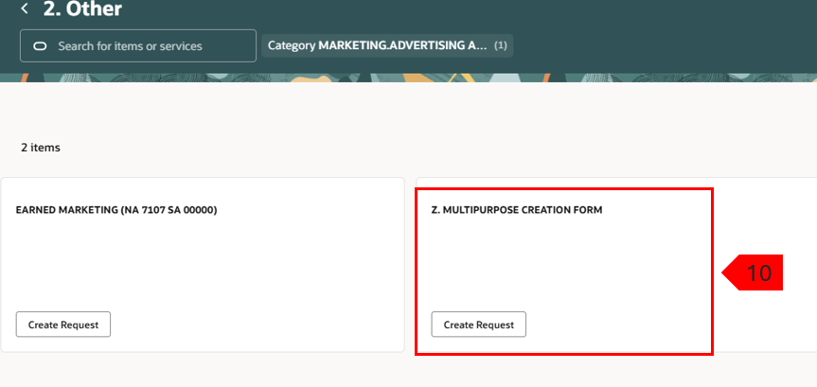
Note: BUs other than Corporate, the Other file contains only the multipurpose (MP) creation form, the requisition (REQ) form will automatically open. The non-catalog requisition creation form is no longer visible since the MP form has replaced the REQ form.
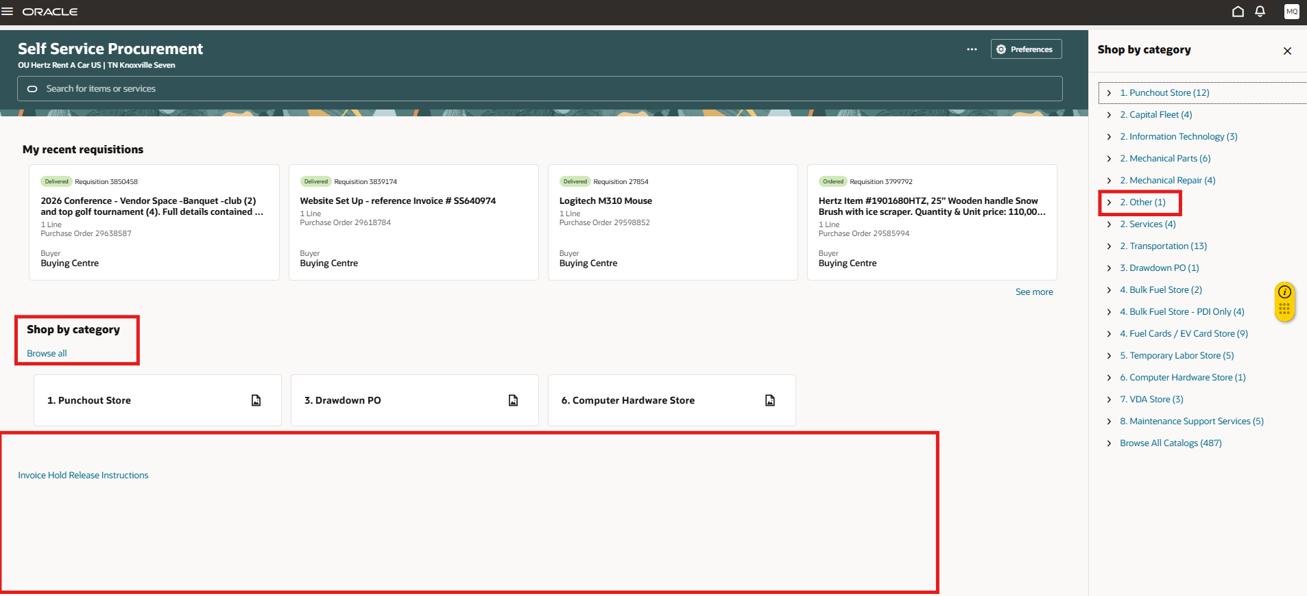
- When the Multipurpose creation form is used, you must enter the item description, select the category from the dropdown, enter the amount, currency (can be updated to align to supplier site currency), supplier, supplier site, if applicable add notes and attachments.
11
- Select Add to Cart
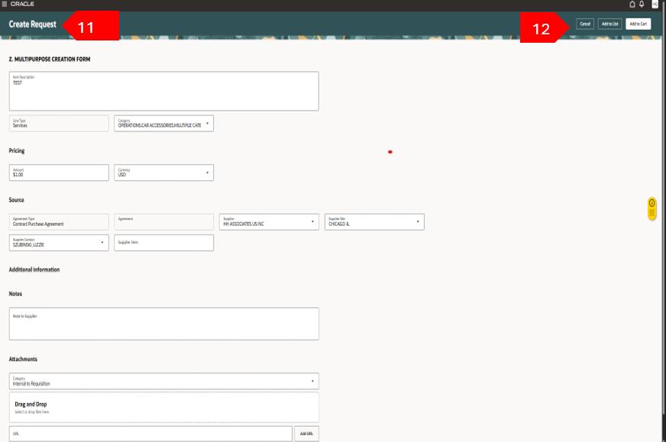
A Confirmation message appears.
- Select View Cart.
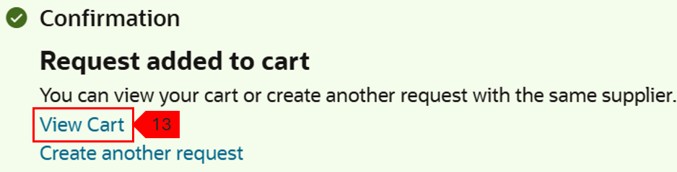
- Select Edit icon (pencil) under requisition summary, to update the “header” details: requester, deliver to location, requested delivery date, charge account. If no changes are needed add the description and justification note on this view ( no need to edit), select Submit.
  - To view the approvers, view REQ pdf or save for later, select the ellipsis: …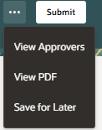
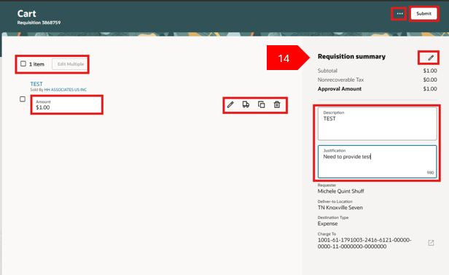
View of requisition header editable fields, to update the charge account from this view, place your cursor in the area of the account segment, back space and enter the updated charge account number. NOTE: never update the LE that does not align with the BU and the natural sub account (NA SA), this is tied to the PO category. If NA SA needs update, choose the PO category that aligns with this number.
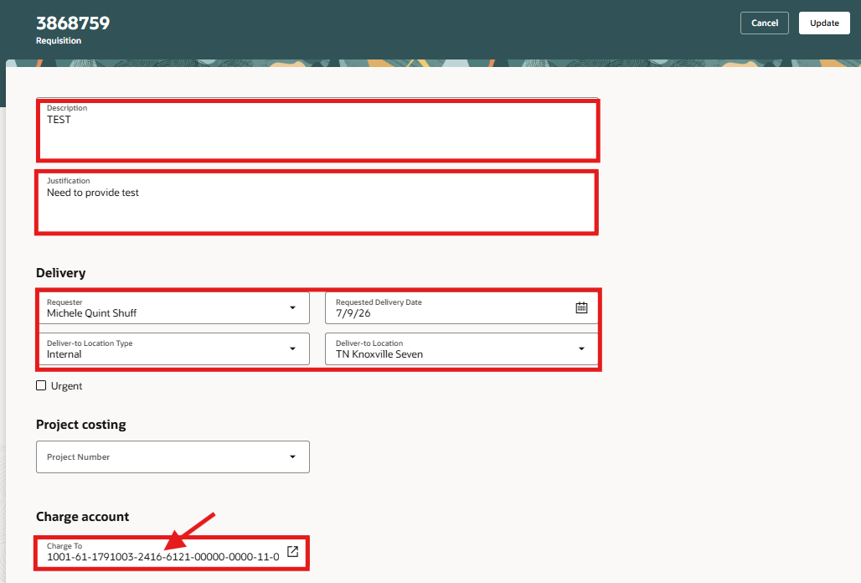
- Review or edit the details for each line. Update the requester if ordering for someone else, always update the requested delivery date, when necessary, add notes and attachments for back up.
- Select Update.
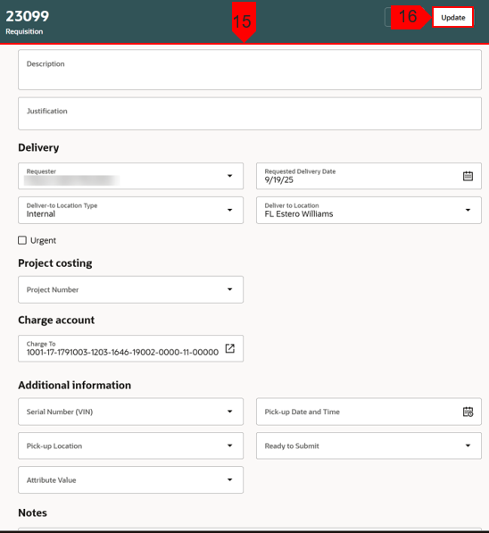
- Select Submit.
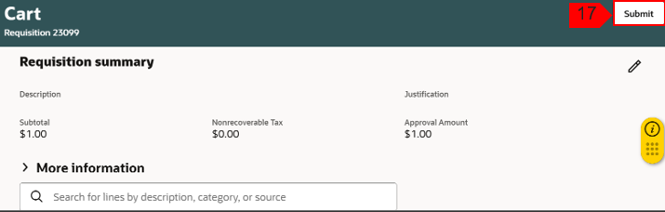

This completes the process to Create Requisition from Smart Form: Multipurpose Creation Form.

