Order Life Cycle View from Purchase Requisitions
Order life cycle shows the receipt and invoice details that have been processed against the PO. Use this view to investigate Oracle hold alerts.

Select Procurement.
Select the Purchase Requisitions (New).
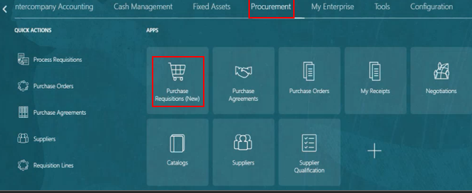
Select My Requisitions.
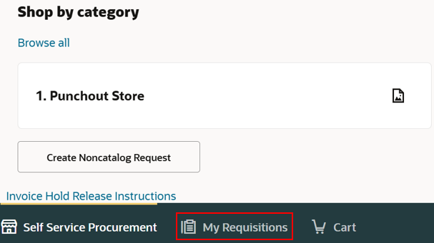
Use the Search bar, enter the requisition or PO number. Use quote marks around the REQ or PO this will define the search to this specific number. This will work any searchable detail.
Use the redefined filters, the ellipsis (three dots) has additional filters
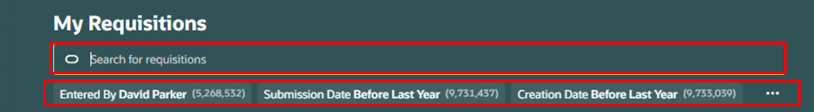
Once the requisition populates, there are two sets of ellipses (three dots) indicate REQ header and line. Select View Life Cycle from the REQ header or select the PO
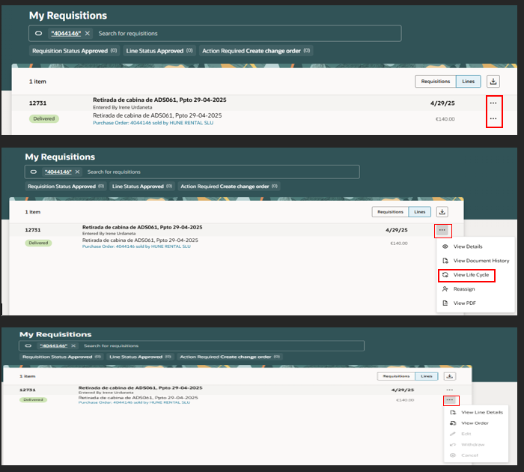
Summary PO details will populate, click on Order Life Cycle
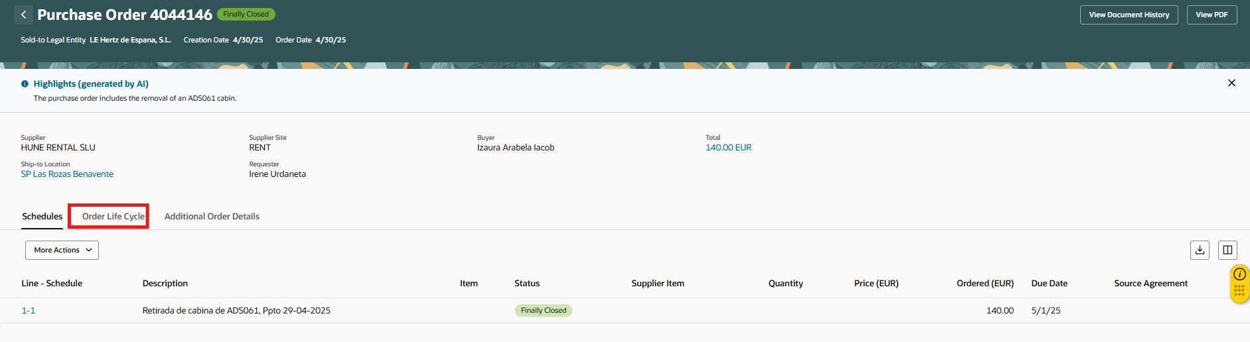
Order Life Cycle view
Select Receipts to view receipt details
Select Invoices to view invoice detail. Note the invoice number is blue is a hyperlink. When you click on the invoice number a new screen will populate, and you will see the manage invoices view.
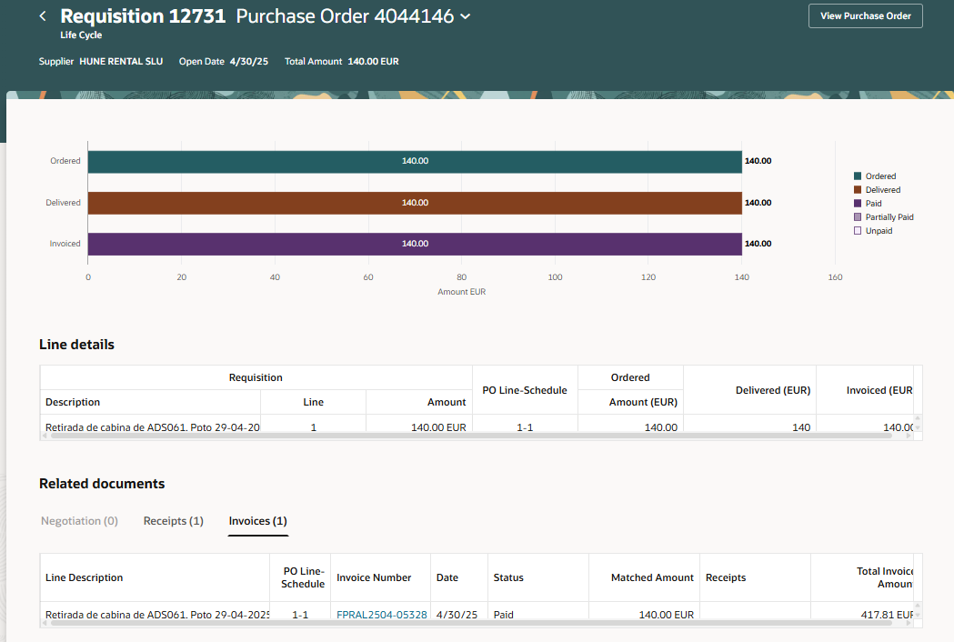
Select Receipt Number link to view receipt details.
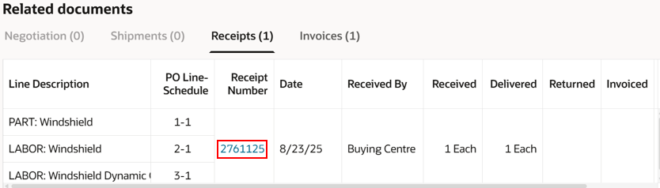
View the receipt details.
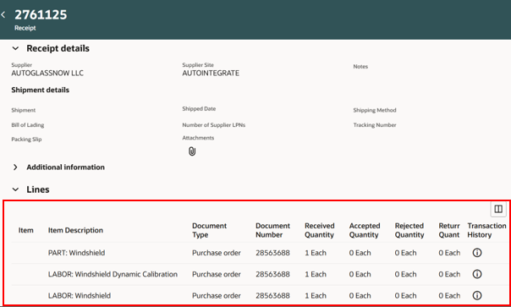
View the invoice details, select the invoice number in blue, this is a hyper link.
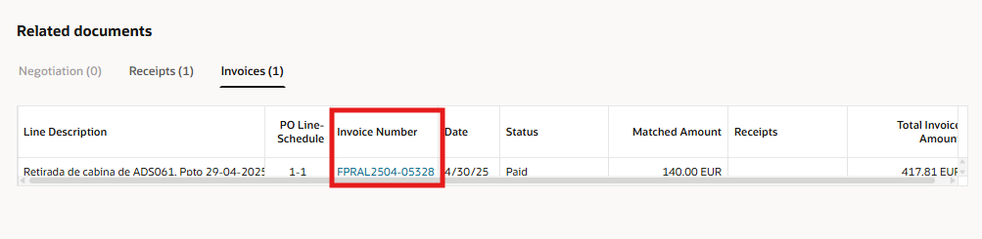
Manage invoice screens will open in a new browser tab, view the invoice, click on the payments tab to payment due date and payment number details.
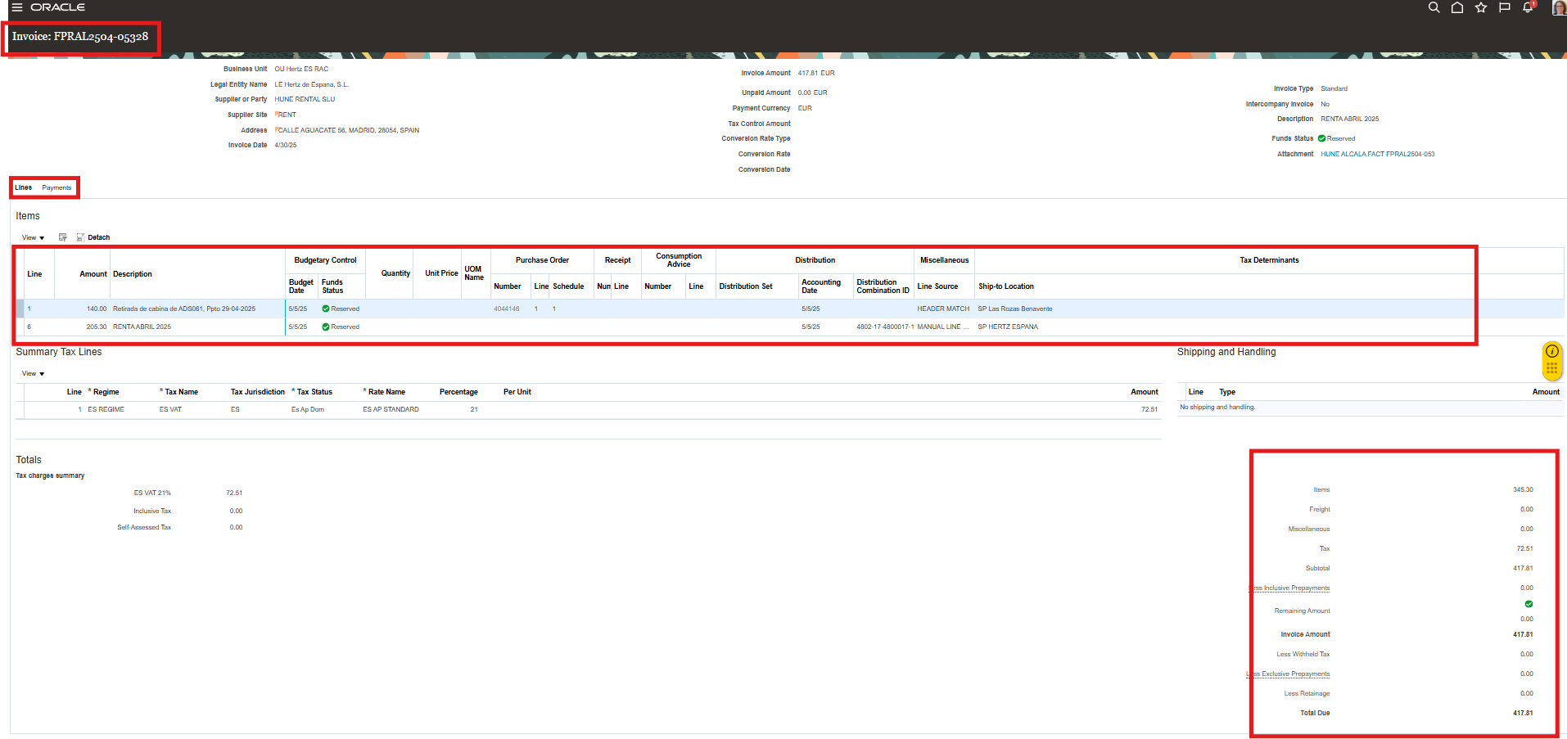

The second option is to click on the PO number in blue, this is a hyperlink.
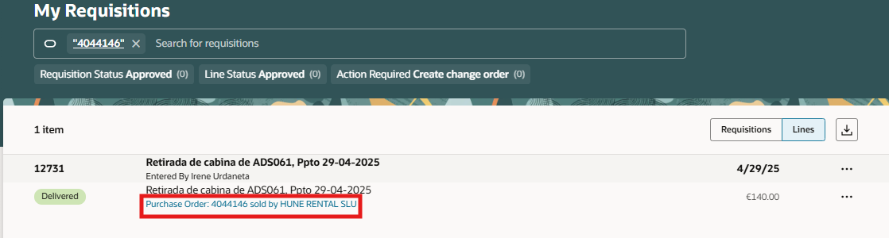
Summary page will display the PO details, receipts and invoices. The icons on the top right allow the export of data or customize the columns. 
