Oracle Home Page Functions

The home page is your main landing page.
You may have access to categories that necessary and you want to streamline your view. To hide them from your main menu, select the + sign.
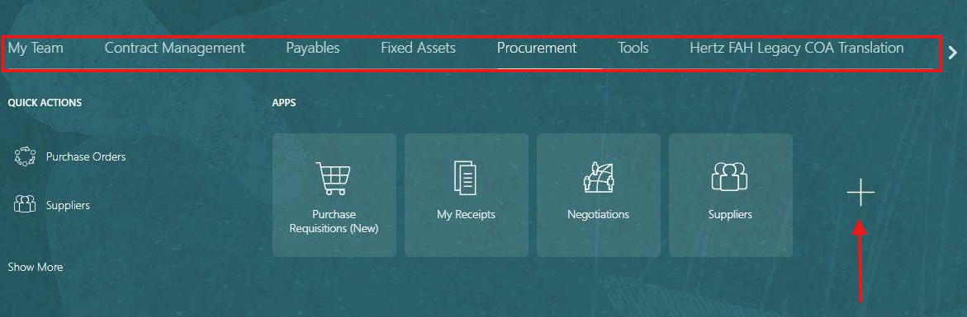

This screen will display the main menu of Apps. Unchecked the boxes of the App’s choices to eliminate them from view. Ensure you unselect all the subcategories to reduce the main menu choices.

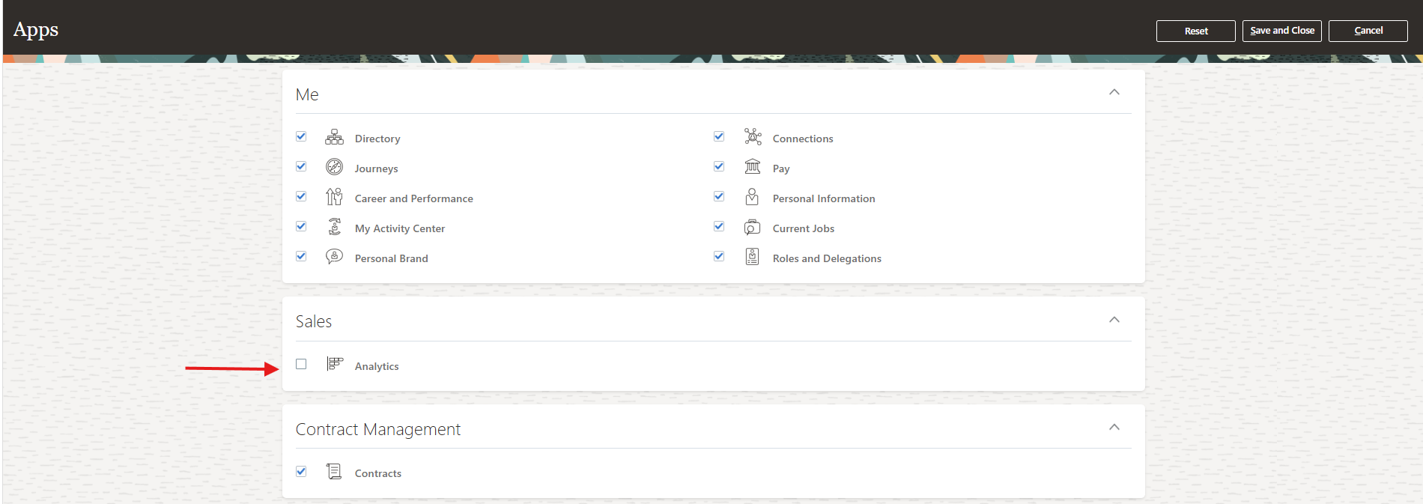

Un-check all the choices and

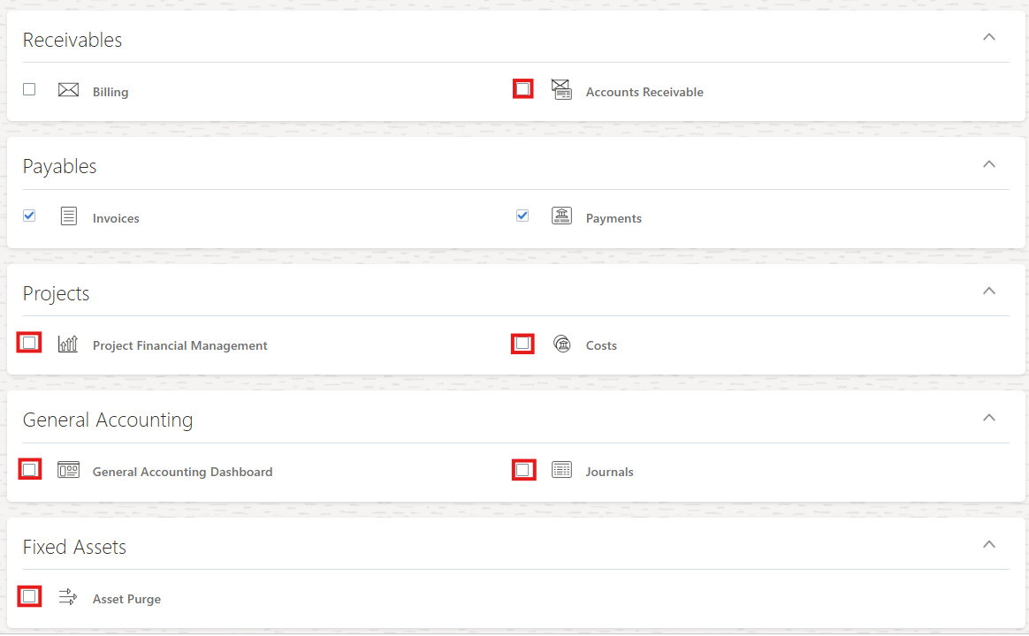

From the top right select Save and Close.


Now the main menu has less clutter, and frequently used categories are visible.

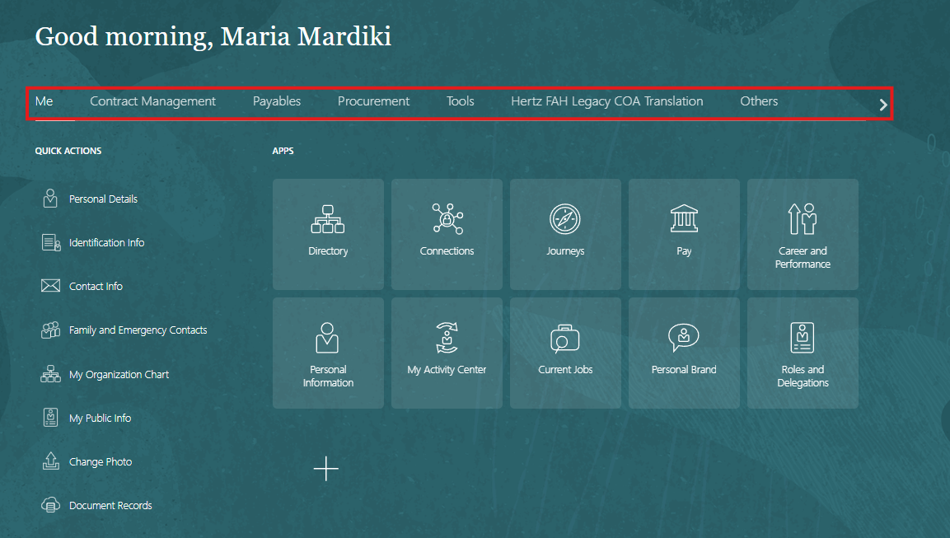

Add a favorite file to save your frequently used screens, select the star icon on the top right.
Here you will see Add to Favorite and Manage Favorite.
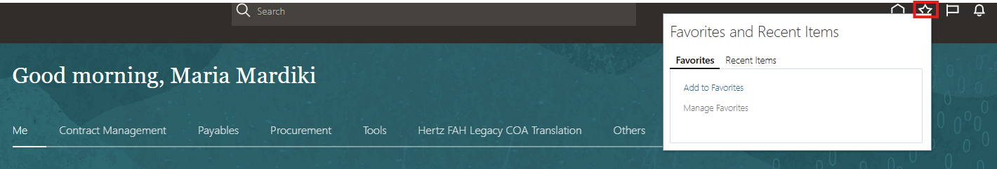

You must be on the screen you wish to save. This screen has an added field to look up POs by locations.
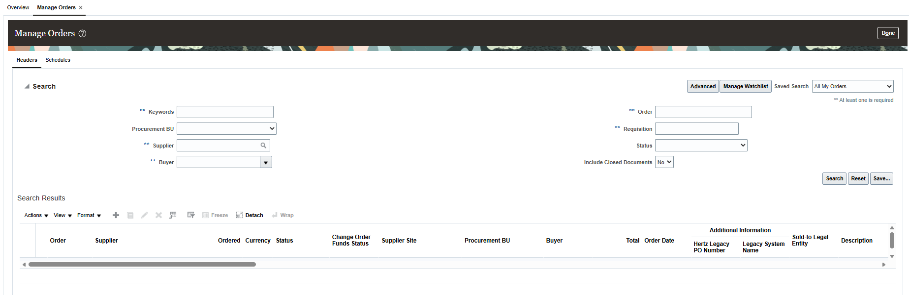

Select the star and pick add to favorites. Update the name of the screen and either create a new file or save in a file previously created.

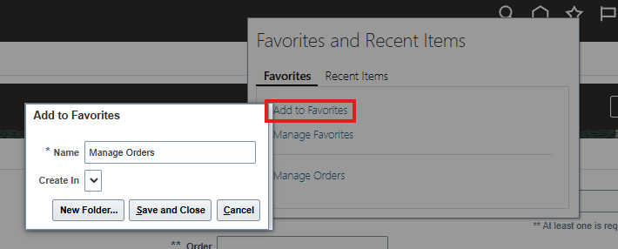

To create a new folder, select New Folder.
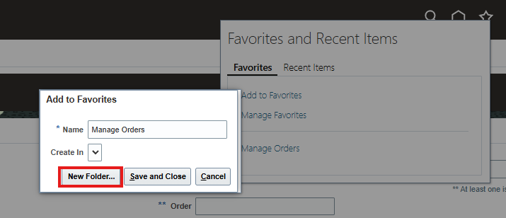

Update the name of the screen, create in’ your new folder, select Save. It takes a few seconds to process.
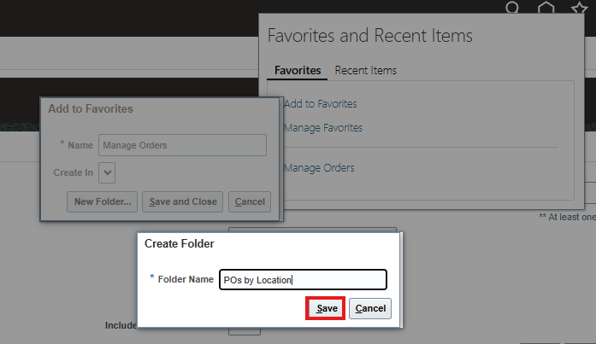

Select Save and Close.
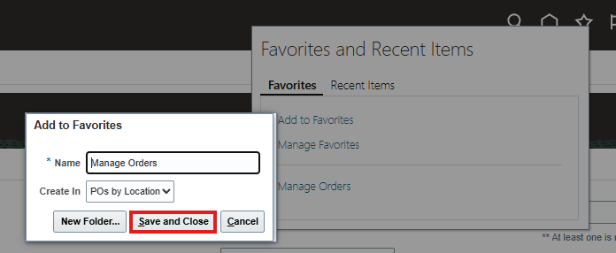

Select the star icon, manage favorites to see your saves, update the names, add new folder or delete. Reminder you must highlight the item to update or delete.

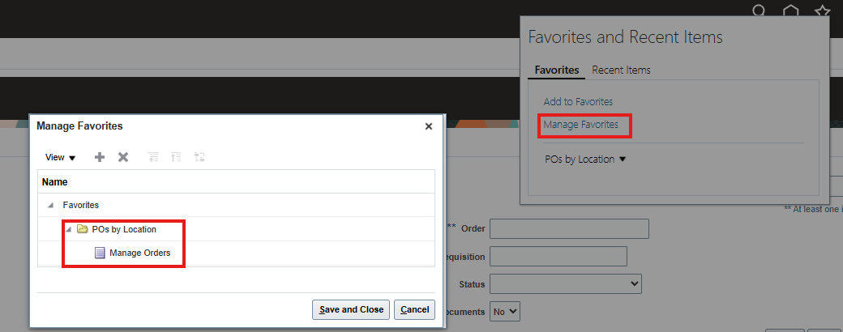

Or Select POs by Location and Manage Orders.

