How to Submit a Help Ticket to Procurement Operations
The most effective way to communicate with the Global Buy to Pay team (procurement operations and buying centers) is to create help request through our ticket system Happy Fox.
Go to https://hertzp2p.happyfox.com
If you find you still need help ‘SUBMIT TICKET’ found at the top right of the Hertz Global Buy to Pay Happy Fox Home page.
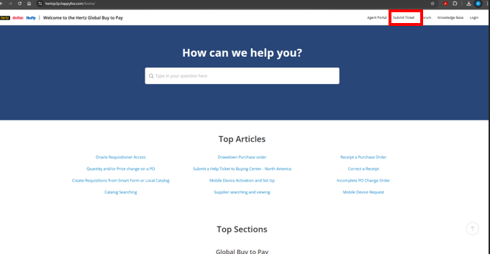​
Select from our team category: GB2P
Next select the sub team:
Buying Centers: select by work location region: examples: North American = Canada / USA, Italy, HESC, UK
Procurement Operations: only one selection as team is Global
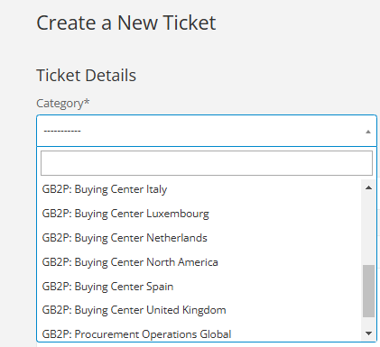​
Procurement Operations, select the country work location, select the type of request: Fleet related, Fuel, General Inquiries, PO Management, Reporting or Trainings.
If you are unsure of type, enter General Inquiries.
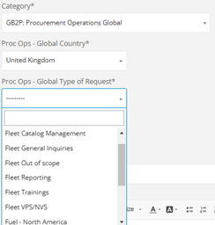​
Buying Center: North America, select the type of request: Catalog Management, Contract Management, General Inquires, Mobile Device Management, PO Management, Requisition/Ordering Management, Trainings or Warehousing Requests.
If you are unsure of type, enter General Inquiries.
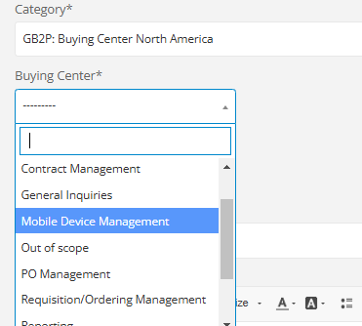​
Buying Center European regions: select your work location. From category select request type: Catalog Management, Contract Management, Costar, General Inquires, PO Management, Requisition/Ordering Management, Trainings or Warehousing Requests. If you are unsure of type, enter General Inquiries.
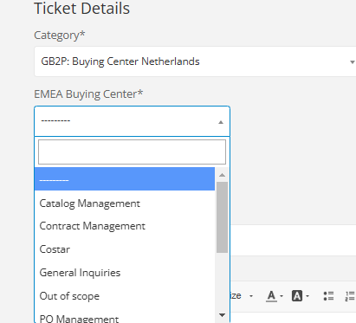​
Next step for select the ticket priority.
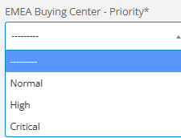​
Enter the subject, message, add someone you wish to copy and attached files: example, Excel list of POs or picture of error or issue.
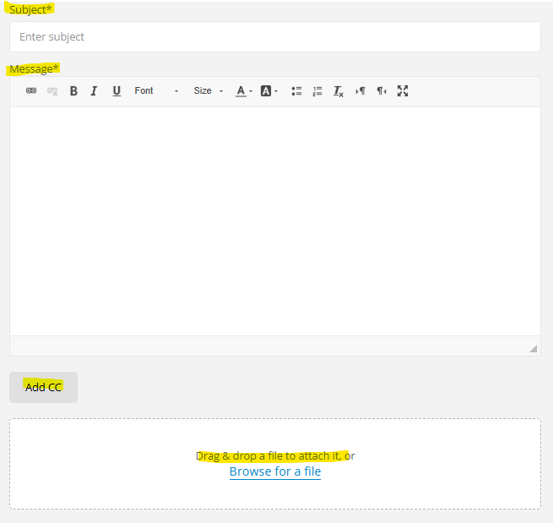​
Add your contact details and select Create Ticket
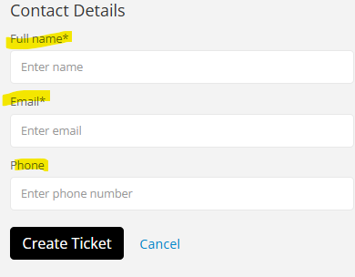​
The following note will appear
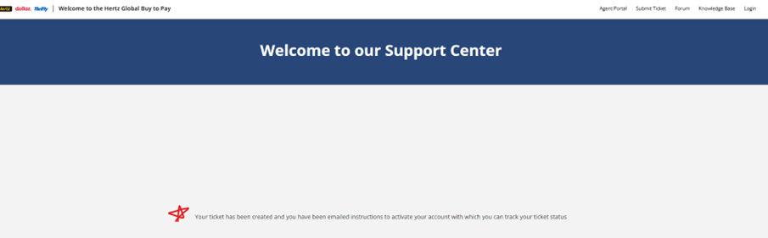​
The help ticket request number will be sent to your provided email.
