Mobile Devices - Request New, Replacement & Changes

This section will introduce you to the Mobile Devices form in ServiceNow. Devices ordered via this form are cell phones, hotspot (MiFi) and push to talk (PTT).
Types of users: Corporate = iPad, iPhone and MiFi are tied to an employee name.
Field phone/Branch device/Branch Manager device = iPad, iPhone, MiFi or PTT devices are tied to a location.
This form can be used to update the phone number, carrier, or billing location.

Ensure you are logged into the Hertz network, go to https://hertz.sharepoint.com/sites/Estero/
Select Technology Support, Request something or use link to ServiceNow: https://hertz.service-now.com/esc
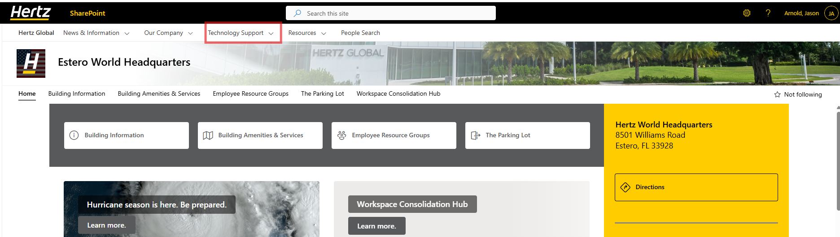
Type Mobile Device into the search and click on the magnifying glass.
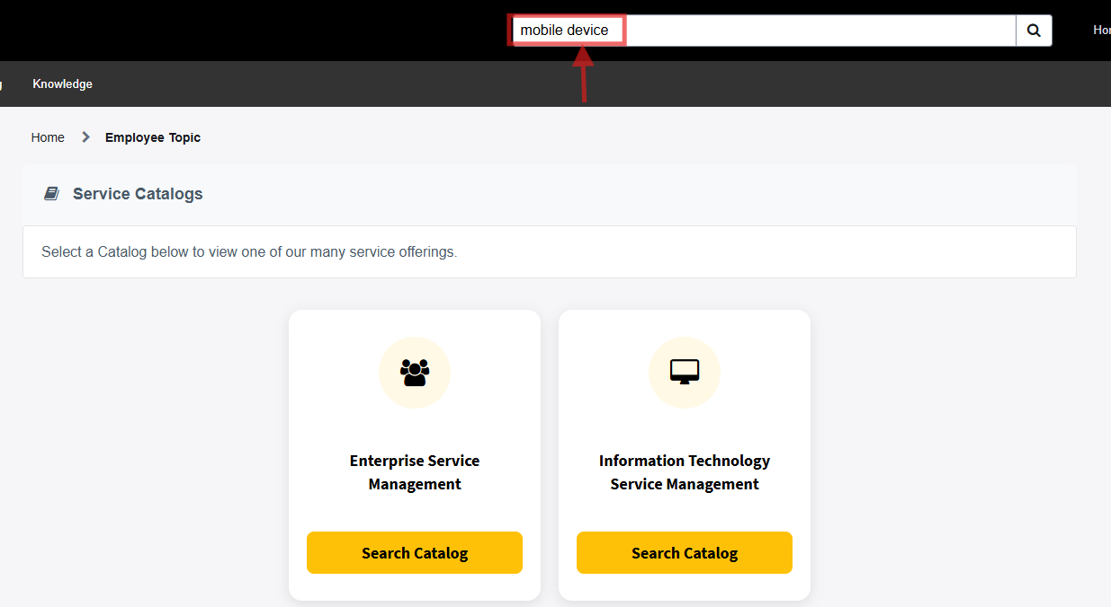
Select the form Mobile Devices with a picture of hand holding a cell phone or click the Request button on the left.
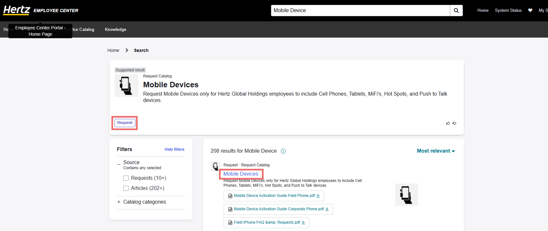

The form can be completed by the device requester or on behalf of the device requester. Once the name is added to “Who is this requested for?” the employee ID will auto populate. If the recipient phone number does not populate, manually add a landline number. The email and job title will automatically populate, these fields are editable.
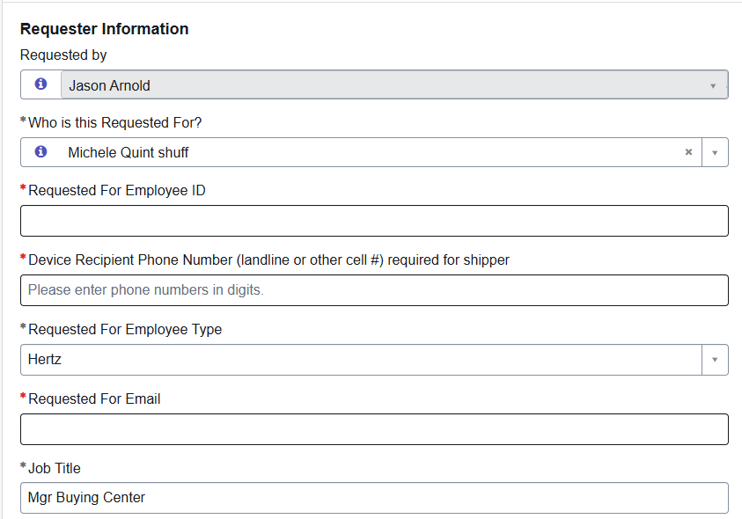

Select the reason for the request.
Examples: New Device = new phone #, Replacement device = keeping the same phone number, Billing / location change = the phone is billed to your location if you move this must be updated.
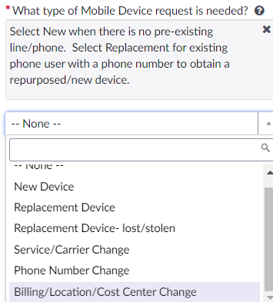

Requesting New Devices
Select New device and add the reason why the device is needed. Select the device type*, enter the location number (often a leading zero is required). If the location address is not the ship to address, select No, and enter the address and select how the device will be used.
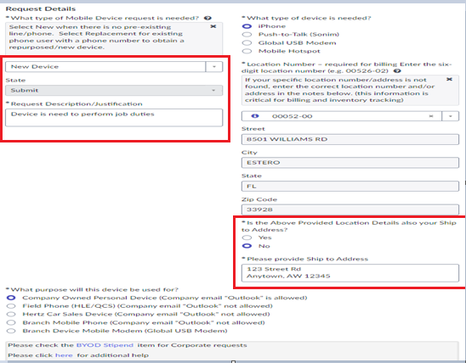
Select the carrier, AT&T and Verizon are the current carriers; Please choose the carrier that works best in your area. Enter the VP for your department, all mobile devices must have a VP approver.
Add additional notes: correction of location address, cost center. For field, branch devices orders: if multiple devices are required, add the number of devices. Device must reside at same location, if not create new request for each device/location.
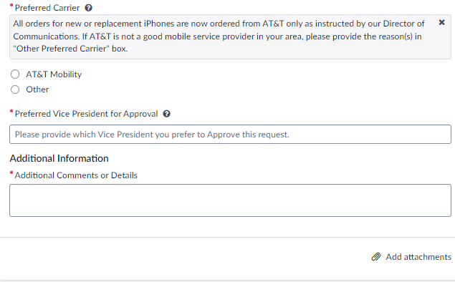
Select Order Now.
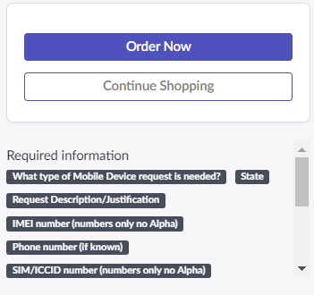

Requesting replacement devices
Use this option for devices that are old (greater than 2 years), not working properly and/or damaged.
Enter the phone number of device along with the IMEI and SIM numbers if possible. If you do have them or they do not apply, enter N/A. Complete the remainder of the mobile device request.
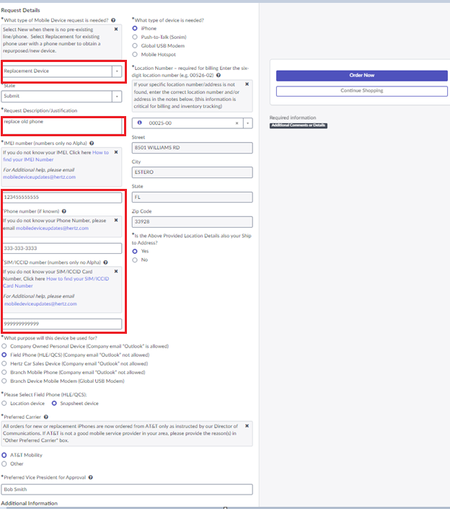

Requesting replacement for lost or stolen device
Before creating this request, a Breach of Security form must be completed. After obtaining the request number, add it to the form.
Enter the phone number of device and the IMEI and SIM numbers. If you do have them or they do not apply, enter N/A. Complete the remainder of the mobile device request.
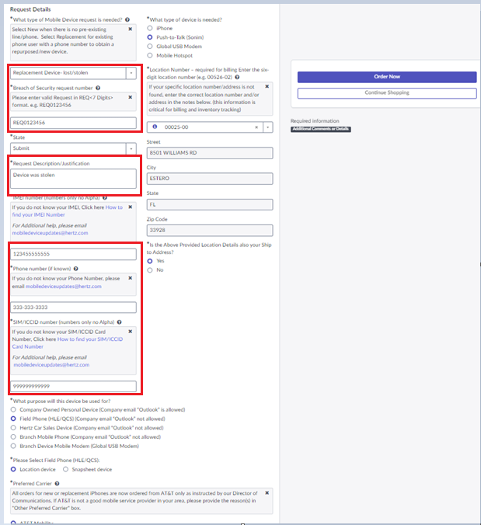
Requesting an update to the billing / location / cost center
Enter the details at the top of the form such as name, who it is requested for, etc.
At the prompt What type of Mobile Device request is needed, select billing / location / cost center change.
Complete the remainder of the mobile device request.
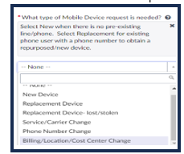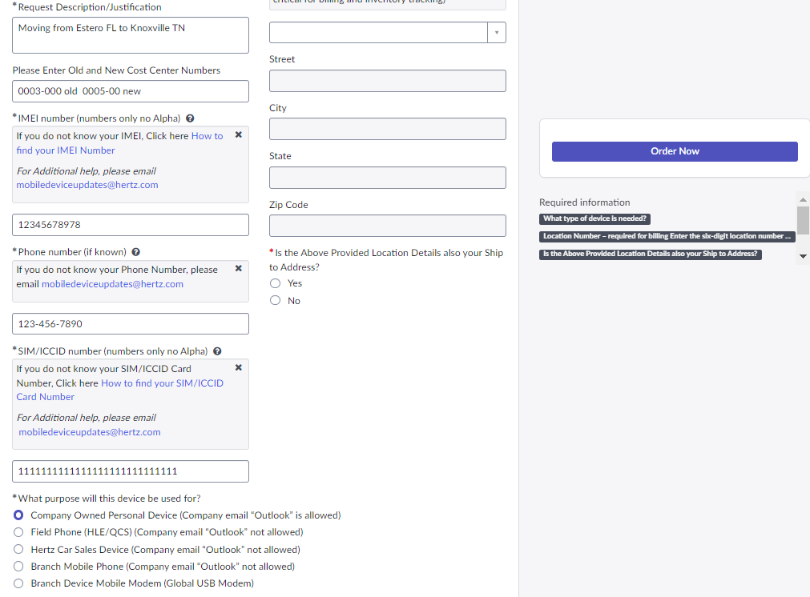

Requesting update to carrier/service or port to another carrier
Change should only be due to poor service/coverage or porting device from one carrier to another carrier.
Select Service/Carrier Change, reason for change, old/carrier new carrier, IMEI. Enter phone number, SIM, select the type of device you have, your location. Confirm ship to, if different from location address. Add your VP name, additional note, select Order now.
