Drawdown Purchase order

How to create a Drawdown PO

Drawdown POs (DPO) are for re-occurring purchases: service or goods provided in the same amount every month (or quarter, bi-weekly, etc.)
Receive DPOs ONLY when the supplier has provided services or goods, never pre-receive the PO in its entirety.
Always use a valid PO end date. Services for annual basis use 12.31.202x. If the DPO is for less than or greater than a year, use the expected end date.
Only use one line on Drawdown PO.

- On the Oracle Cloud homepage, select Procurement.
- Select Purchase Requisitions.

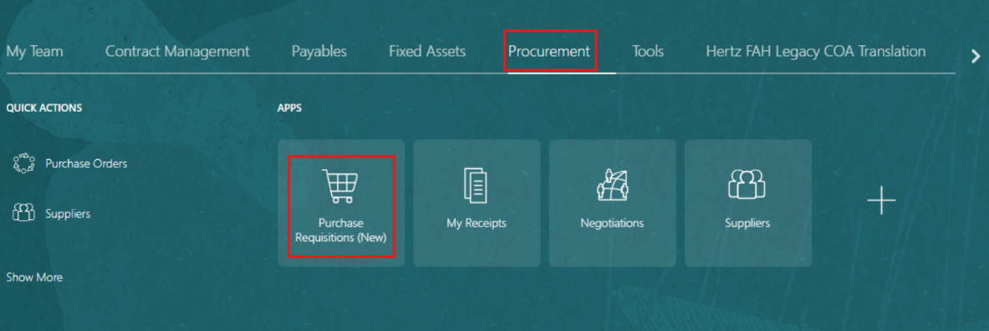

- Select the Preferences.
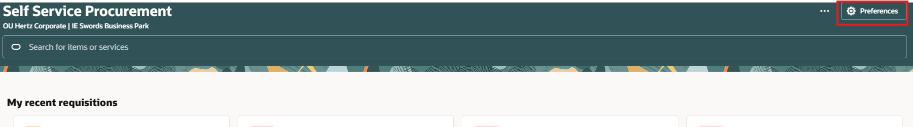

- Select the relevant BU from the Requisitioning BU dropdown menu and also the Requester.
- Select Update.
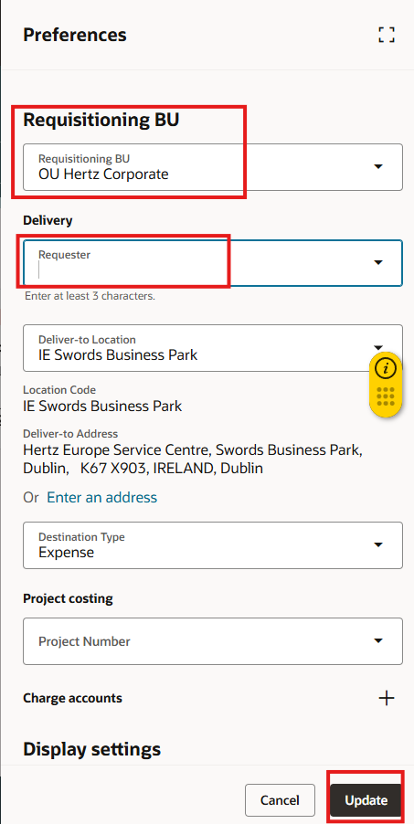

- Select Browse all under Shop by category.

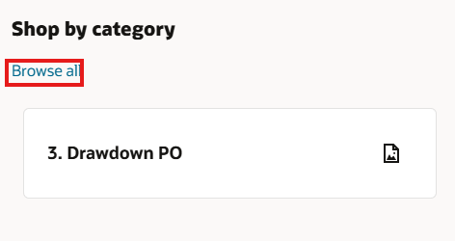
- Select Drawdown PO.

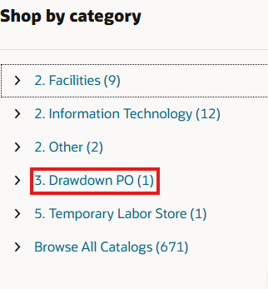

- When creating a DPO for an annual basis use a description as such “Drawdown PO <<current year>>” to begin the item description.
  - The example below has “Drawdown PO 2026 for Landscaping services” as the Item Description.
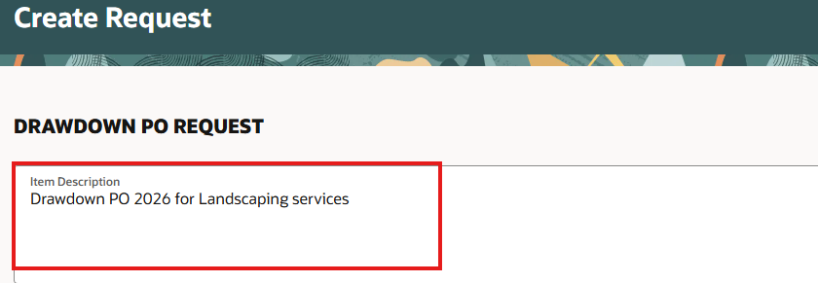

- Select appropriate Purchasing Category depending on the type of service you are creating the Drawdown PO for. For example, if the Drawdown PO is for landscaping, you will search by “FACILITY”. Select FACILITY.BUILDING AND GROUNDS MAINTENANCE.MULTIPLE CATEGORIES.
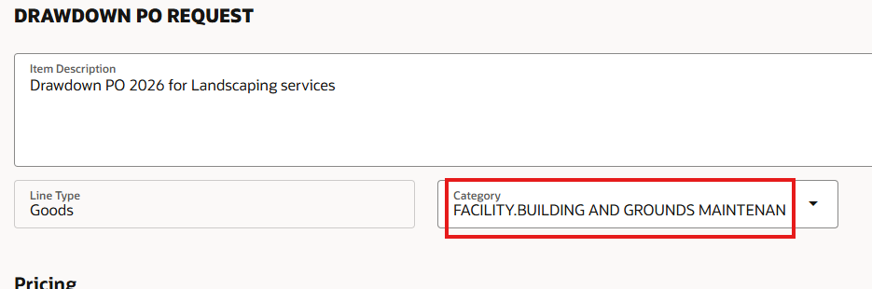

- Enter the Amount of the expected spend during the DPO covered period.
  - If you are creating it at the beginning of the year and you estimate spending $800 a month, enter 9600.00.

- Enter the Supplier name directly or search the keywords and select from the dropdown menu.

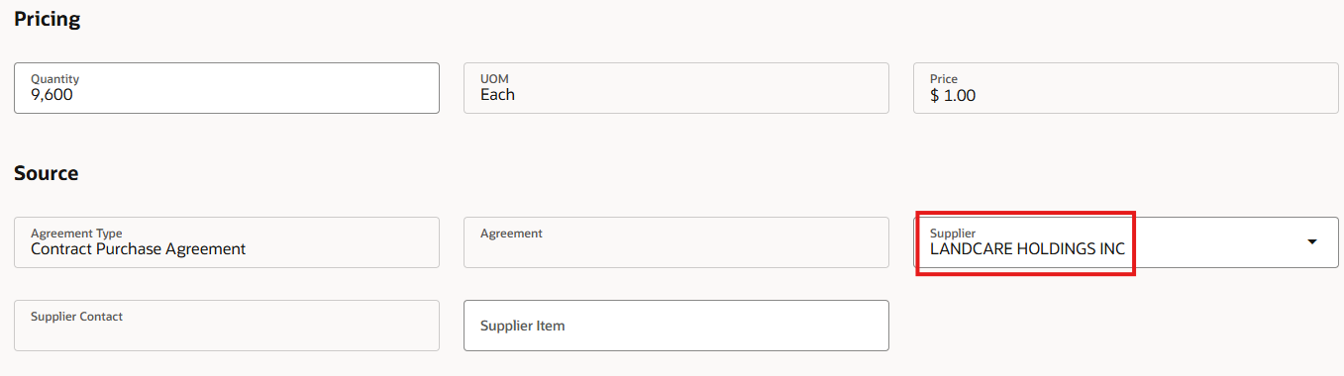

- If the supplier has only one site, it will automatically pull into the supplier site field.
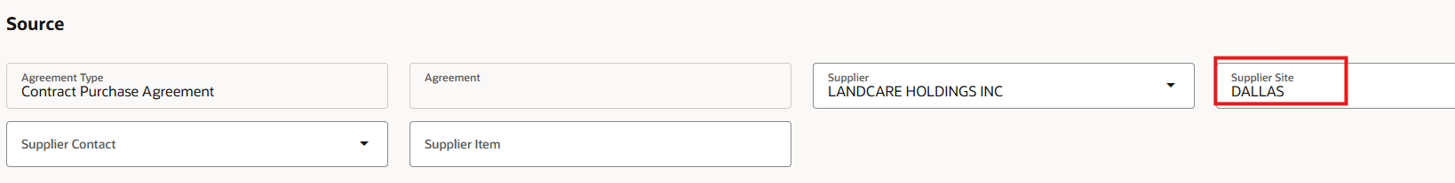

- If more than one site exists as shown in below example, select the site (city) displayed on the supplier invoice.

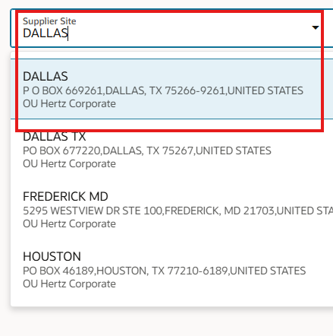
- Enter the previous Drawdown PO (DPO) if it is replacement from a prior year.
- Select PO type DPO 202X - if you are creating for the following year, use that year.

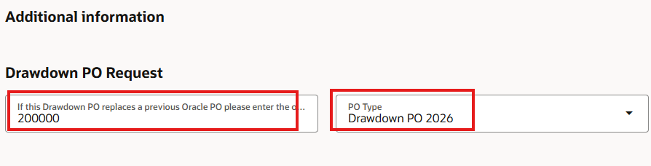
- Attach relevant documents using Drag and Drop or Add URL.

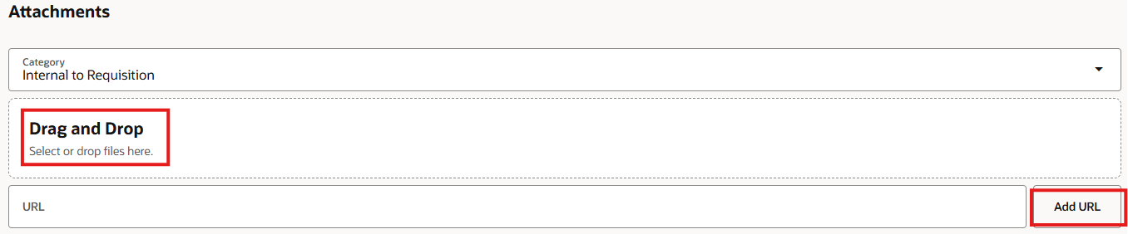

- Review the DPO and select Add to Cart.
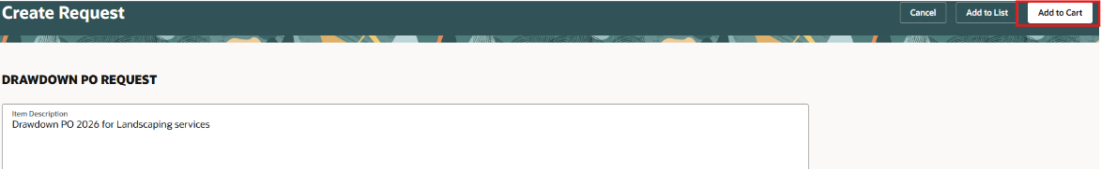

- A Confirmation message appears. Select View Cart.
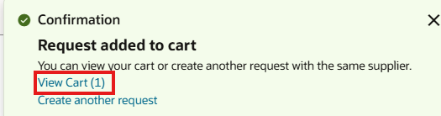

- Select the Edit icon (pencil).

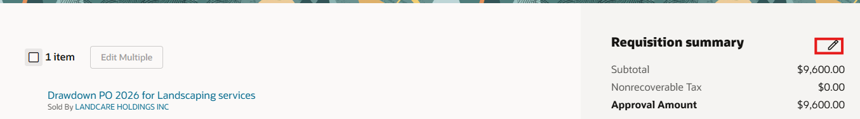

- Update the fields as follows.
- Justification: Information for the approver(s). This field is only for the approvers and will not be transmitted to the vendor.
- Requester: Enter name of person who request is for, this will determine the location and department
- Need-By Date: Must be set to 31-Dec of current year.
- Note To Supplier: If this PO is replacing another previous PO, enter “This PO replaces PO# xxxxxxxx.” This information will be on the PO for the supplier.

- Select Update.

Note: You can update the fields if needed.
- Charge account
- Deliver to location type
- Deliver to location
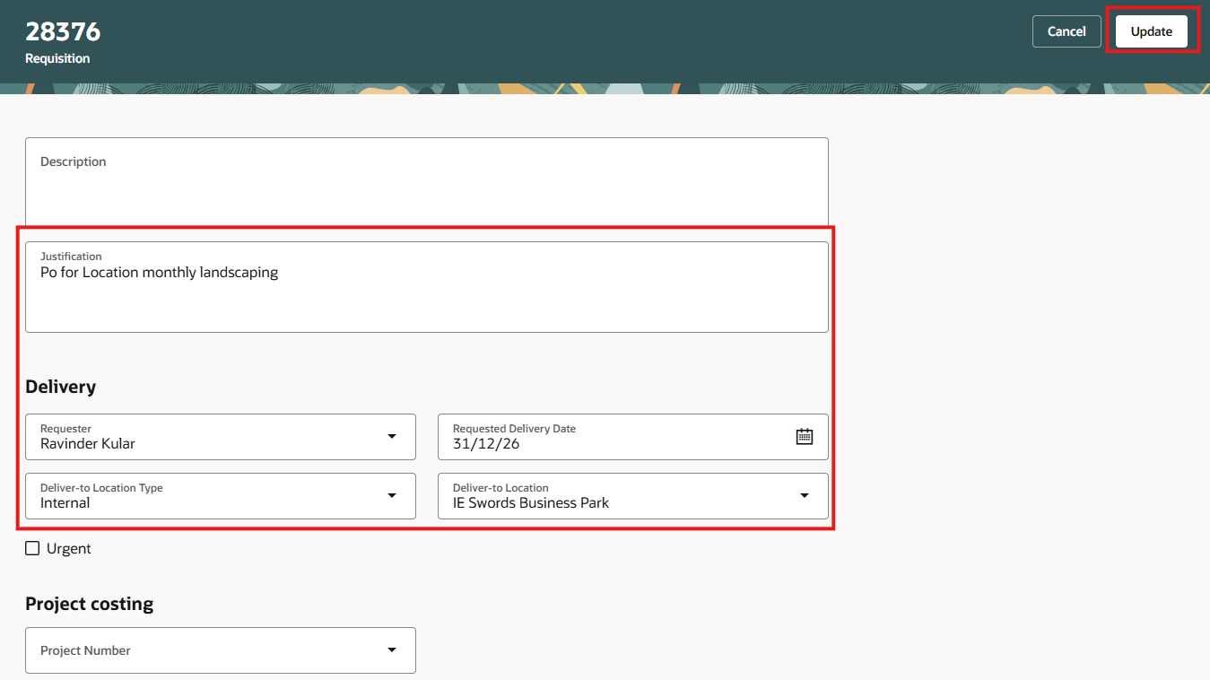

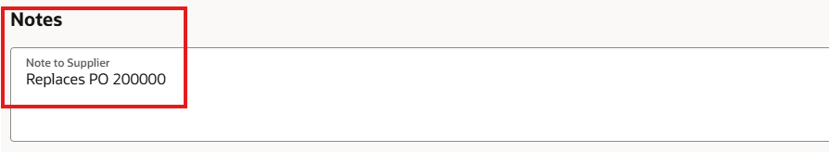
22. Select Submit
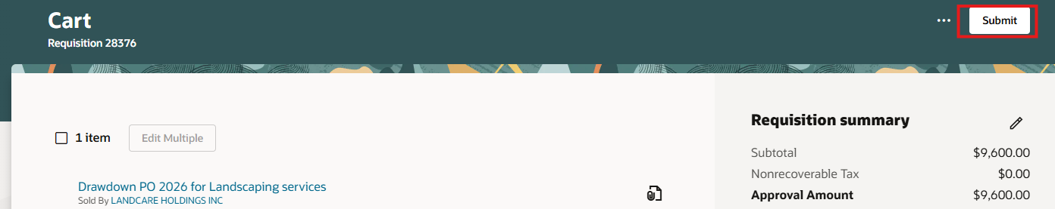

- The status of submitted requisition can be viewed under My recent requisitions.
Note: You can select the tab to see more details like list of approvers as shown in subsequent slide.
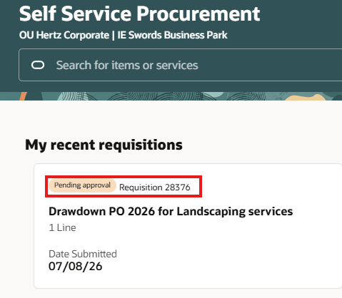

- Select Ellipsis (three dots).

- Select View Approvers.
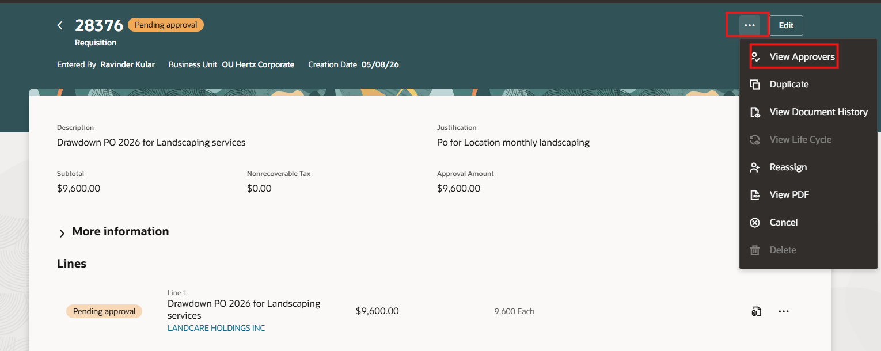

- View the list of approvers.
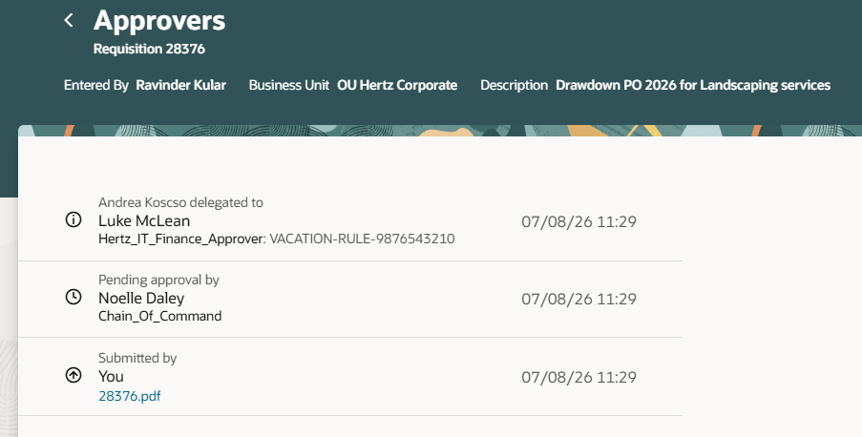

This completes the How to Create a Drawdown PO process.
See attachment to download a copy of this process via Word document.

