How to Correct a Receipt

Select My Receipts
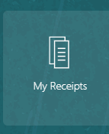
Select the task pane.
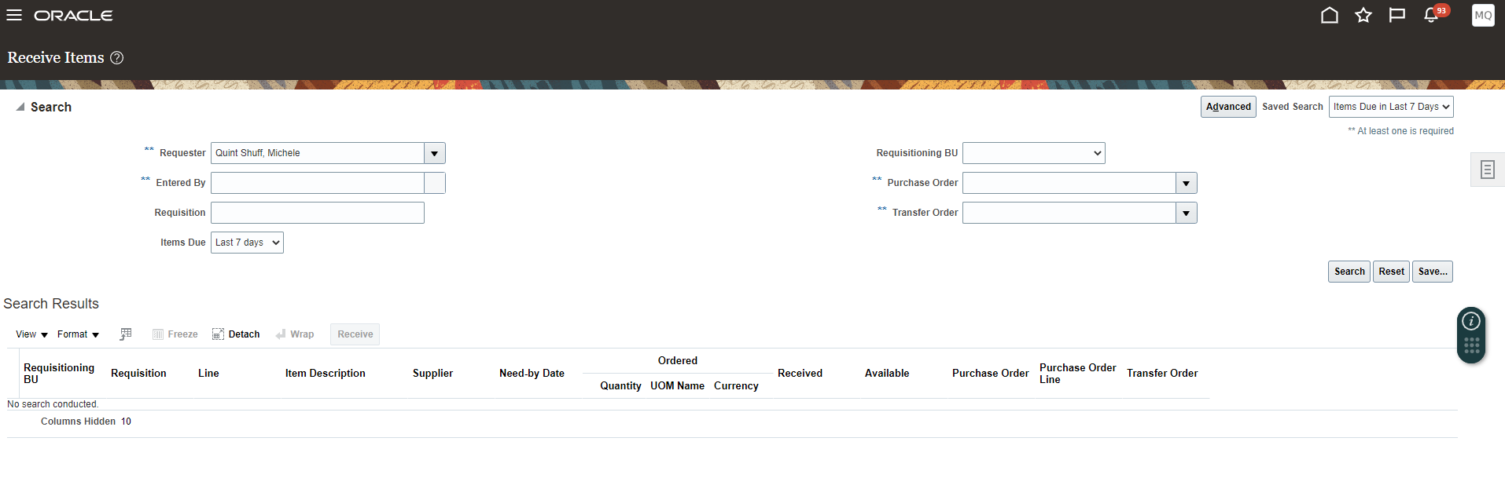Select manage receipts.
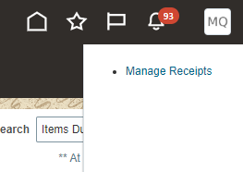
Below search will populate.
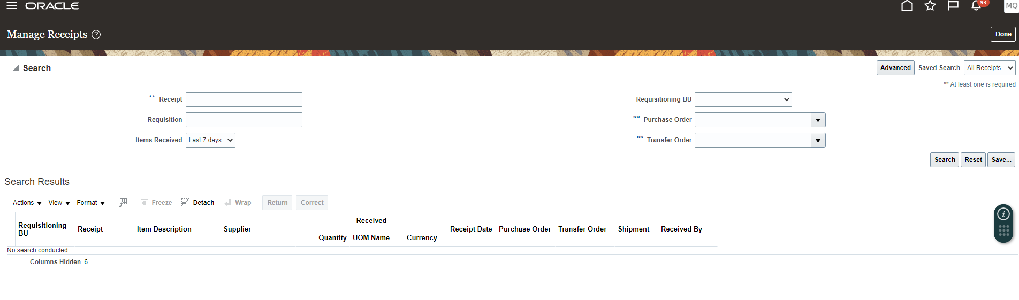

Change the items received date to: any time
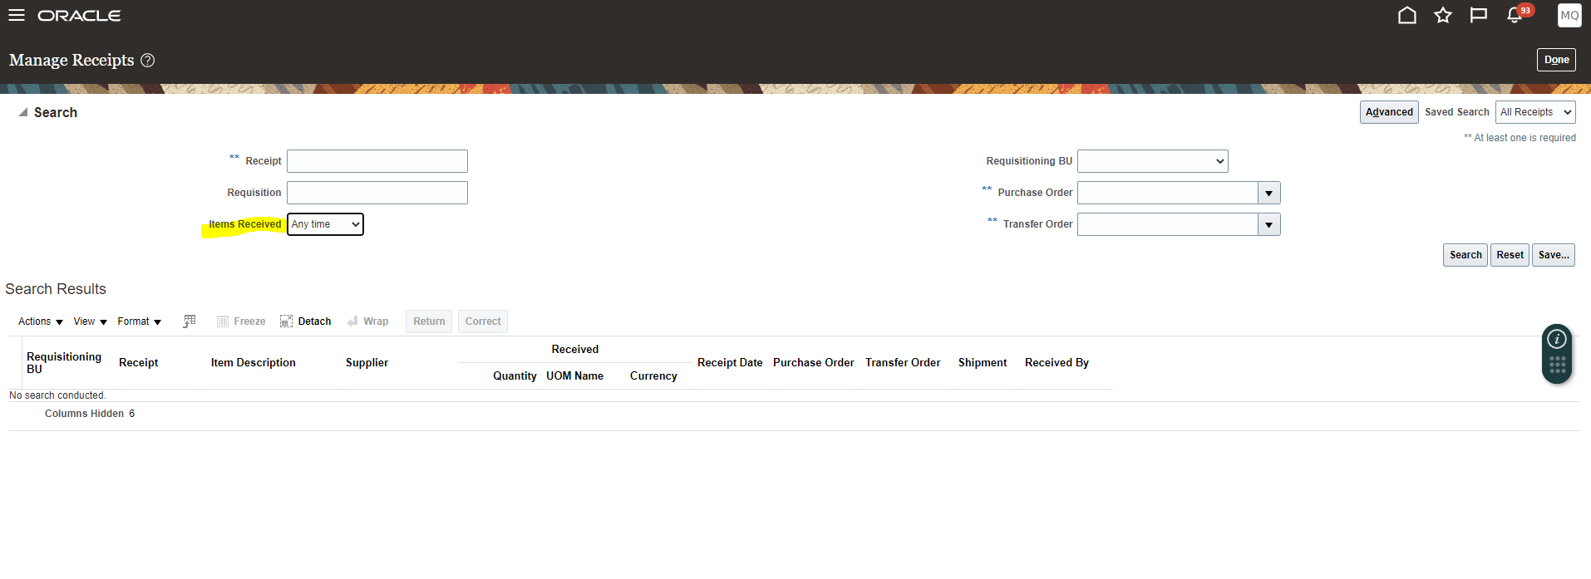
Add the PO number.
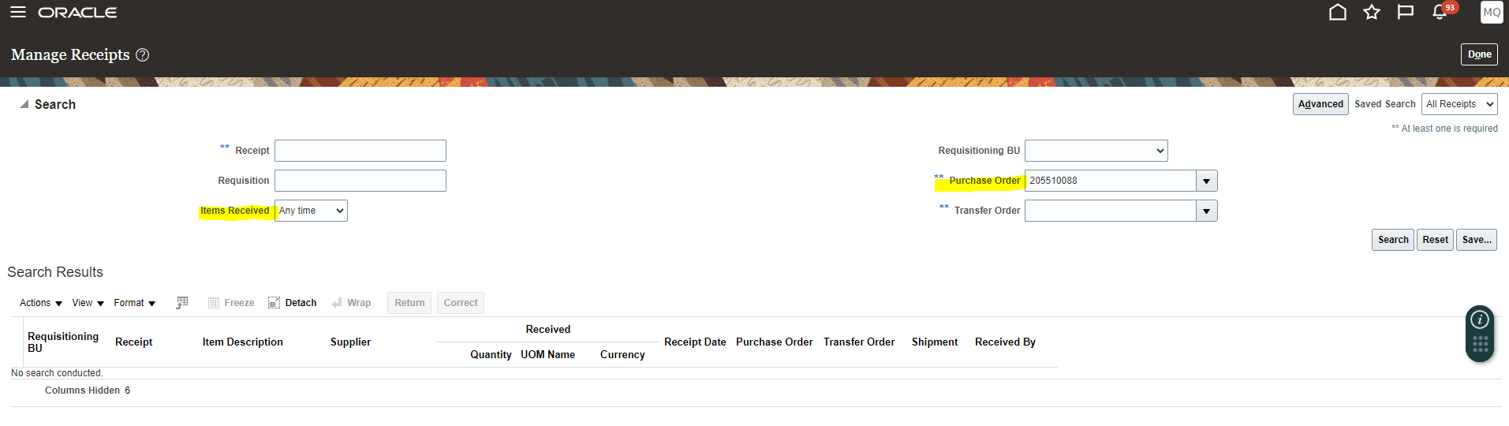
Highlight the line and select CORRECT
*do not use Return as the method will not work for some POs, best to use Correct for all changes or returns
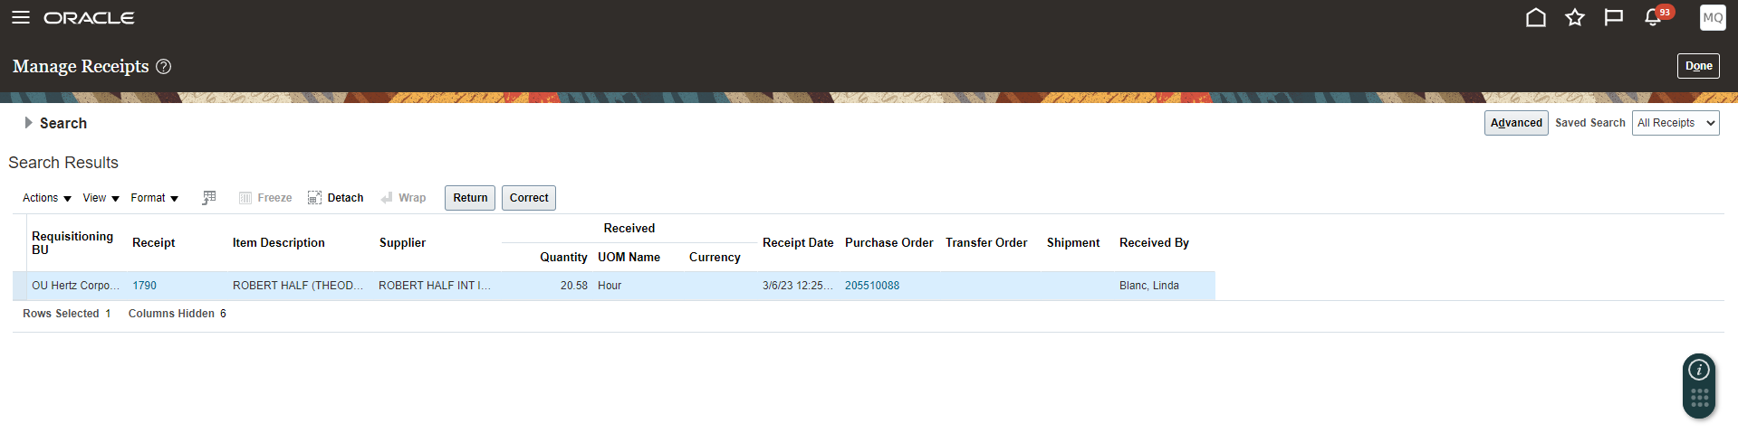
Correct the amount to match the desired amount. Example if the receipt was in error, correct quantity to zero. If the US invoice is $1000 less tax or freight, correct amount to $1000. Once amount is entered select Submit.
