Multi Line Requisition

On the Oracle Cloud homepage, select Procurement.
Click Purchase Requisitions (New).
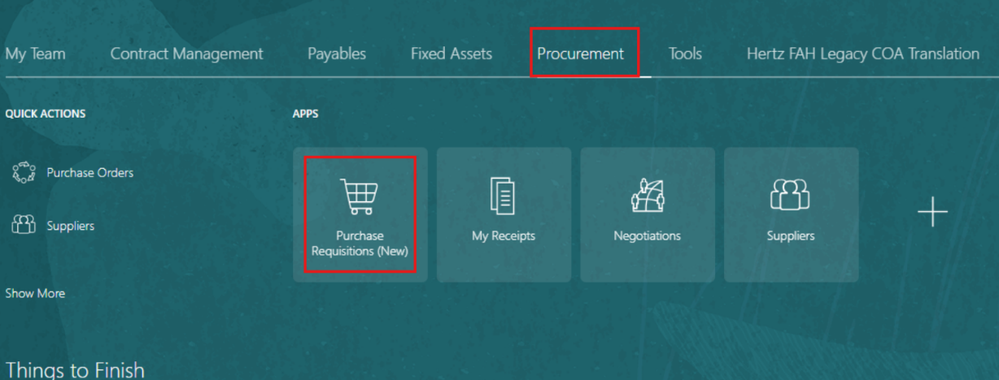

Select the Preferences tab.
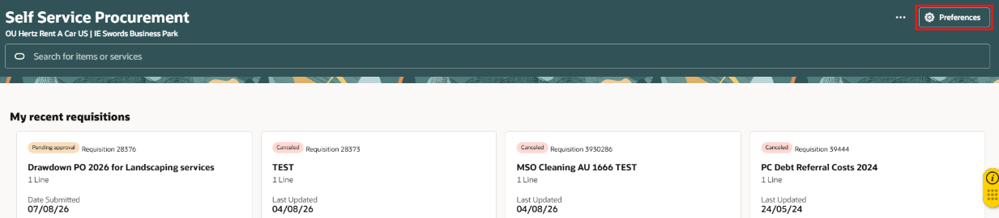
Select the required BU from the Requisitioning BU dropdown menu.
Select Update.
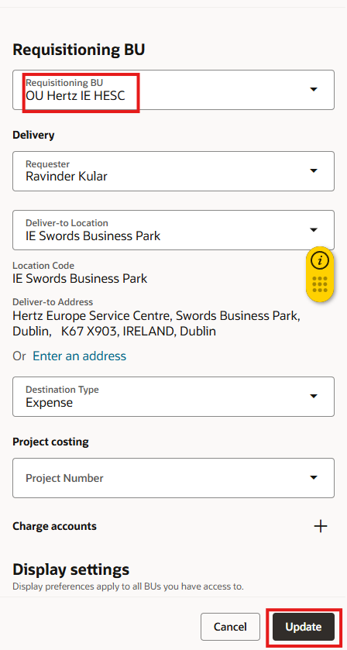

Select Browse all under Shop by category.
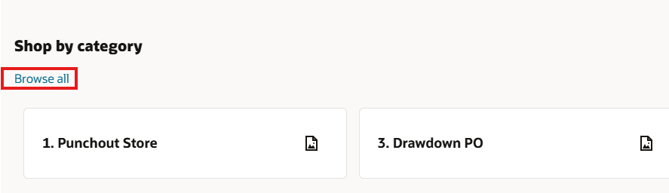

Within Shop by category, select a form or browse all catalogs, or search for the catalog in the Search bar. Note: Here, we have selected Browse All Catalogs.
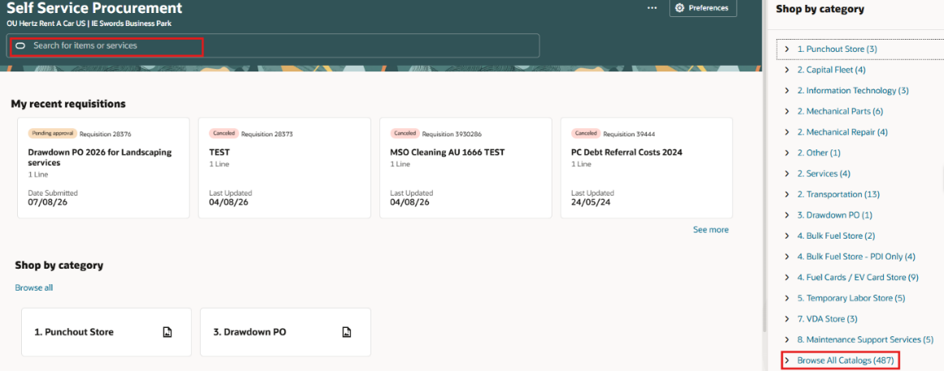
You can change the view of the card by selecting either Table View or Card View.
Note: Here, we have selected Table View.
Update the Quantity for the selected entity. You can also add other description from the list.
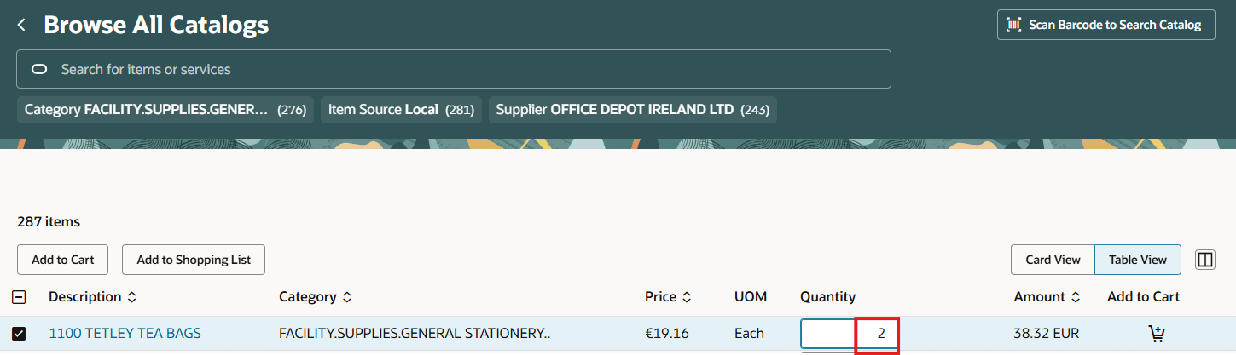

Select Add to Cart or select Add to Cart icon (cart).
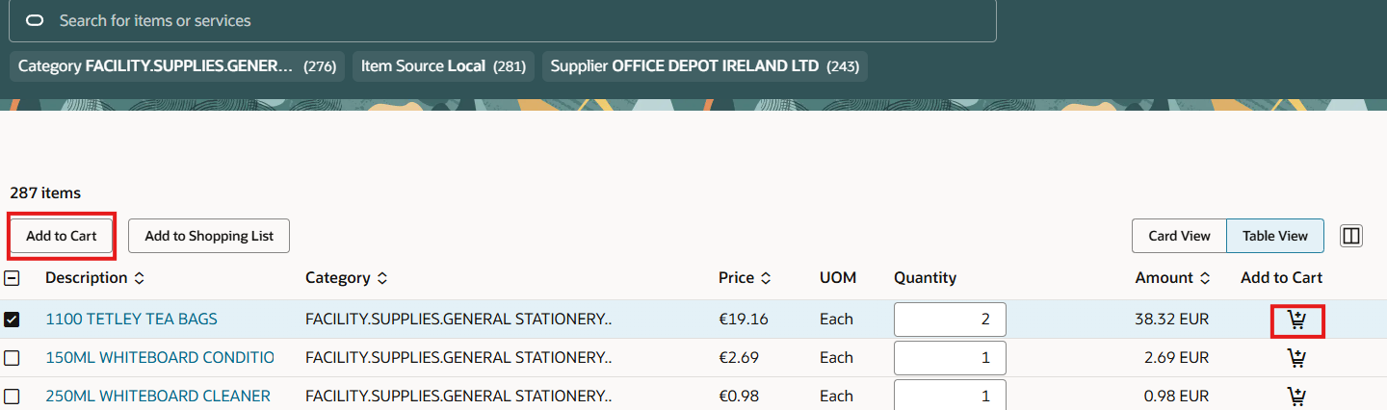
Select Car icon from the footer, the pop-up note can be used to add additional lines or new requisition.
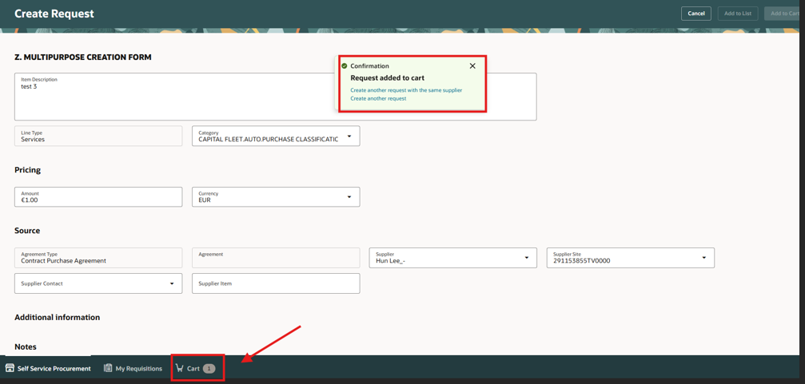

Tick the checkbox at the top to select all the lines.
Select Edit Multiple to edit multiple lines. Note: You can also select lines as per the business needs. For example, select any two lines and then select Edit Multiple.
You can also delete all lines using Delete icon, if needed.
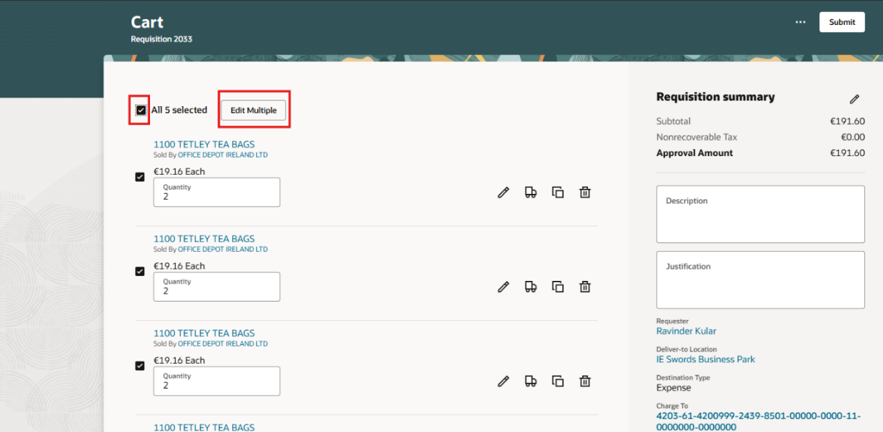

Update the details in the relevant fields.
Note: Edit line box will display showing all the lines selected. Update the requester name, requested delivery date and ensure the deliver to location match the same business unit region as the requester. Example: If REQ is created in Hertz Rent-A-Car US, then the requester deliver to location must be in the US. If not, then manually update the US address. Once done, select OK.
Select Update.
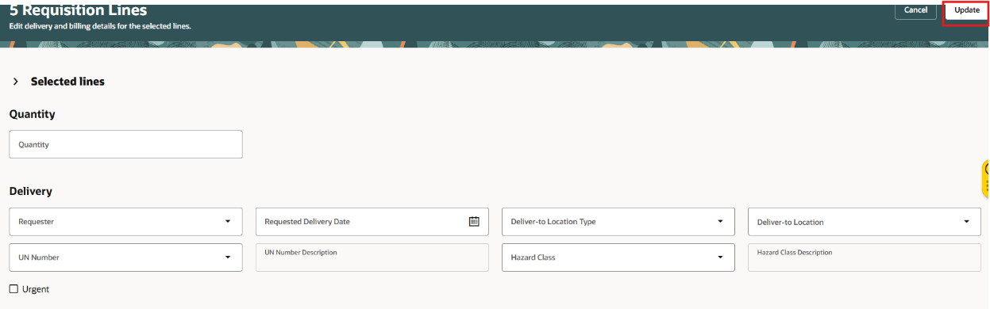

Select the line level Edit icon at to make sure that changes are updated at each line level. Note: You can change quantity at line level also.
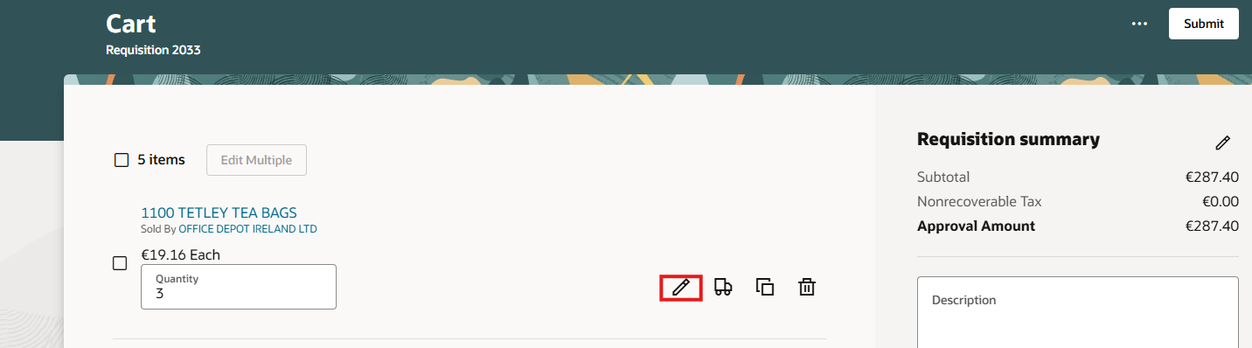
Enter or review the details under Line Details.
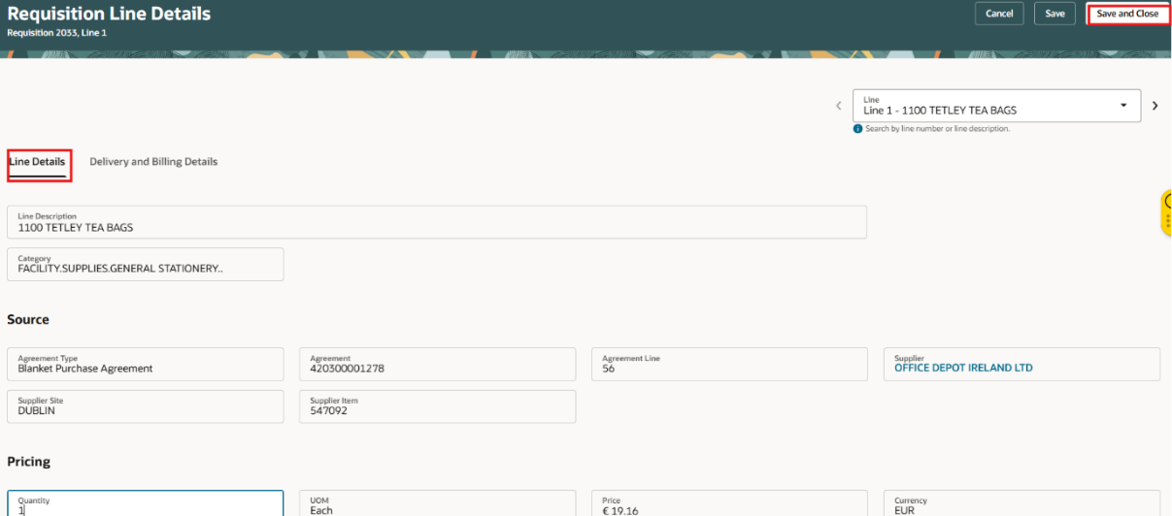
Enter or review the details under Delivery and Billing. Select Save and Close
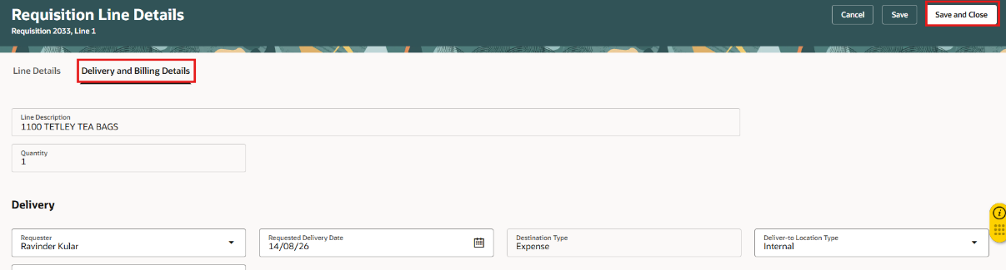

Select Submit.
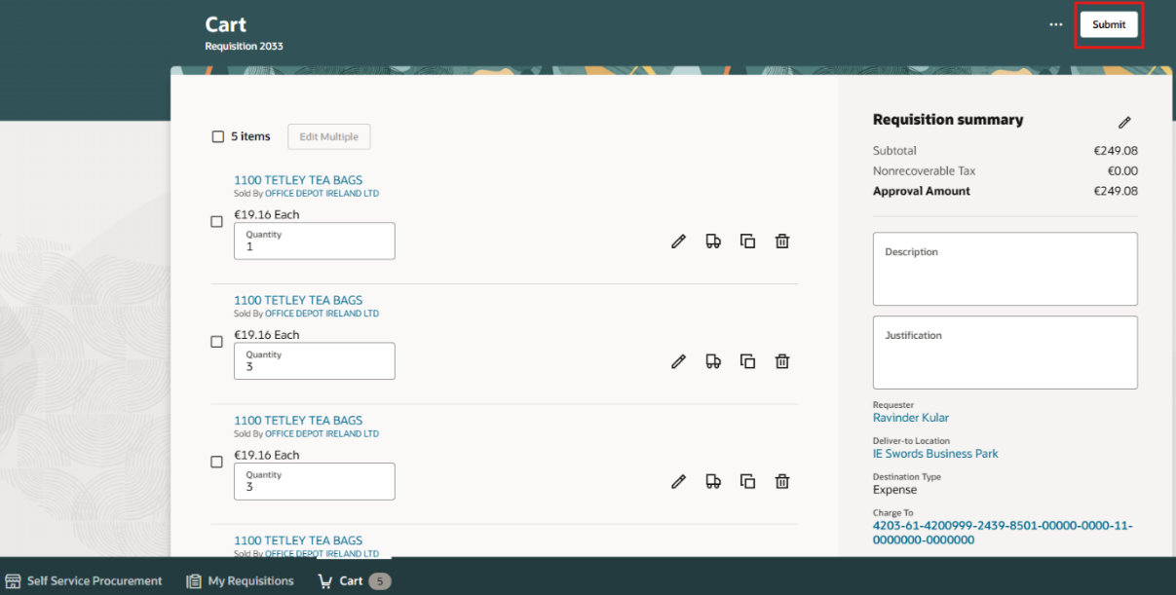
You can select View requisition to view the requisition.
View the status of the requisition under My recent requisitions.

