View PO Receipts, Invoices, Payments
From Procurement,
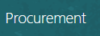
Select Purchase Order from under the quick actions menu

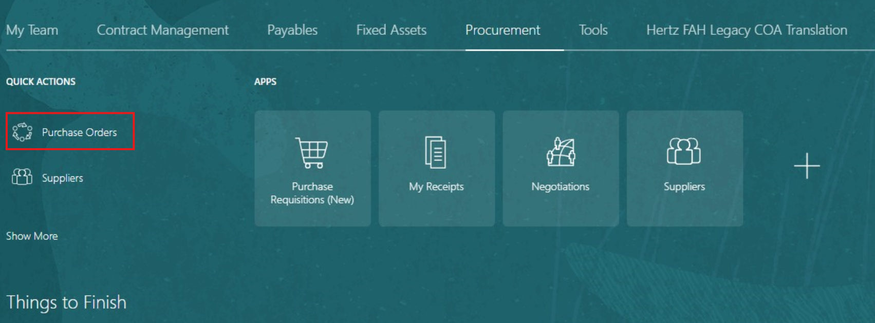

Search Options:
#1 on the right side of the screen, select the magnifying glass, this is a keyword search.
Select the option you wish to see, Orders = POs
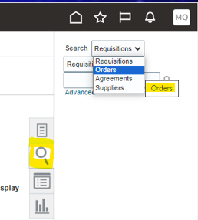
Enter the PO number, let the PO number populate, click on the PO #
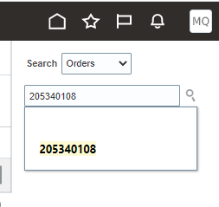

#2 on the right side of the scree, select the paper icon, this view provides more detail options for searching.
Select Manage Orders
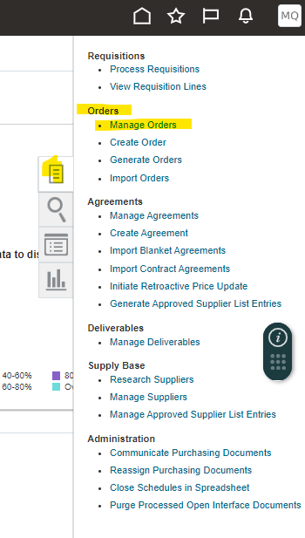
Manage Order View, clear all the search fields if necessary
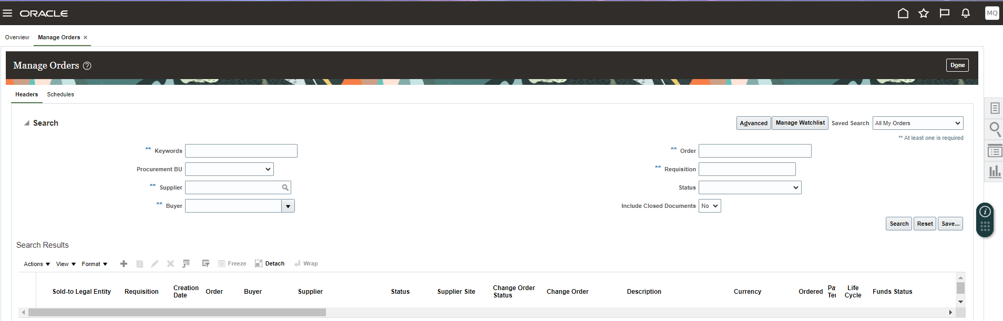
Once the PO populates, look at the right side for Order Life Cycle. This will summarize the PO amount, receipts, and invoices, if you hover over each bar the amounts will display.
If the Ordered amount bar is only visible possibly no receipts or invoices have been applied. To be sure always check. Select View Details to see receipt and invoice detail.
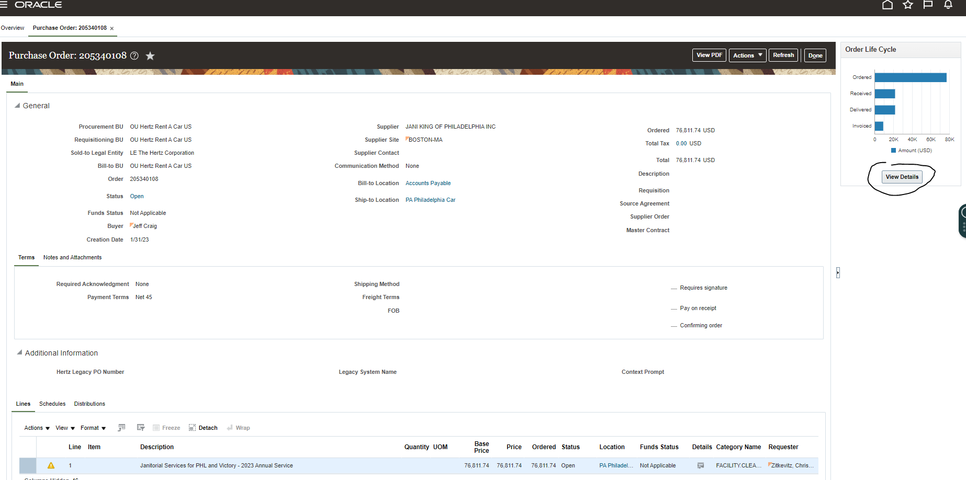
Scroll down toward the bottom, you will see receipt and invoice details, if you select anything in Blue this will show more details.
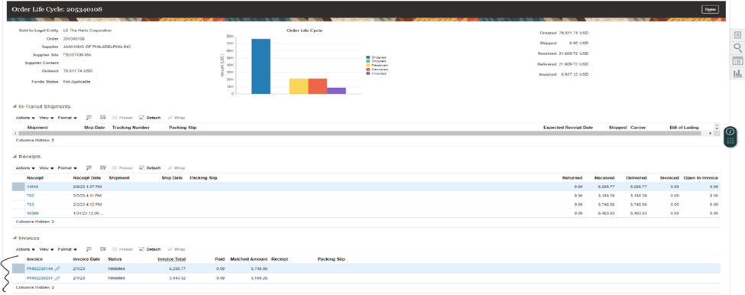

Receipt 11816 selected, shows the detail. On some screen the data columns may not be visible. To set up a similar view, select View, Columns.
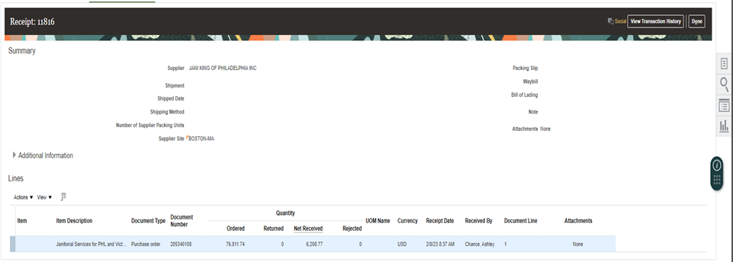

To adjust view and add more data columns: select from the available choices. Once added they will remain. Note: if you Select All from the top - this is a onetime view.
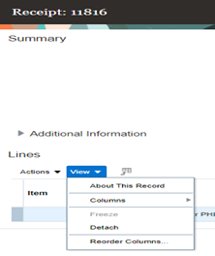

Invoice view show validated have passed the matching and will be paid according to payment terms.
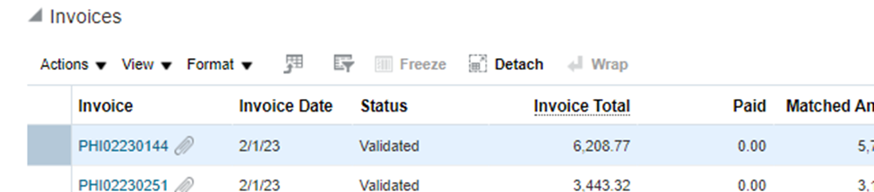

Selected invoice PHI02230144, more details will show regarding the invoice line. NOTE: the top right, Attachment box shows a URL to the invoice copy. This is in blue, so it is selectable to view.
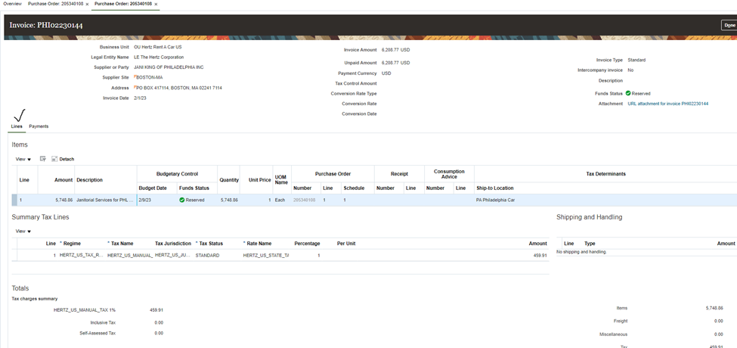
If you select payment, this will show if invoice has been paid, when and amount.
Reminder any text or number in blue is selectable for more detail or a link to documentation.
