Edit a Requisition Or Purchase Order
- On the Oracle Cloud homepage, Select Procurement.
- Click Purchase Requisitions (New).
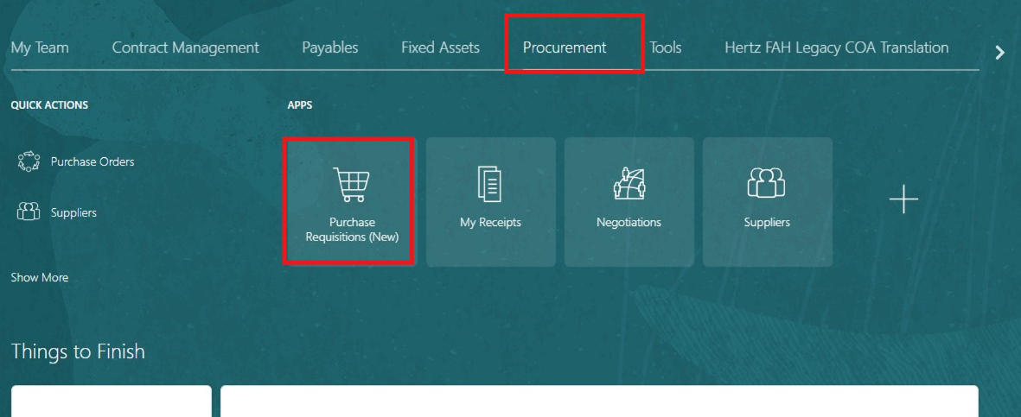
- Select My Requisitions.
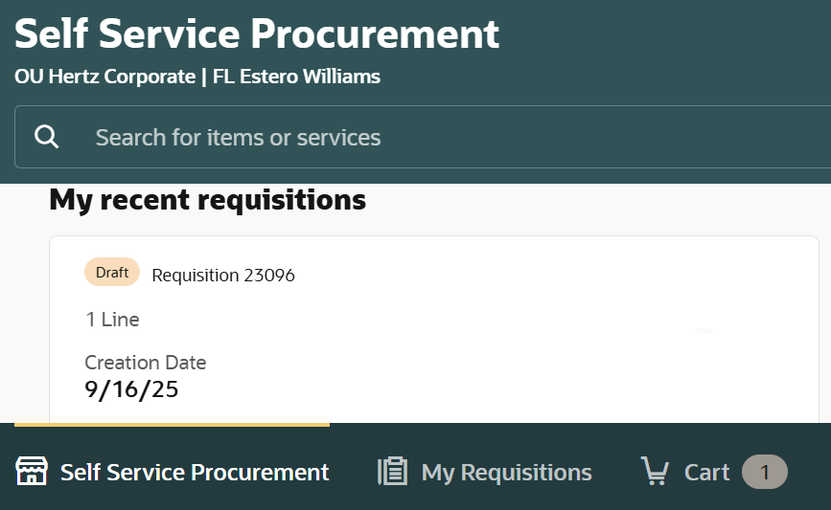

- Search for the requisition in the Search bar.
OR
- Use More filters to filter for a specific requisition.
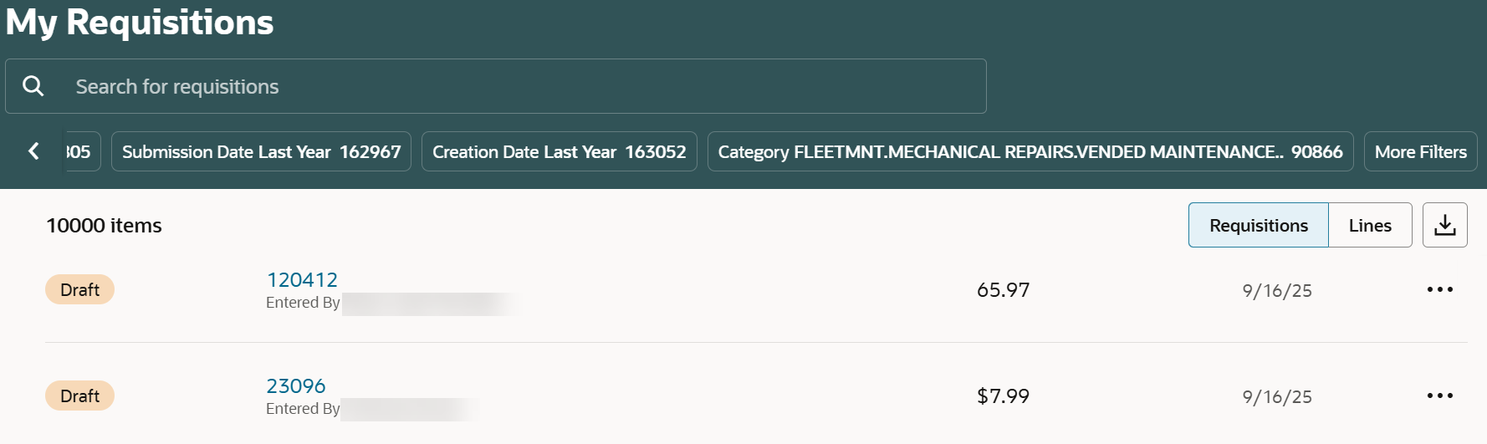

- Select Ellipsis (three dots) against the chosen requisition.
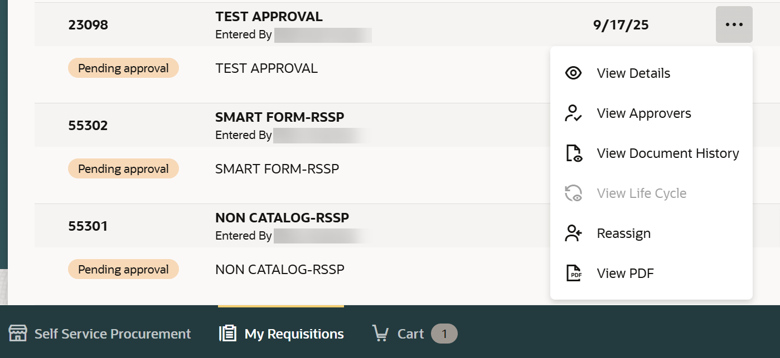
- Select View Details.

- Select Edit.
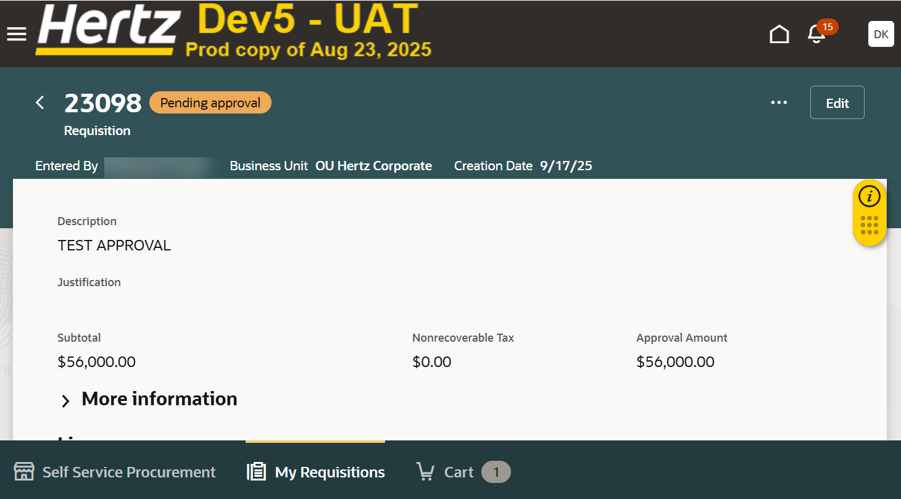

- Select Edit.
Note: The requisition is removed from the approval process, or from ‘Approved’ status.

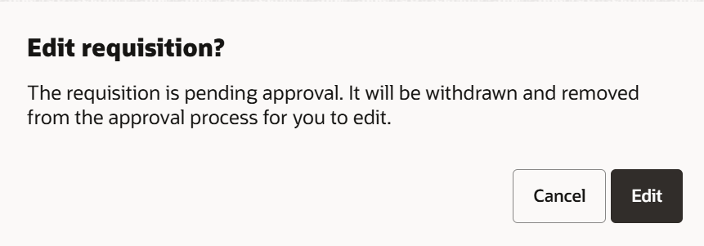

- Select Continue.
Note: You will get this message only if you already have existing item(s) in your cart.
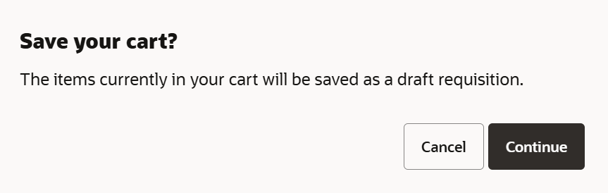

- Select Edit icon (pencil) of Requisition summary to make changes at header level.
Note: You can also select Edit icon (pencil) against each line to make changes for each line level.
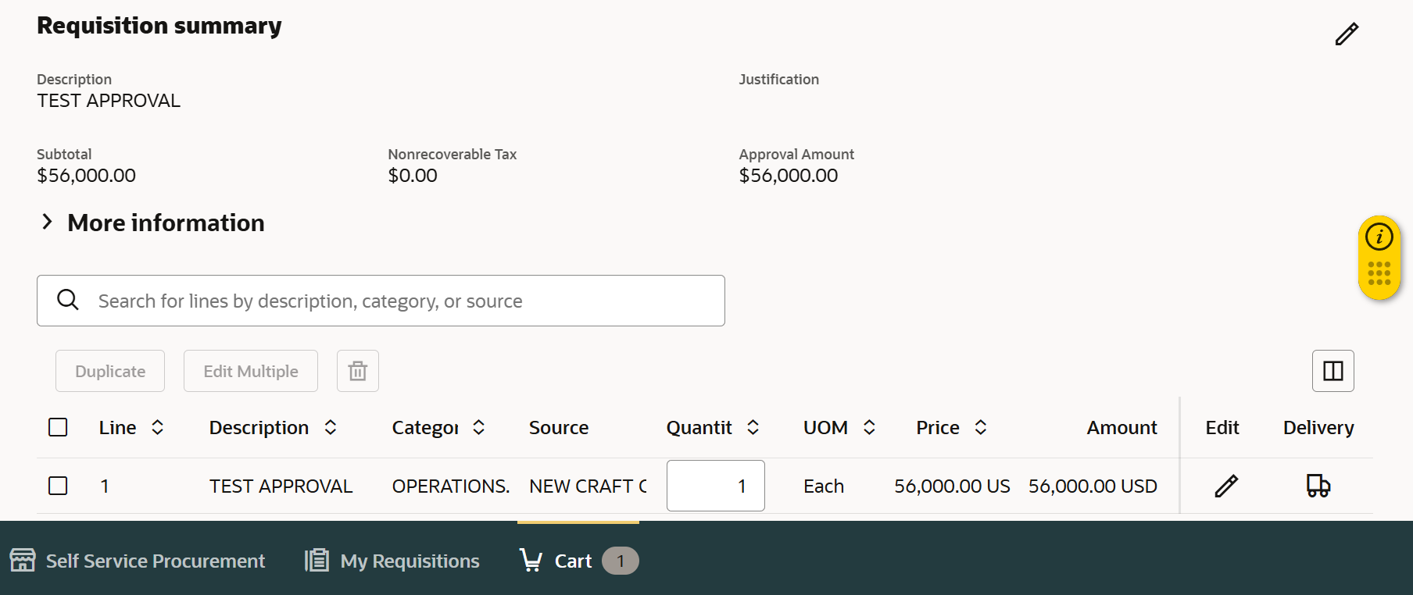

- Review or add details: check requester name, deliver to location (BU and country must match), update requested delivery date, add note or attachments.
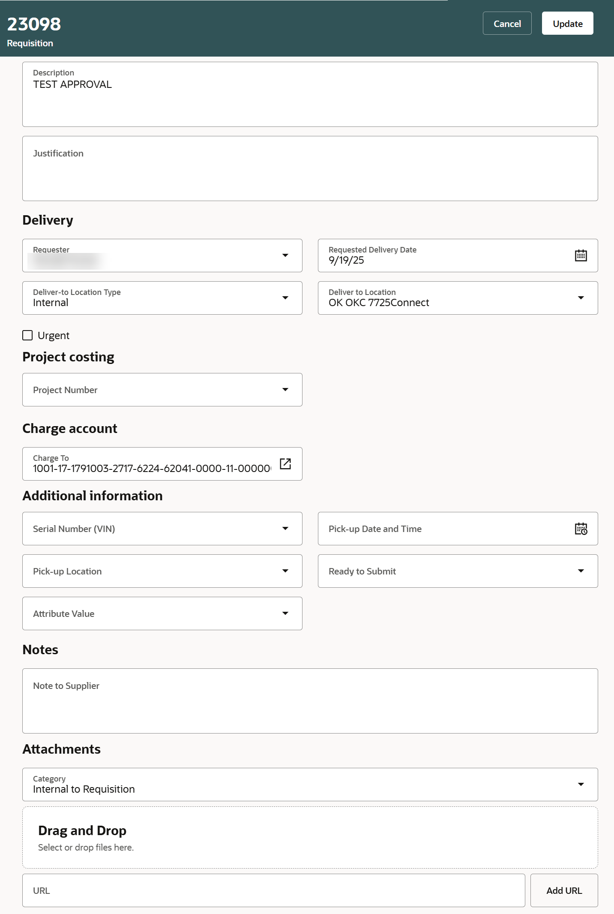
- Select Update.

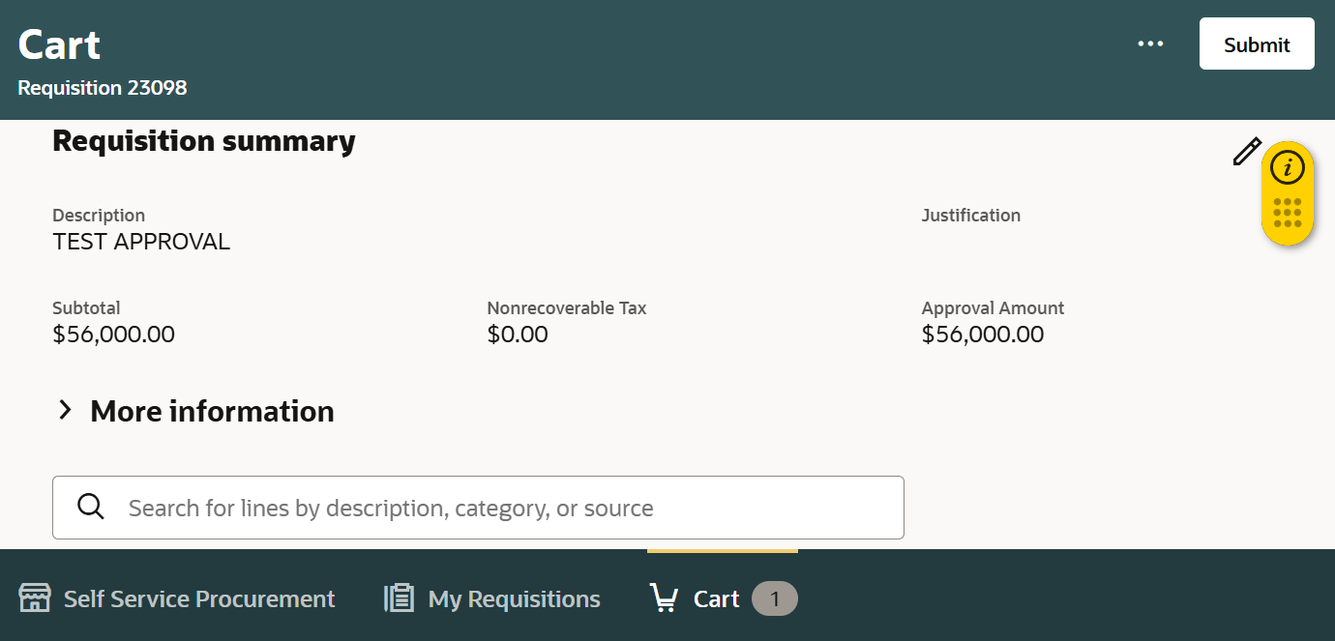
- Select Submit.

- You can select View Requisition to view the requisition when a confirmation message appears.
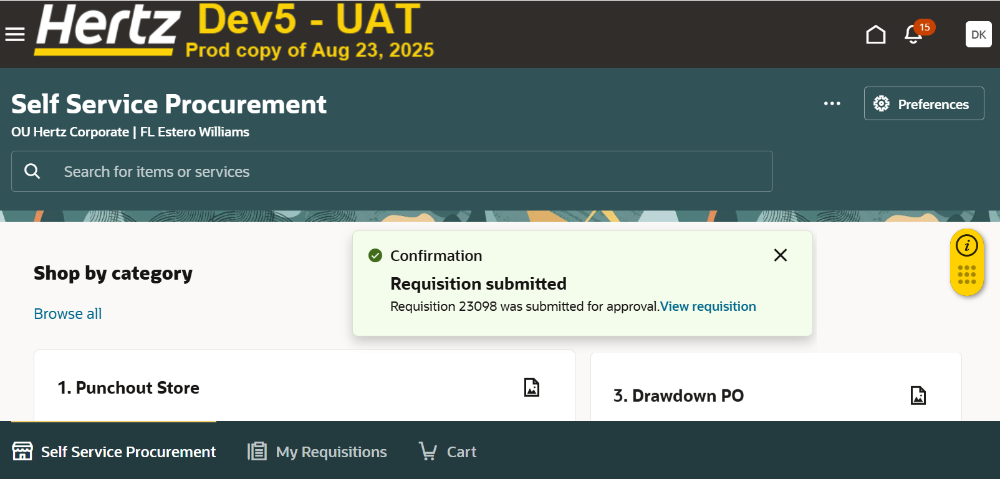
15

You can view approvers and document history also.
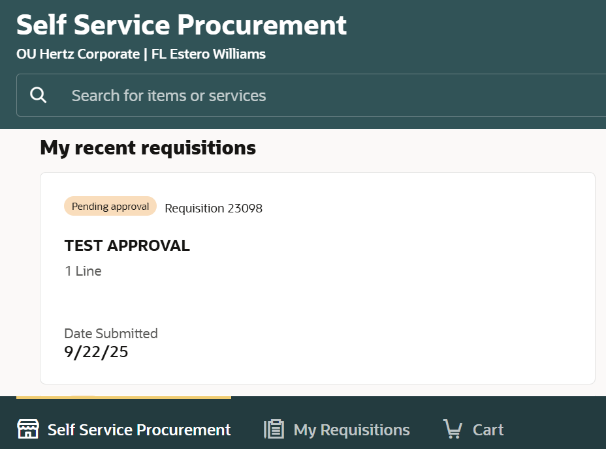
- Select the requisition under My recent requisitions to view the requisition.

- Select Ellipsis icon (three dots).
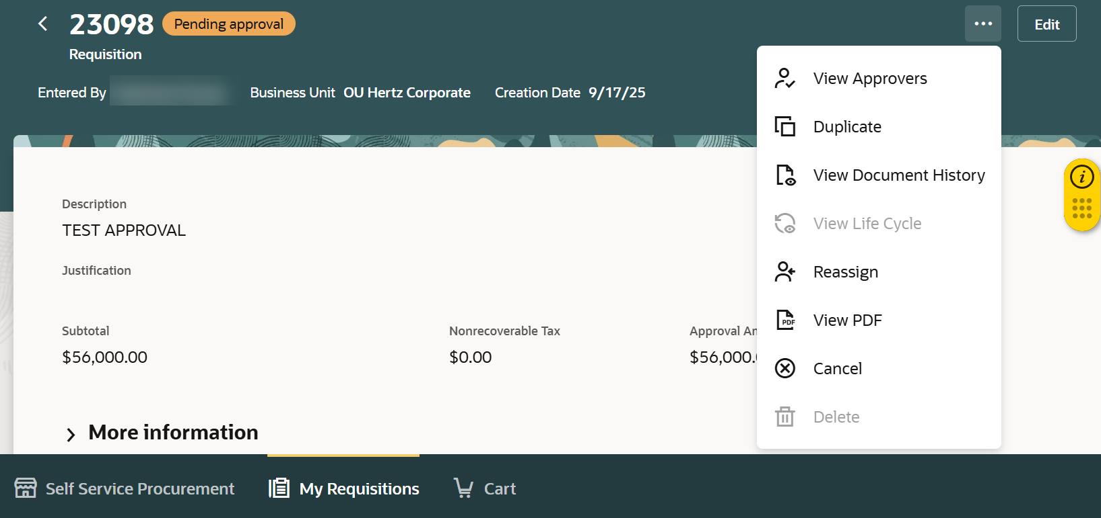
- Select View Approvers.

- You can view list of approvers.
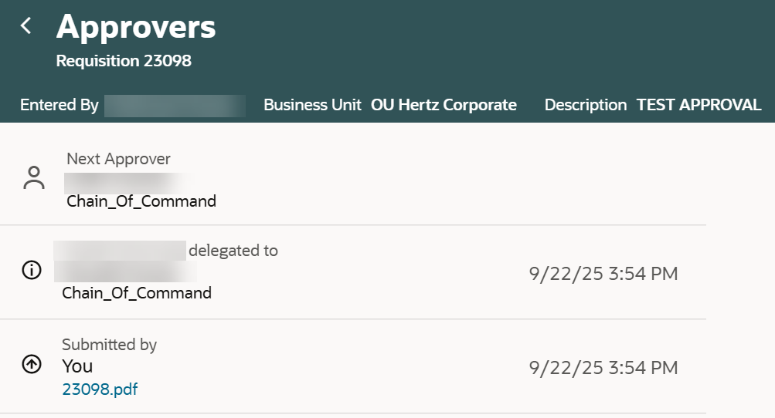

- Select Ellipsis icon (three dots).
- Select View Document History.

- You can view the history of the document.
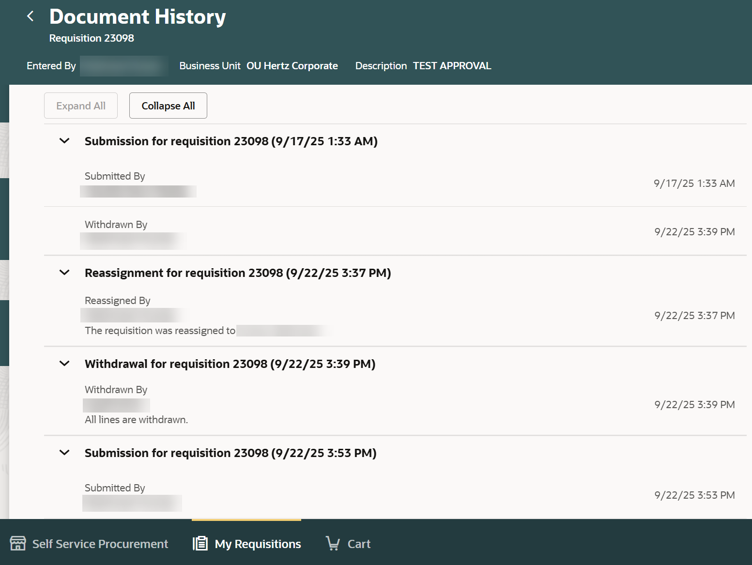

Edit a Requisition with a PO. Search for the requisition or PO in the search bar under My Requisitions.
- Select Ellipsis.
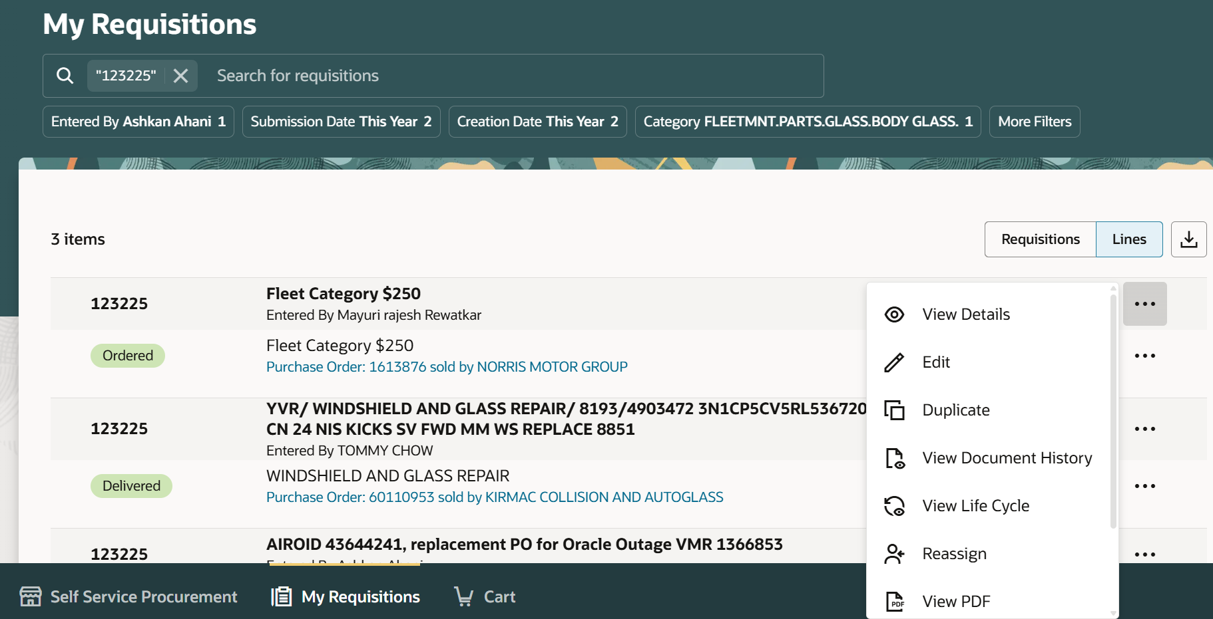
- Select Edit.

- Enter Change Description.
- Select Edit.
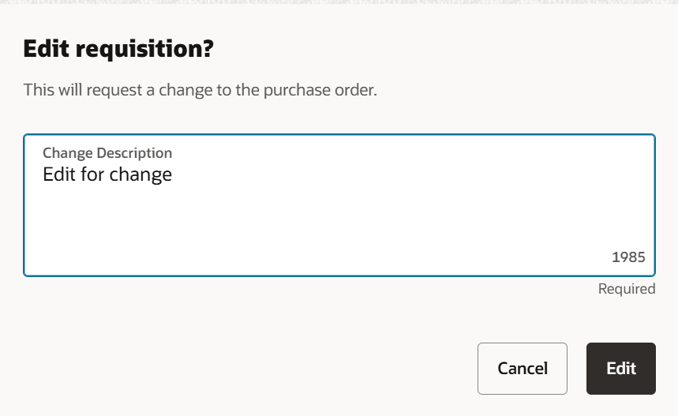

- Change the Quantity, if needed.
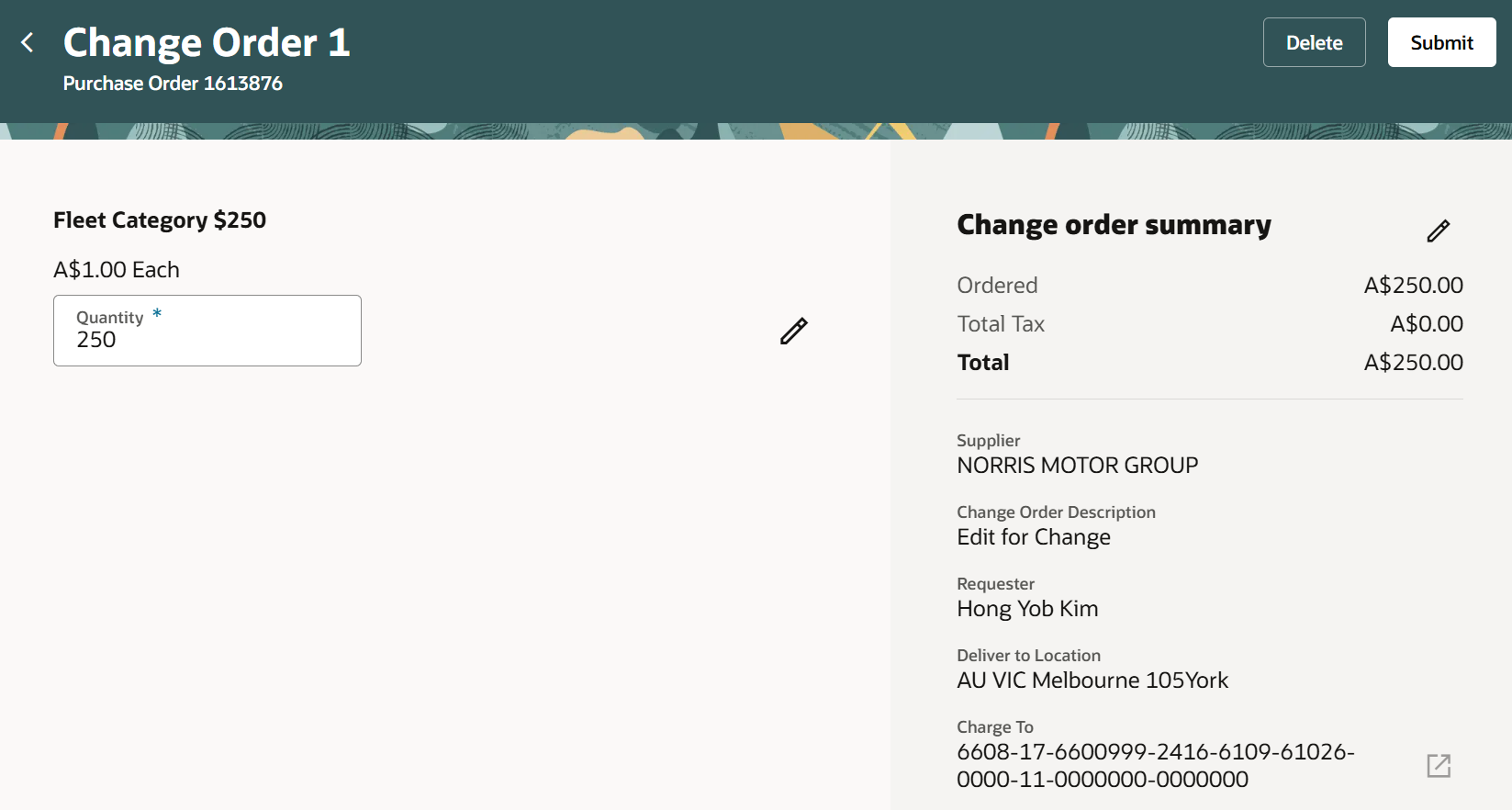
- Select Submit.

This completes the Edit Requisition OR PO process.

