How to view Supplier / Vendor pay terms
Go to ‘Procurement’, then ‘Suppliers’
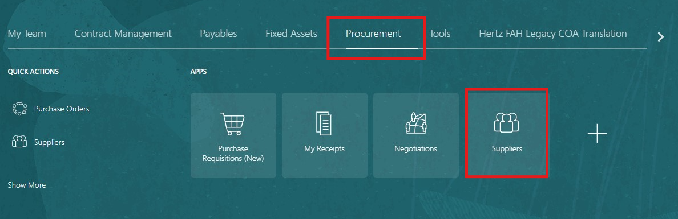

Click on ‘Task’, then ‘Manage Suppliers’.

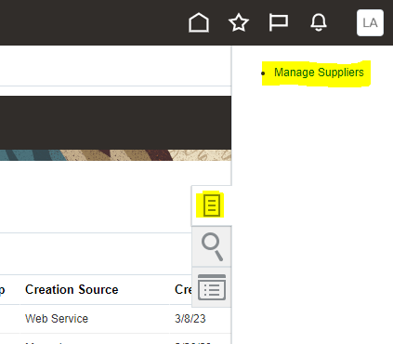

Search by supplier name or supplier number. Click ‘Search’.
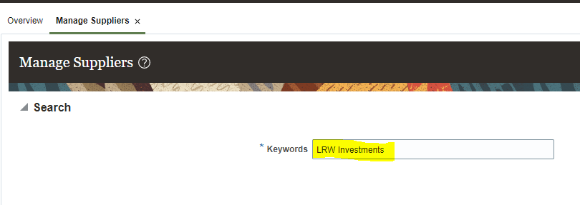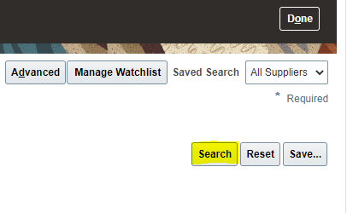

Click on supplier name to open supplier profile.
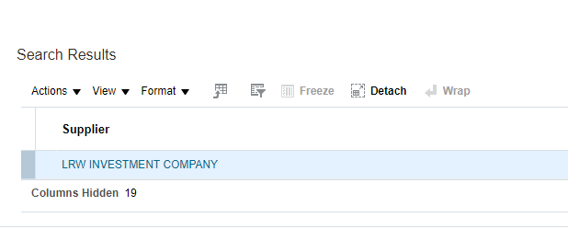

Click on ‘Sites’ to view Site Name(s) and Site Address(es).
Payment Terns are set up per Site Name. You need to click on the Site Name to view the payment terms set up for each.
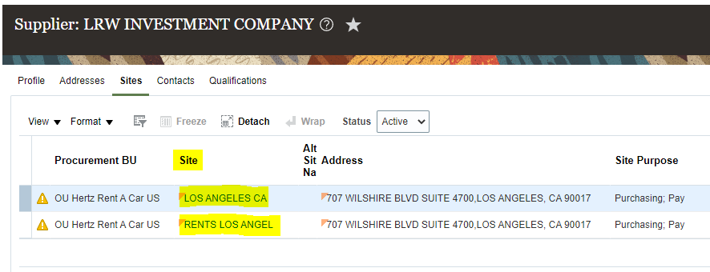
Click on ‘Invoicing’ by the Additional Information box, then scroll down to see the Payment Terms for the Site Name selected.
