​
How to check a suppliers payment remittance email address and payment method
Click on the Suppliers Tile
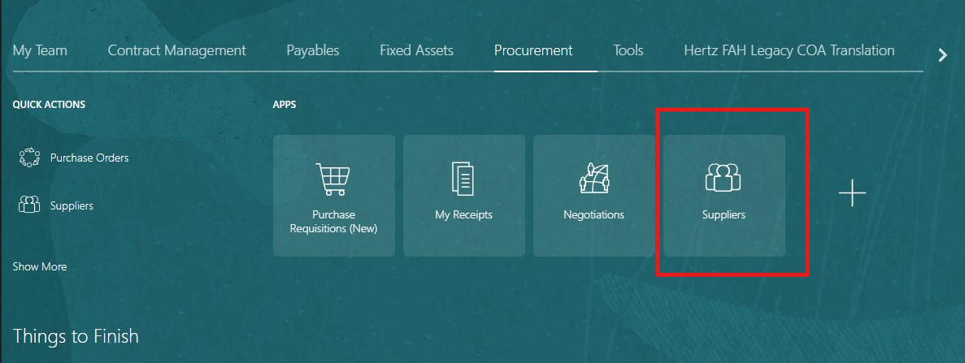​

On the right-hand side of the screen click on the magnifying glass: enter the supplier name or number in the search field.
Click on the supplier’s name to begin search for the supplier.

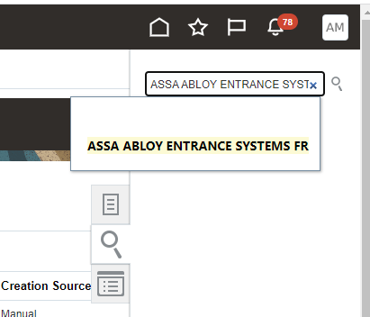​

Click on the supplier name in blue
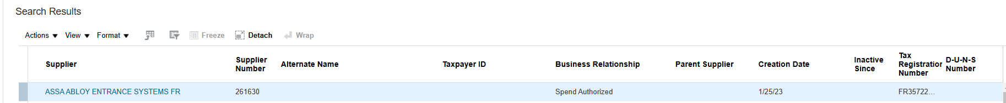​
Within the supplier view, there on tabs along the top and mid sections, each tab will contain additional supplier details.
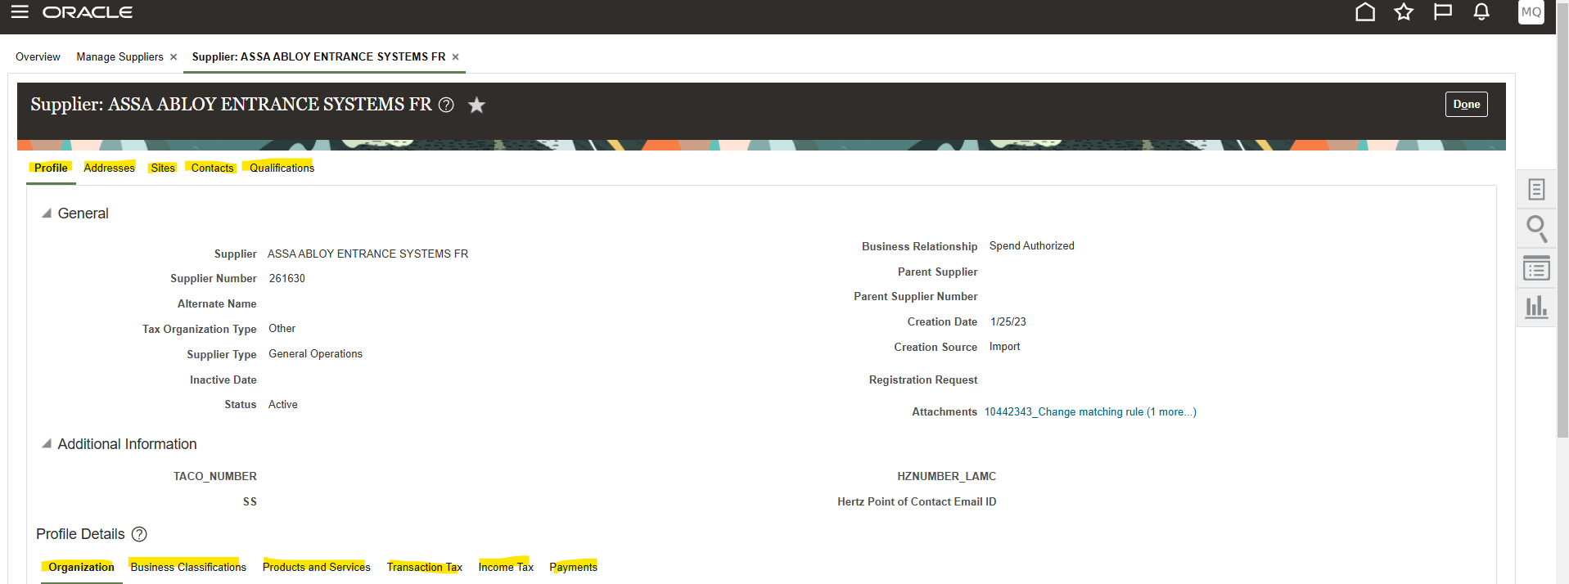​

Select the Sites tab, (this is where all the pay details are stored), click on the site name you wish to view
o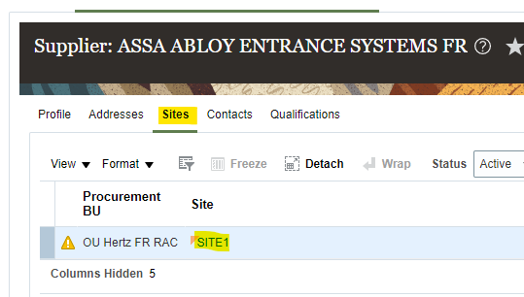​

There are several tabs in the mid section, to view term and pay type, this detail is saved Invoicing and Payments.
To see the payment method, Click on Payments -> payment method. Below show electronics is method of payment.
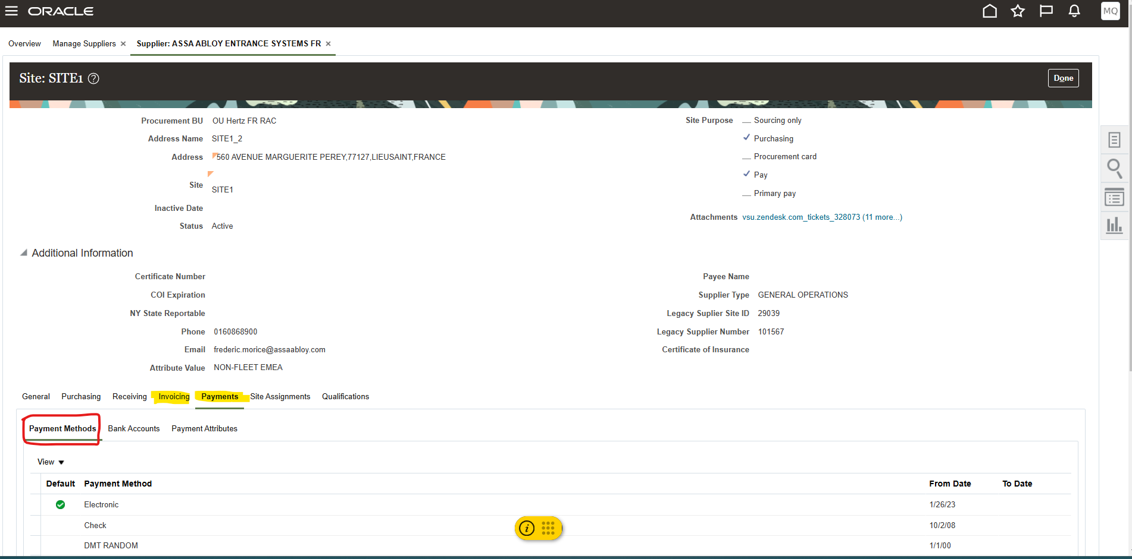​
To view the bank account, select Bank Accounts
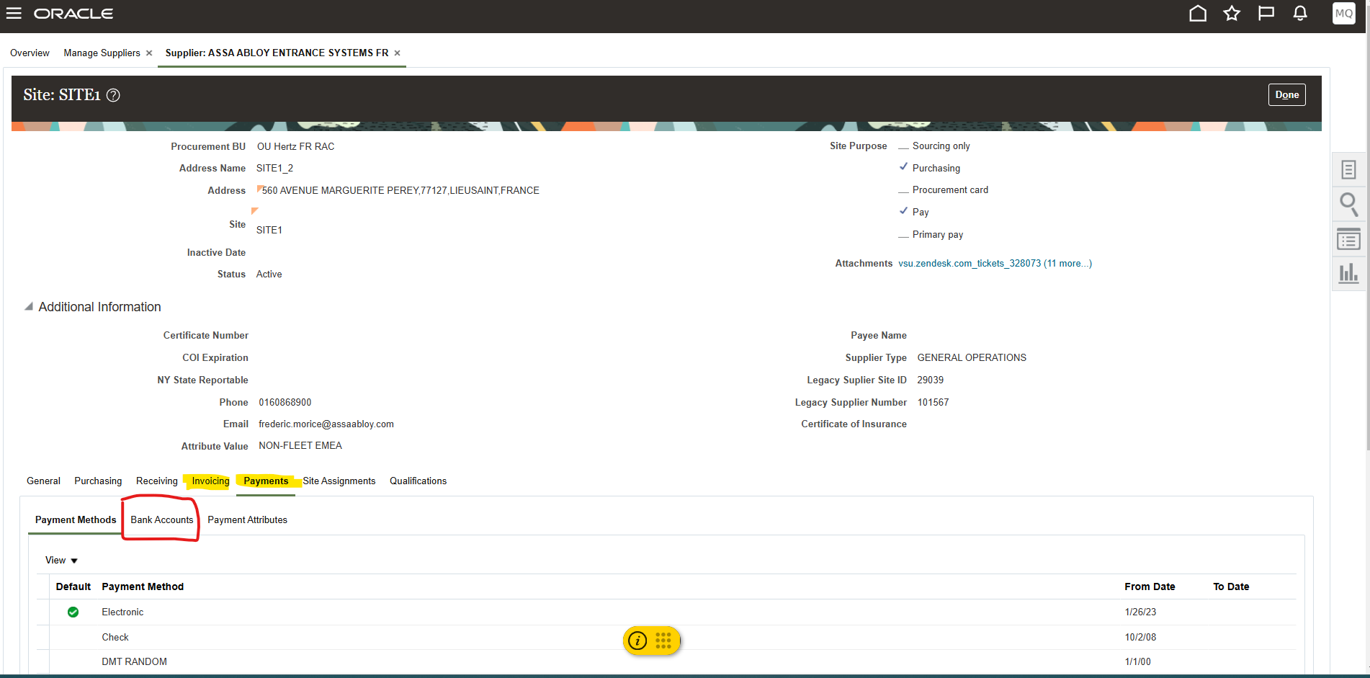​

To see the remittance email address, Click on Payments -> Payment Attributes -> Separate Remittance Advice Delivery

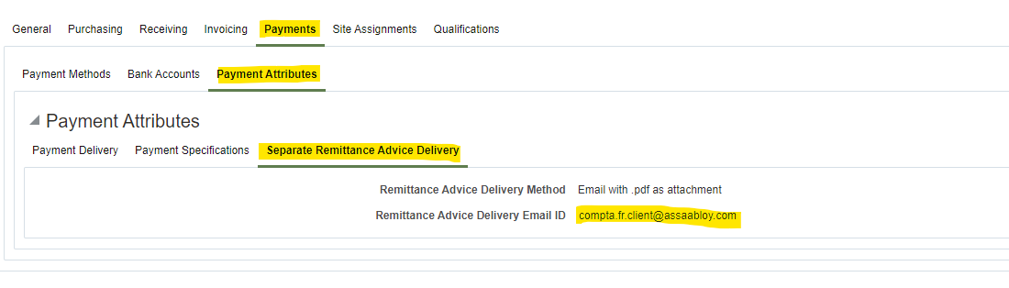​

If invoice details are incorrect and require a change submit a change request to the Vendor Set up (VSU) team.
Obtain the supplier change template found on the SharePoint site: VSU Hub under the regional documents section. Once supplier has completed the template, submit a vendor set up request.
​

