Receipt a Purchase Order

From the home page, under Procurement, click on ‘My Receipts’

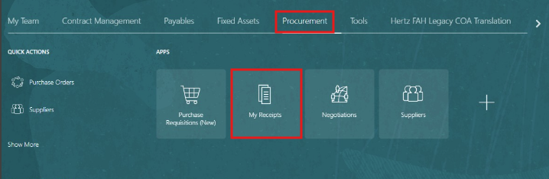

Clear your name from ‘Requester’ and change the Item Due to ‘Any Time’. Then, add PO number or requisition number you need to receive on. Click ‘Search’.

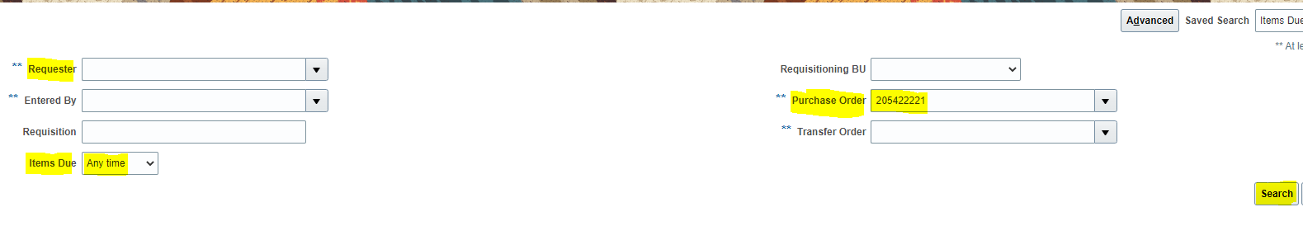

From this screen, you can select the line you need to receipt or highlight all lines if you need to receipt the entire order.

Click on a line needed to be receipted and it will get highlighted in blue.

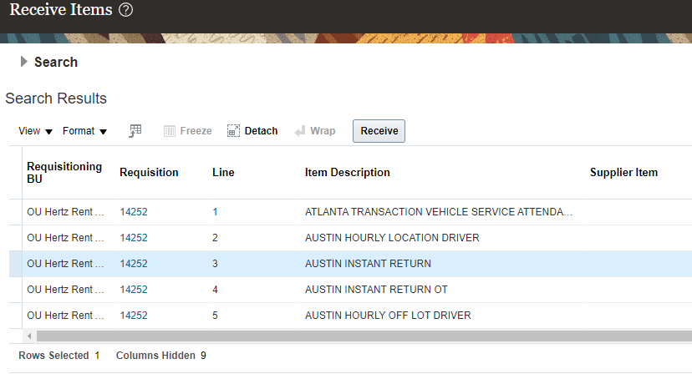

Use ‘Ctrl’ and your cursor to select the lines you need to receipt. They will highlight in blue.

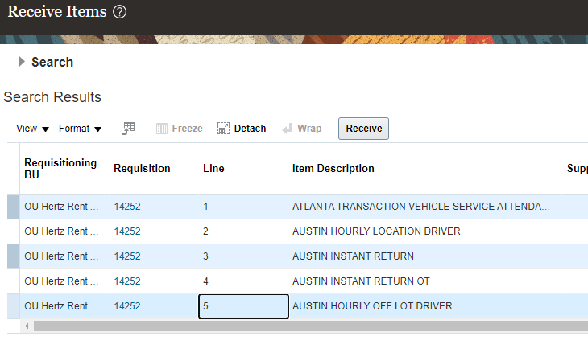

Click on the box before ‘Requisitioning BU’ and all lines will highlight in blue. ONLY use this option to receive the entire order.

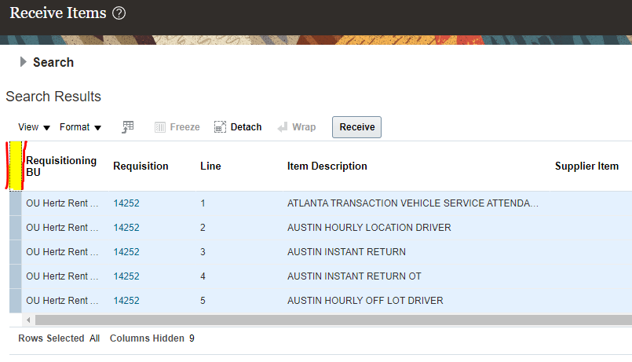

Click ‘Receive’.

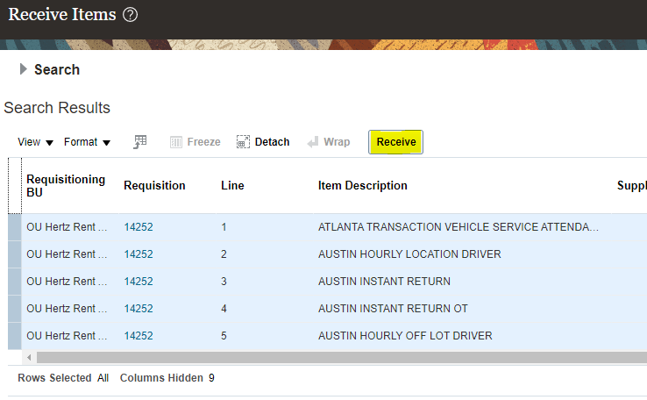

NOTE: the requisition/PO line types will reflect differently in the receiving screen.

‘Services’ line type: the quantity will be populate based on remaining value.
You can accept this amount or enter the desired amount.

PO line showing services
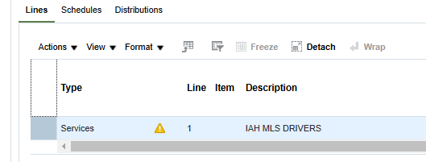

Receipt quantity populates based on remaining amount
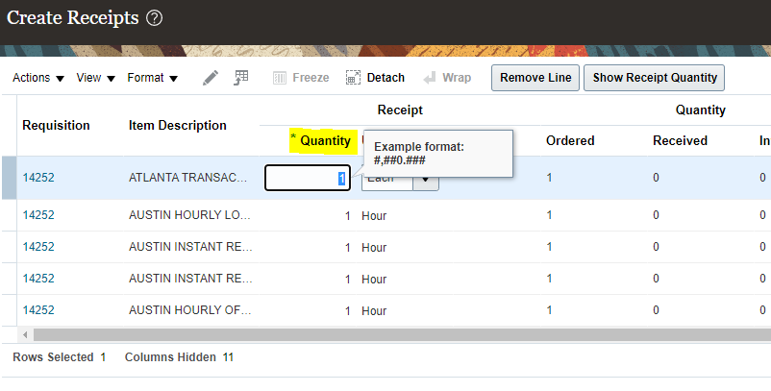

‘Goods’ type: the quantity will be blank, manually enter the amount or use the show receipt quantity button.When this button is selected this button, the remaining available quantity will automatically fill in.

PO line showing services
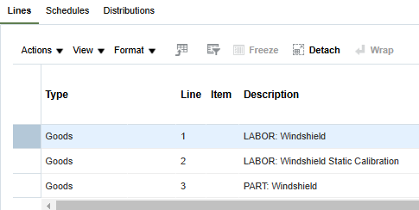

Receipt quantity is blank, use show receipt quantity button or manually enter
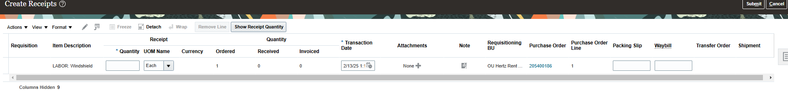

Packing Slip, Waybill, Attachment and Notes can be added before proceeding. All these fields are optional.
‘Services’ POs do not have packing slip or waybill options, only notes and attachments
‘Goods” POs have packing slip, waybill, attachments and notes

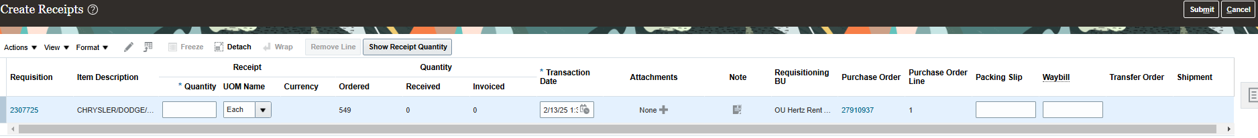

To add text information, click on ‘Note’ box per line to create a note, then click ‘OK’.

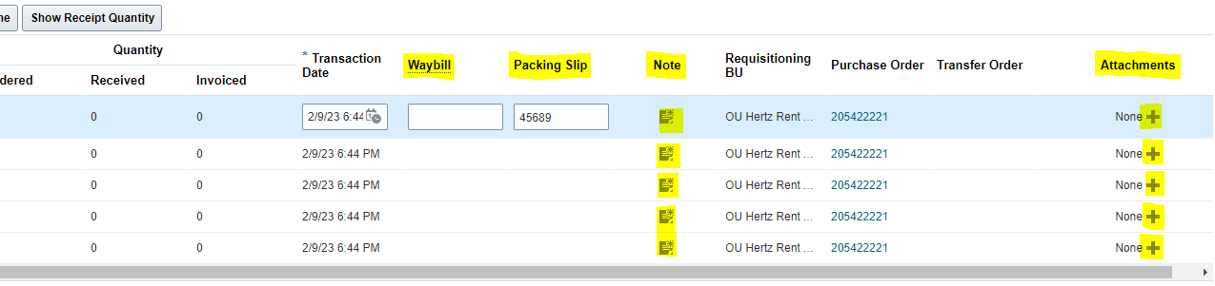

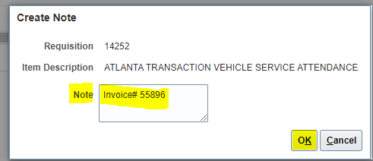

Click ‘Submit’

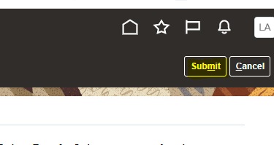

A confirmation with the receipt number will be shown.

