How to add email account to an existing Outlook profile
- Open Outlook and Click on File > Add Account
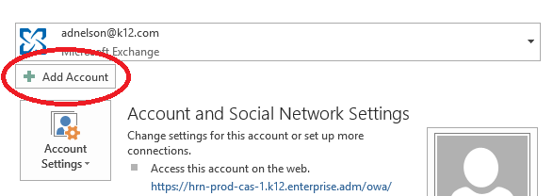
- Type your Name in the “Your Name” box > Type your email address username@school.org in the email address box. Do not type your password. Press Next
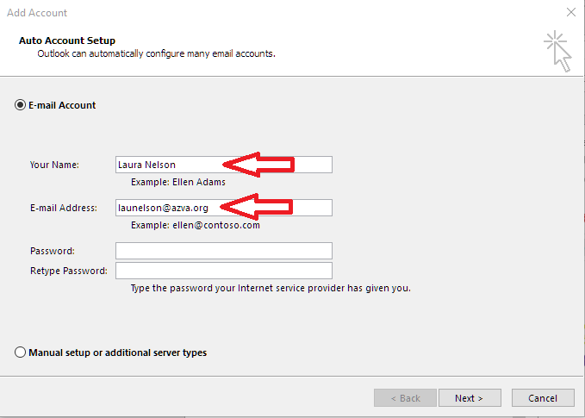
- Type your OLS password and press OK.
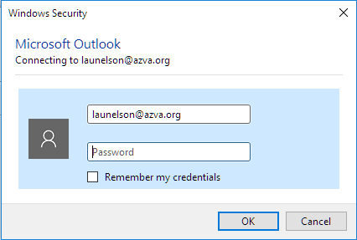

- Three green checkmarks should come up. Press Finish.

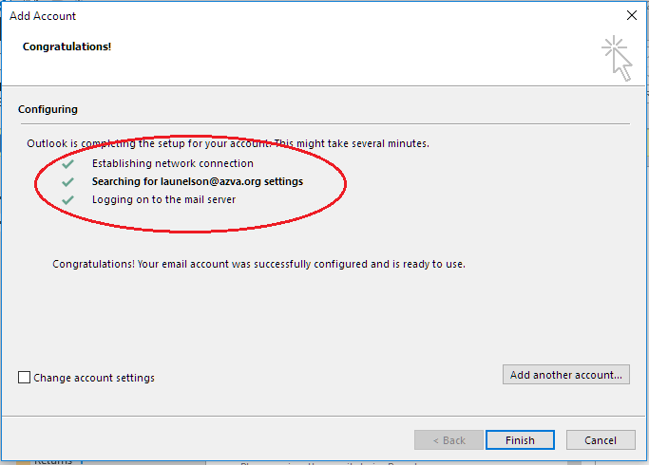
- A confirmation prompt will tell you that you need to restart Outlook for changes to take effect.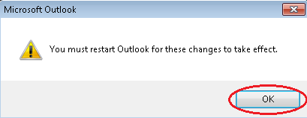
- Close Outlook and re-open
- This should open Outlook and you will see the newly added account on the left hand side. 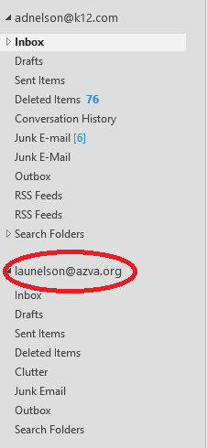
- If you want to set the new account as your default account (send account) Click File > Account Settings > Account Settings then click on the school.org account and press Set as Default then Close

