Applying Rules to Outlook where copies of messages from OLS are Stored

School Email

Messages sent from the OLS automatically appear in your Sent Items. To change or update where your messages from OLS are stored in your inbox, follow the instructions below.

Step 1: Log into Outlook (<https://portal.office.com/>)

Username: your school email address ([jdoe@school.org](mailto:jdoe@school.org))

Password: your OLS password is your email password

Step 2: Select “Mail” from the login screen

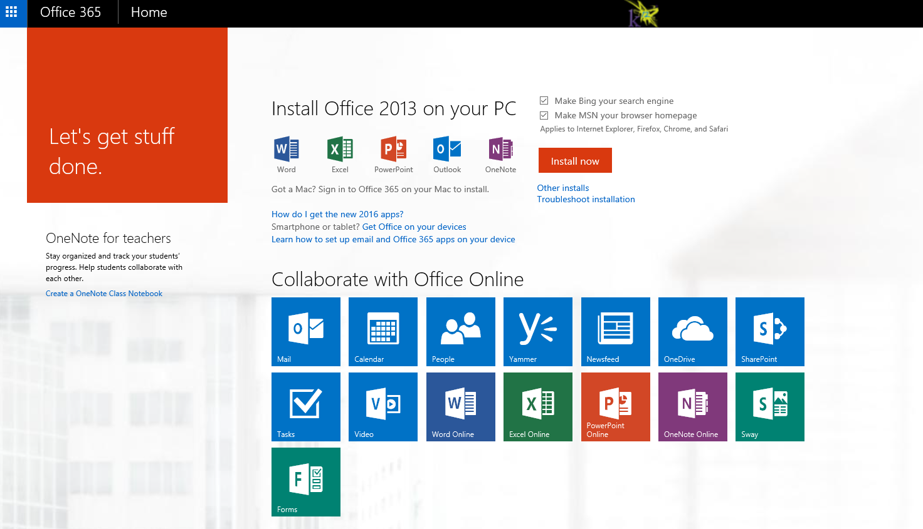

Step 3: Select the Gear Icon from the upper left navigation bar. From the settings menu select “Mail”.

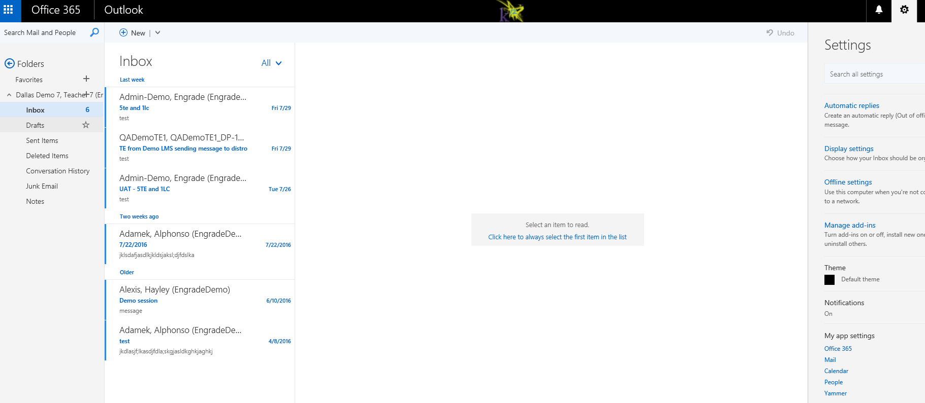

Step 4: Select “Inbox and Sweep Rules”

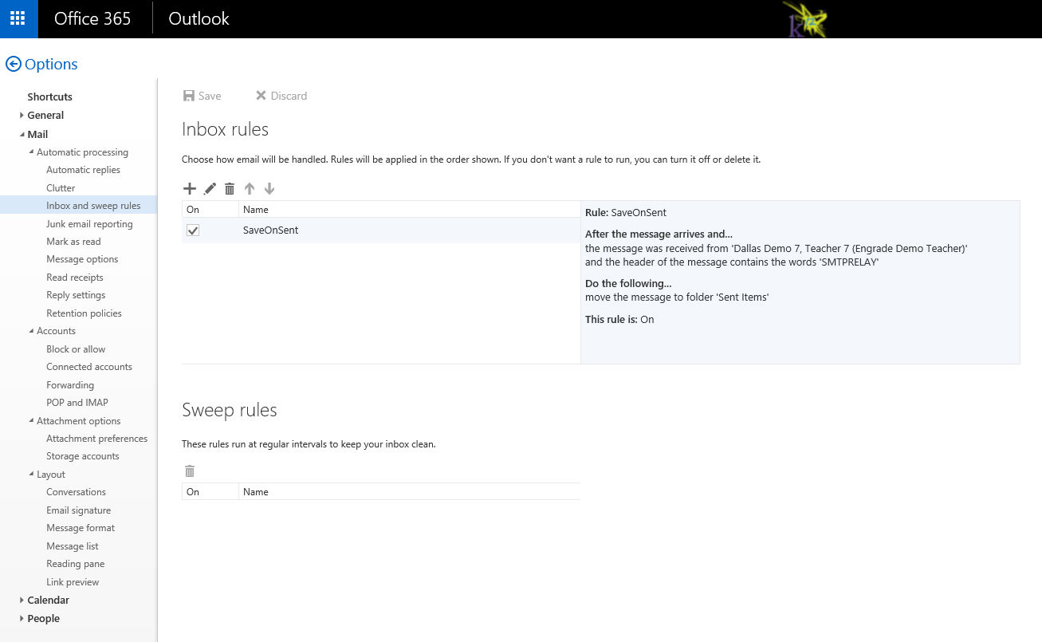

To add a new rule, select “+”

To edit an existing rule, select the pencil icon

To setup a new rule, click on the pencil Icon. For the first dropdown select “It includes these words…in the message header” and type in “SMTPRELAY”. This is the system designation as to how the message was sent. SMTPRELAY means through the OLS widget. From there you can select the folder the messages go to (sent items, inbox, deleted items, etc.) and accept changes.

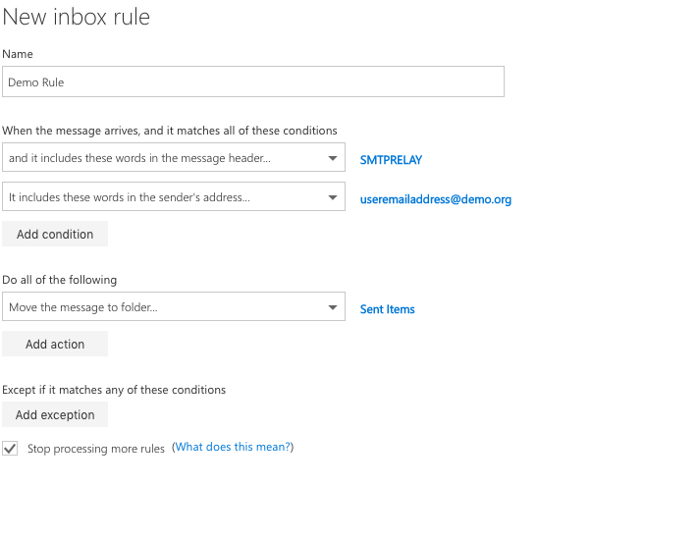

This is your school email address

To flag all messages from the OLS/TVS widget, you must have “SMTPRELAY” as a word in the message header