Offer Brief

Offer name:
Page(s) URL(s): |  | URLs where the offer will appear
Duration: |  | Provide dates the offer should be active for
Display:
 | ☐ | Immediately after page load
 | ☐ | Exact interval
 |  | If the above chosen, provide the interval in seconds
 | ☐ | User shows exit intent
Audience
 | ☐ | Target all visitors
 | ☐ | Create custom audience
 | ☐ | If the above chosen, please provide details
Appear on these devices:
 | ☐ | Desktop
 | ☐ | Mobile
Choose the Style (only 1 style per page):
 | ☐ | Header (on top of the page)
 | ☐ | Footer (at the bottom of the page)
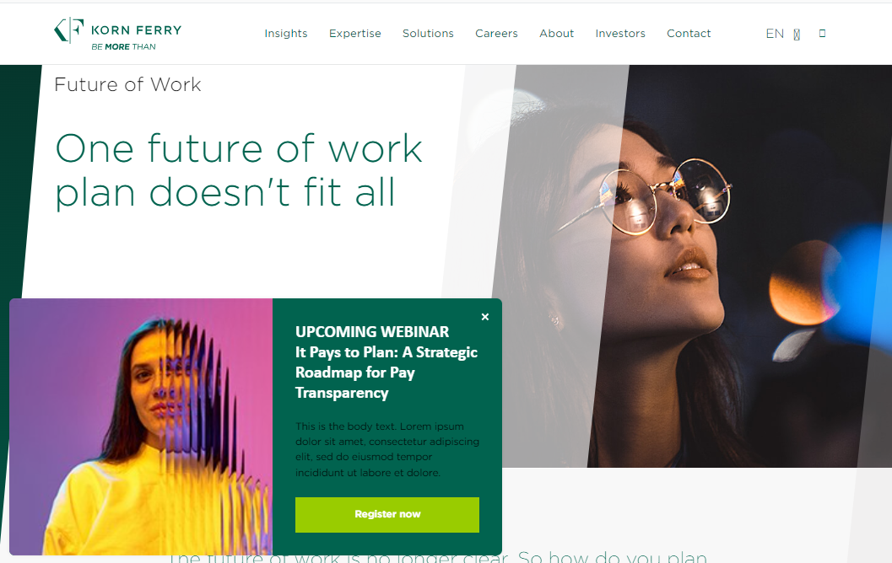 | ☐ | Sidepop (appears on the side)
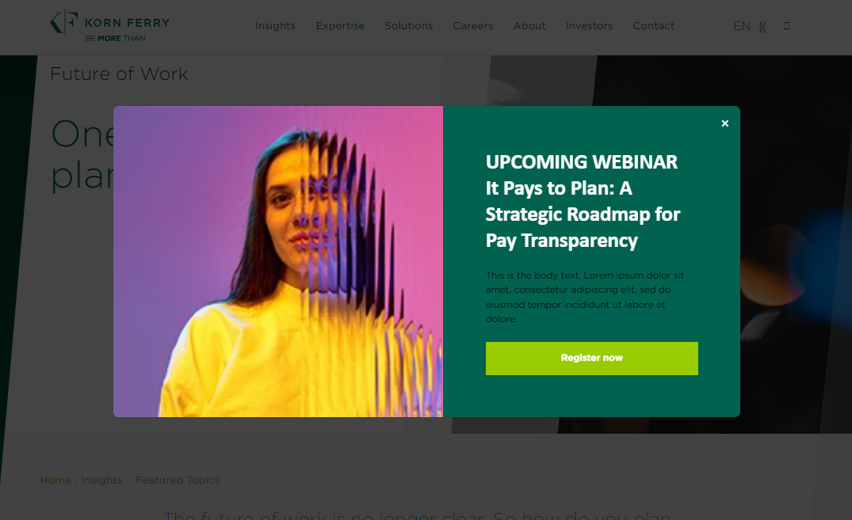 | ☐ | Popup (appears in the centre of the page darkening the background)
Header/Footer Design
 | ☐ | Header/Footer plain
 | ☐ | Header/Footer with image
 | ☐ | Header/Footer with image background
Sidepop/Pop up design
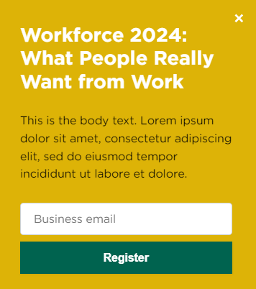 | ☐ | Sidepop/Popup plain
 | ☐ | Sidepop/Popup with image
 | ☐ | Sidepop/Popup with image background
CTA Type for Header/Footer:
 | ☐ | Button
 | ☐ | Link
 | ☐ | Form (please only use this option for content)
CTA Type for Sidepop/Popup:
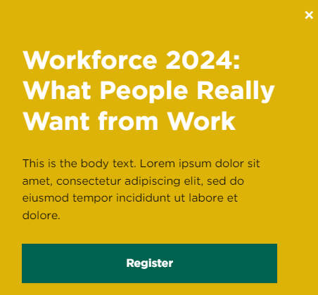 | ☐ | Button
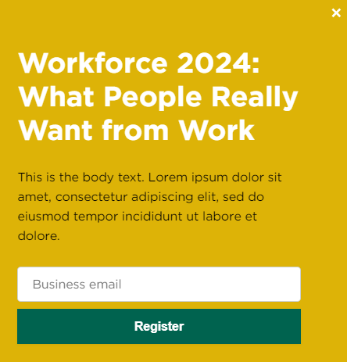 | ☐ | Form (please only use this option for content)
Background color
 | ☐ | Plain
 | ☐ | Gradient
 | ☐ | Image
Please provide color(s) code(s) or the image
Base font
Base text color
Headline (max 140 characters for Header/Footer and 80 characters for Sidepop/Popup offers)
Body text (max 540 characters limit, available only for Sidepop/Popup)
Button text
Button url
Button color
Image |  | Please add to the ticket as a separate file

