for Canvas Instructor Guide

This guide has been created to help you setup an assignment with Turnitin.

Setting up an Assignment in Canvas with Turnitin

- Navigate to your dashboard and click on your course.
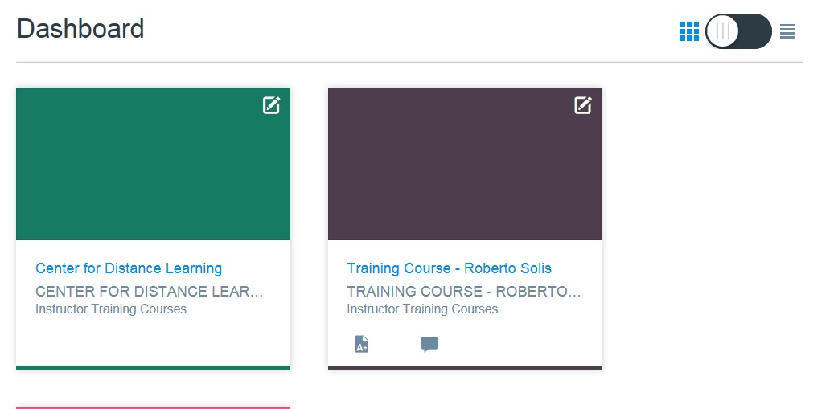
- Under your course menu click Assignments.
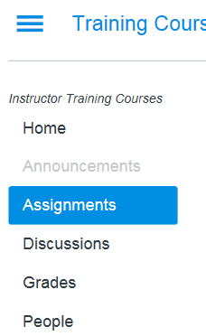

- Click add assignment on the top right.
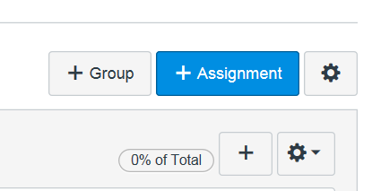

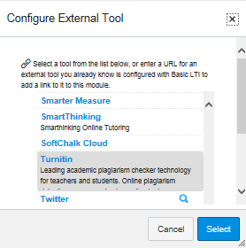
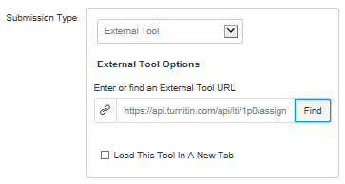
- Fill in all details for your assignment
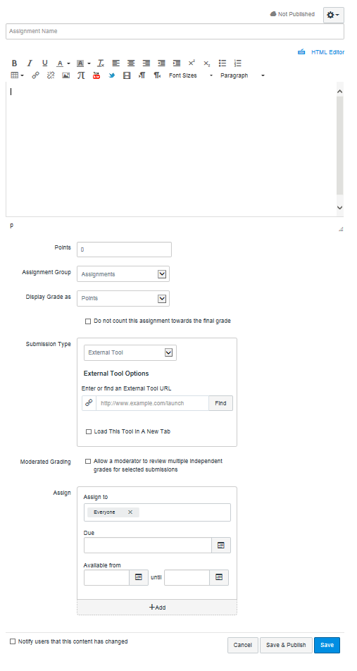
Due dates will be assigned in Turnitin
Display grade as points
Enter assignment description
Enter assignment title here
Save and publish
Assign to everyone
Remove Checkmark
Click find button
Select External Tool
Select assignment group
Set points to 100
5. Go back to assignments and open the Turnitin assignment you just created.
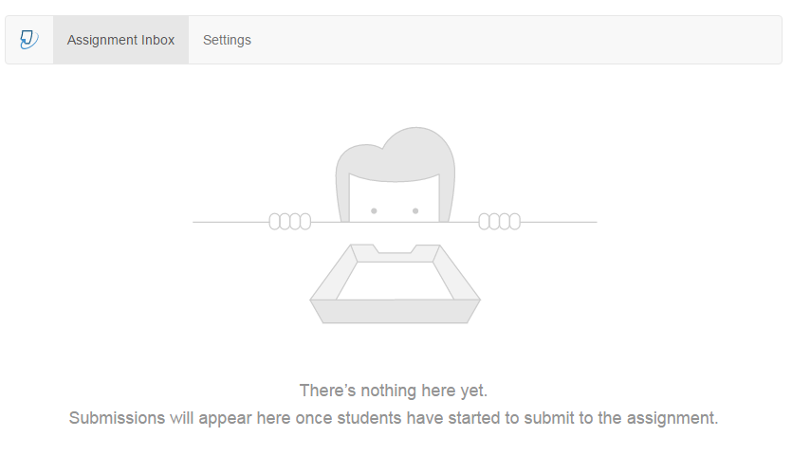
This page is your assignment inbox. All student submissions will be stored in here.

- Click settings on top to set assignment start and due date.
Set file type to No

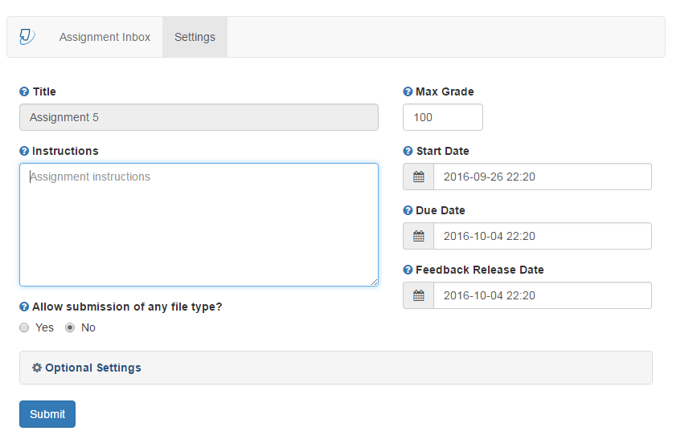
Assignment title will transfer from canvas

Leave this area blank. All instructions from Canvas will transfer.

Set max grade to 100

Assign due date

Set date for students to start viewing your feedback and grades

Assign start date

- Click optional settings to display additional assignment settings.
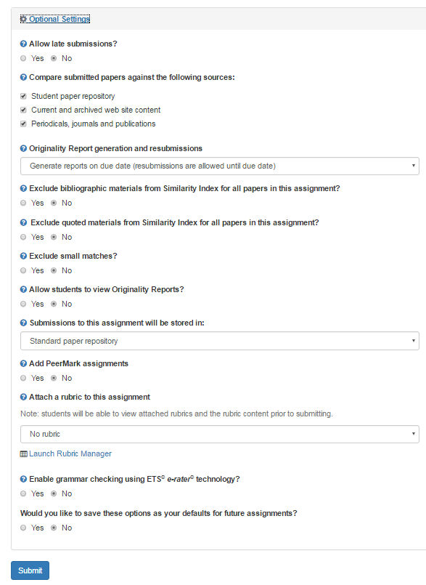
Submit your changes

Save settings for future assignments yes or no

Enable grammar feedback from turnitin

Refer to step 8 to learn how to create a rubric

Set it to your discretion

Leave this option as is

Set it to your discretion

Set it to your discretion

Make sure all three options have a check mark

Set it to your discretion

Exclude quoted materials from report

Exclude works cited page yes or no

Set it to your discretion

- Under optional settings click launch rubric manager

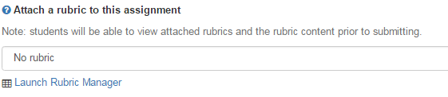

- The rubric manager will open in a new window

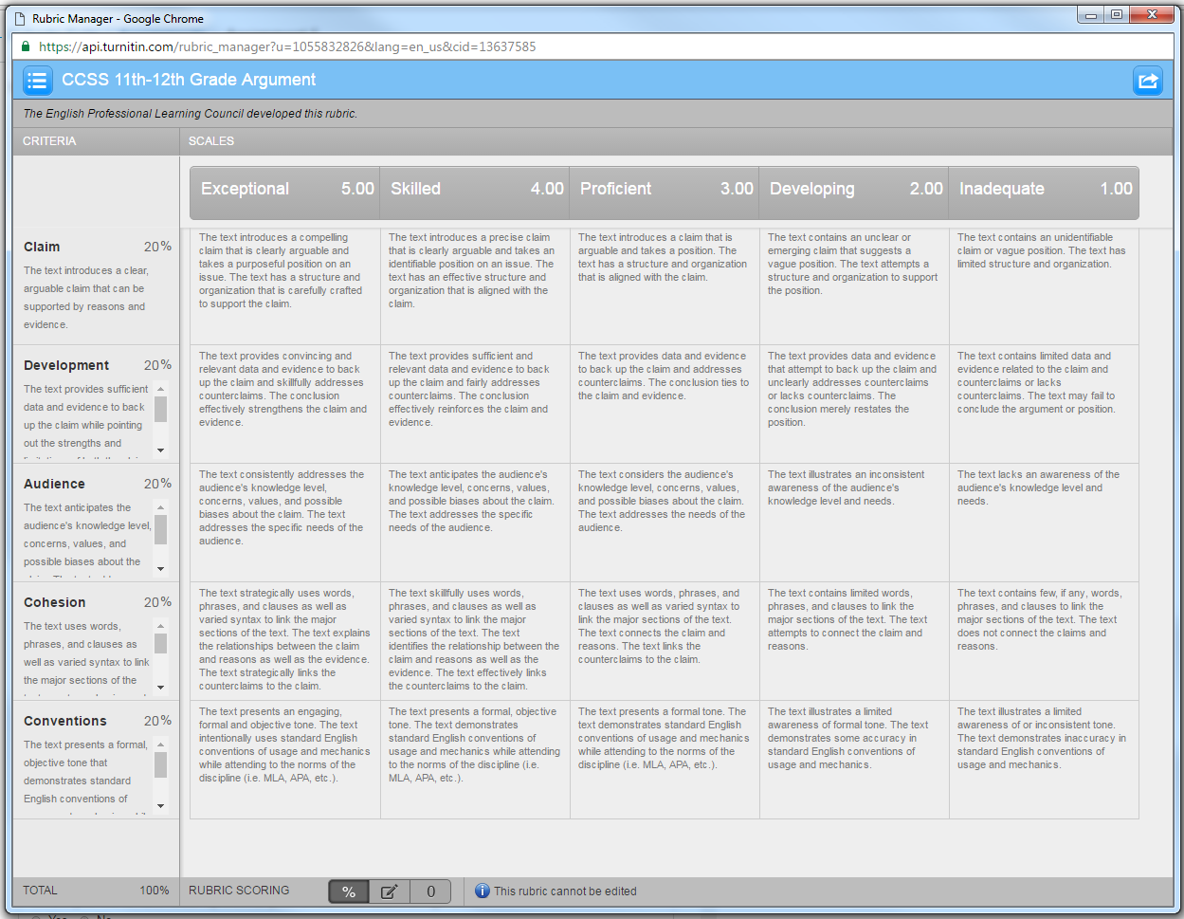

- Click menu button on the top left and select create new rubric

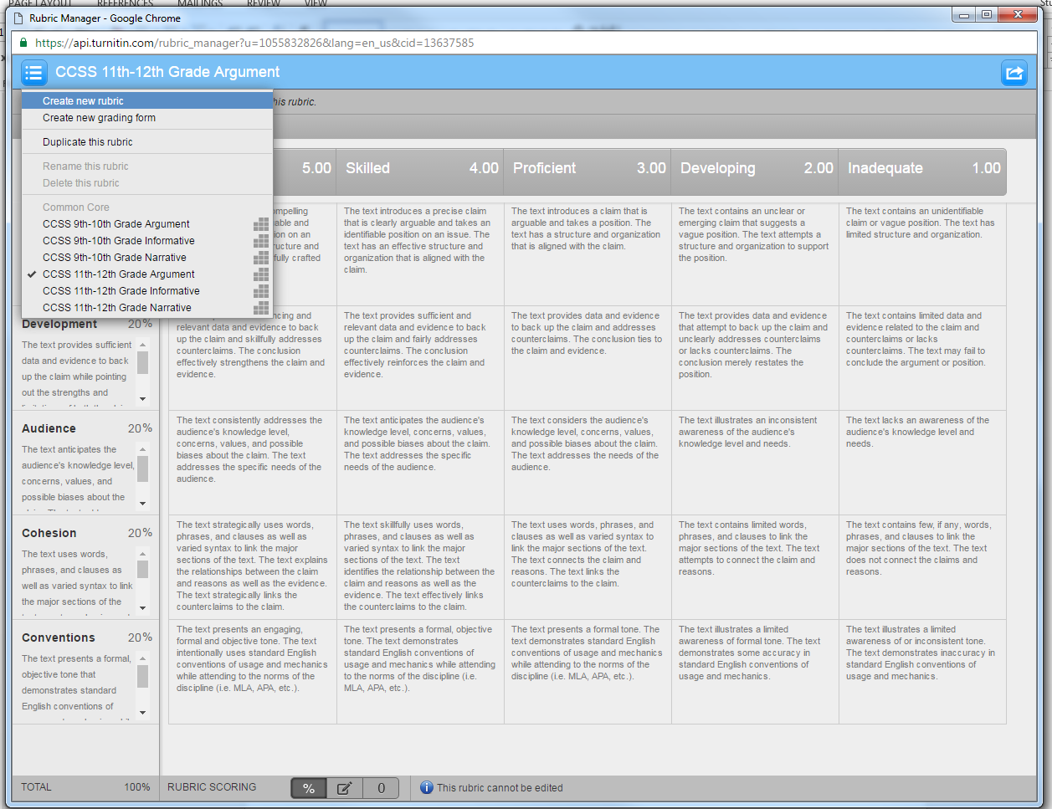

- Customize the rubric to your needs

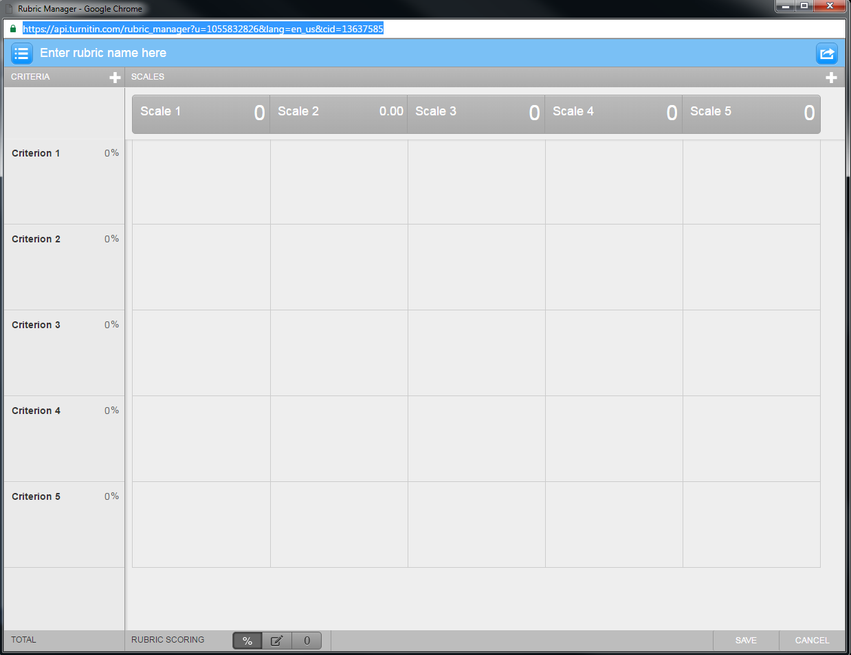
Click to edit scale description

Edit scale value

Edit percentage value

Click to edit or delete criterion 2

Click to edit or delete criterion 1

Save your changes

Enter title for your rubric

- Save all changes

Grading an assignment in Turnitin
All grades assigned in Turnitin will transfer to the Canvas gradebook.

1. Click assignments to view your student submission

2. Click the blue pencil below grade to open “Feedback Studio”

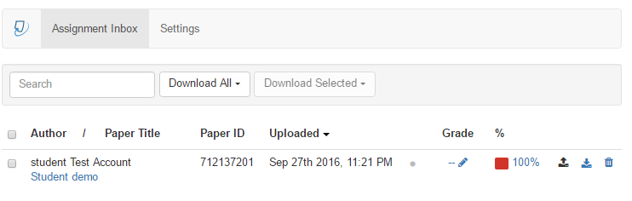
3. Feedback studio should open in a new window

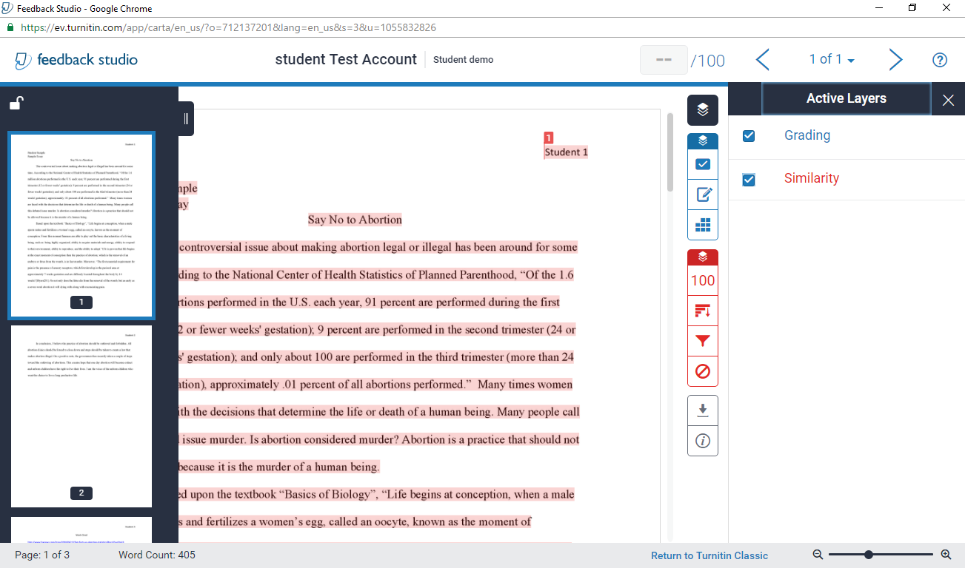
Enter grade here

Download paper
Show / hide layers
Paper navigation

Uploading an Assignment from the Students perspective
- The student will access the assignment in Canvas and click upload submission

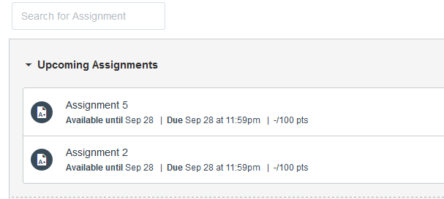
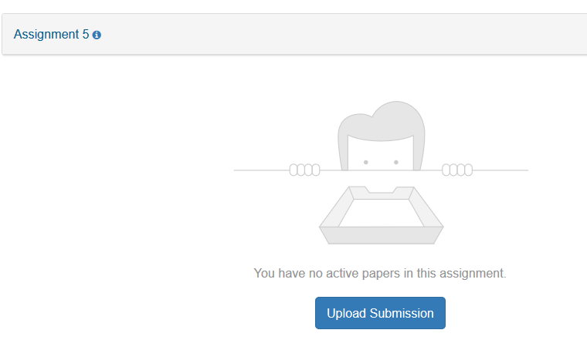

2 The student will enter the assignment title and select the essay file

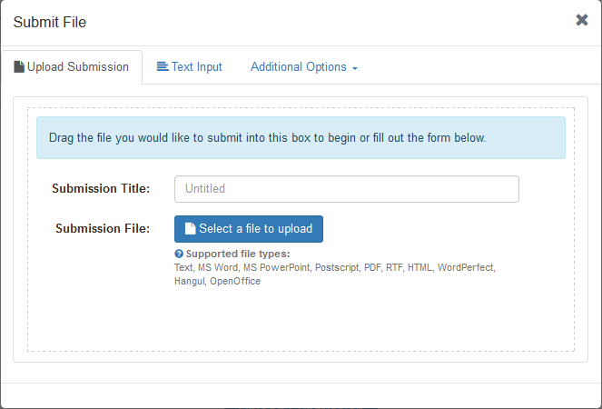
Click select file button

Enter a title for your submission

- The student will click accept submission and save
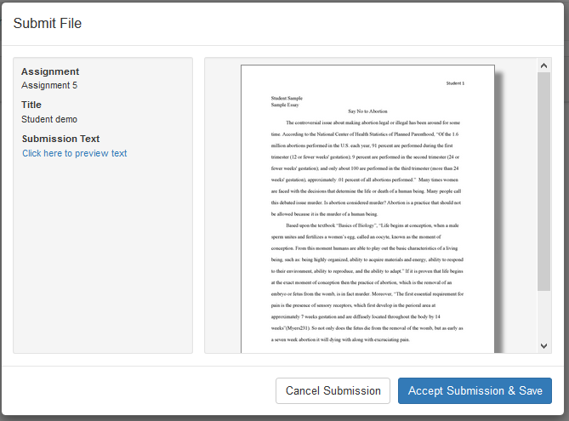

For questions on how to use Turnitin, contact the Center for Distance Learning at 956-721-5211 or distance@laredo.edu.

