- Purpose
  - This work instruction describes how to replace a speed wheel assembly including two speed sensor hubs and one hub stop.
  - These repair instructions are for the E8V rev J, E8F rev J.
- Equipment/Software

ITEM # | PART # | DESCRIPTION | QTY.
1 | 101103 | Speed Sensor wheel | 1
2 | 101104 | Speed Sensor Hub | 2
3 | 101105 | Speed Sensor Hub Stop | 1
4 | 100787 | Blind Rivet, SS | 2

  - #1 Phillips screwdriver
  - Rivet Gun
- Instructions
  - Confirm that all necessary components are present to complete the conversion.
  - Ensure the unit is unplugged and not powered on. Unlock the lid latch and lift the lid to allow access to the rotor.
  - Remove any test tubes inside the rotor.
  - Unscrew the rotor screw (100090) and remove the washer (100404).
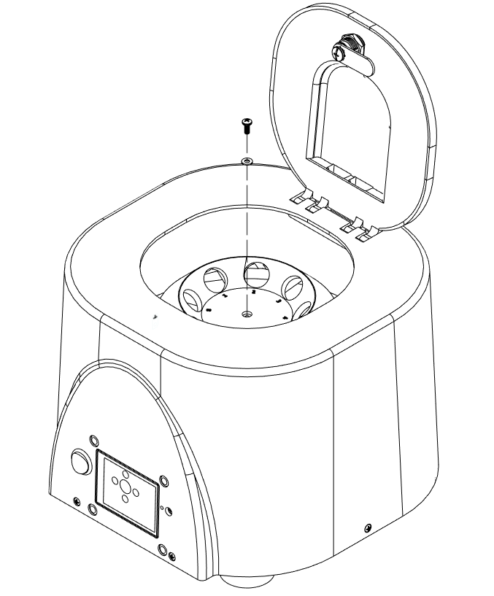
Remove 1 (100090) screw
Remove 1 (100404) washer

  - Remove the rotor (100094).
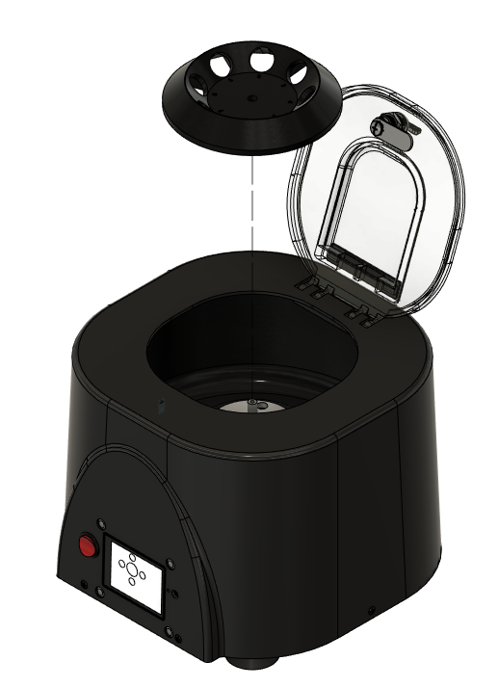
Remove 1 (100094) rotor
  - Remove 5 (100530) screws.
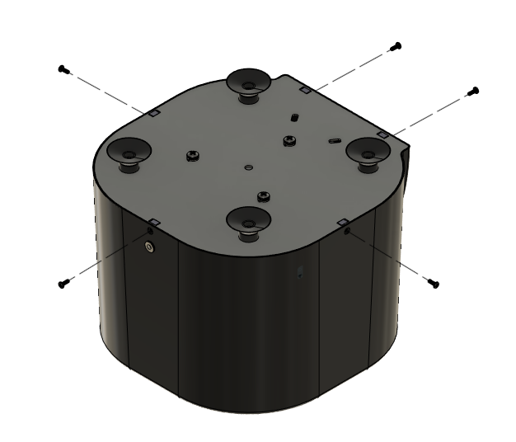
Remove 5 (100530) screws

  - Remove base and motor assembly. Remove motor assembly from the base by removing three hex nut m6 x 1.0 and three split lock washer m6.

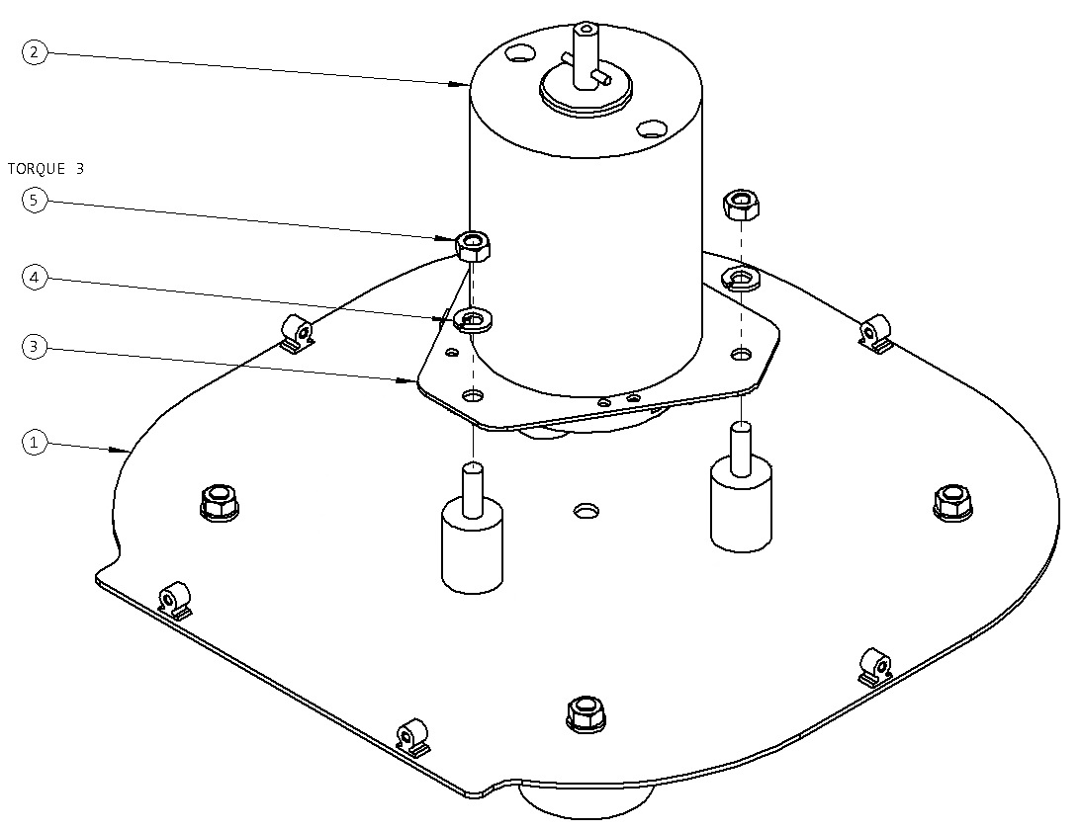
Base Plate (100206)
3 x Split Lock Washer M6 (100067)
3 x Hex Nut M6 x 1.0
Motor
  - Disassemble the speed sensor wheel assembly from the motor mount plate (100552) by removing one PHMS M3 x 0.5 x 8 screw (100398) and washer (100091). Make sure to keep the speed sensor secure and in place.

Motor Mount Assembly
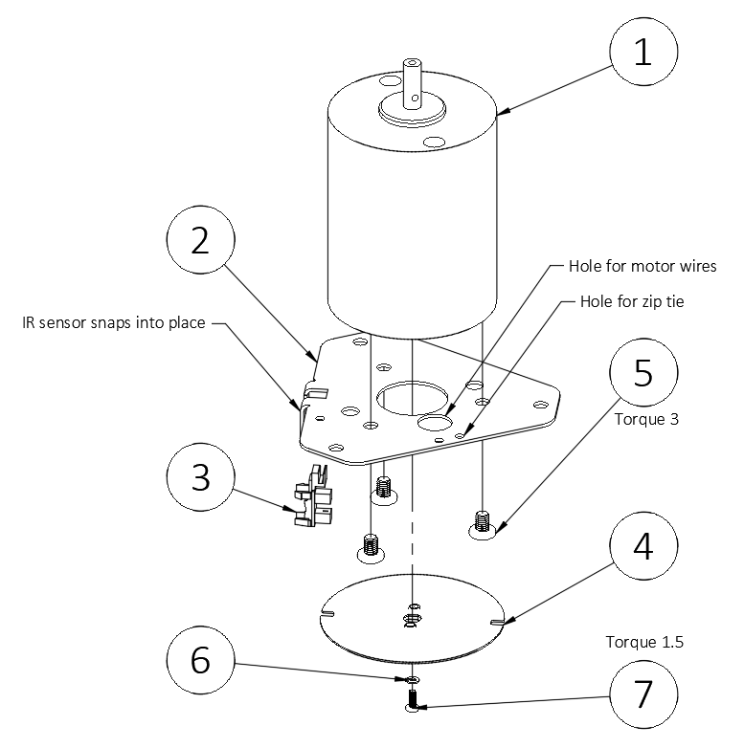
1 x PHMS M3 x 0.5 x 8 (100398)
Speed Sensor
1 x Split lock washer M6 (100091)

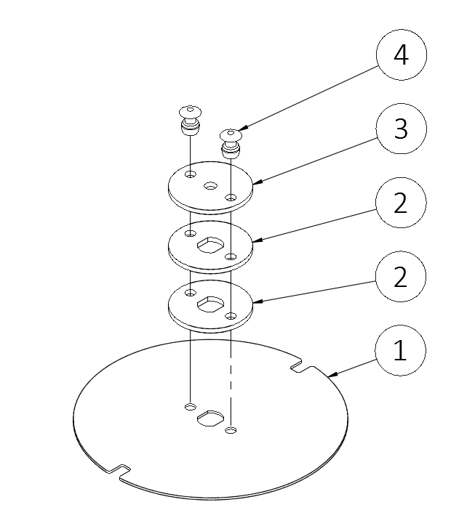
  - Assemble the speed sensor wheel using the provided parts. Stack the speed sensor hub stop (101105) on top of two speed sensor hubs (101104) on top of the speed sensor wheel (101103). Then rivet using two blind rivets (100787).
1 x Speed Sensor Wheel
1 x Speed Sensor Hub (101104)
1 x Speed Sensor Hub (101104)
1 x Speed Sensor Hub Stop (101105)
2 x Blind Rivet, SS (100787)

  - Tighten the new speed sensor wheel in to place again, making sure that the wheel is very secure and that the speed sensor wheel notches align in between the IR speed sensor to be detected.
  - Reassemble the unit. Reattach the motor assembly to the base plate using 3 M6 x 1.0 hex nuts and 3 M6 split lock washers (from step 3.7).
  - Reattach the base plate to the body using 5 (100530) screws (from step 3.6).
  - Reattach rotor, washer, and screw (from step 3.5).
  - Close lid, power unit on, and check for normal behavior for laboratory operation.

