1. Purpose
   1. This work instruction describes the process to replace the door magnet of 10L, 20L, and 30L Incubators.
2. Equipment/Software

|  |  |  |  |
| --- | --- | --- | --- |
| ITEM # | PART # | DESCRIPTION | QTY. |
| 1 | 101407 | Stainless Steel Covered Magnet | 1 |

* 1. TOOLS NEEDED
     + 1. 2 mm Hex Key

1. Instructions
   1. Confirm that all necessary components are present to complete the conversion.
   2. Open the incubator door.
   3. Use a 2mm Hex Key to unscrew the Hex Screw (100738) behind the old magnet (100739) as shown in Figure 1.

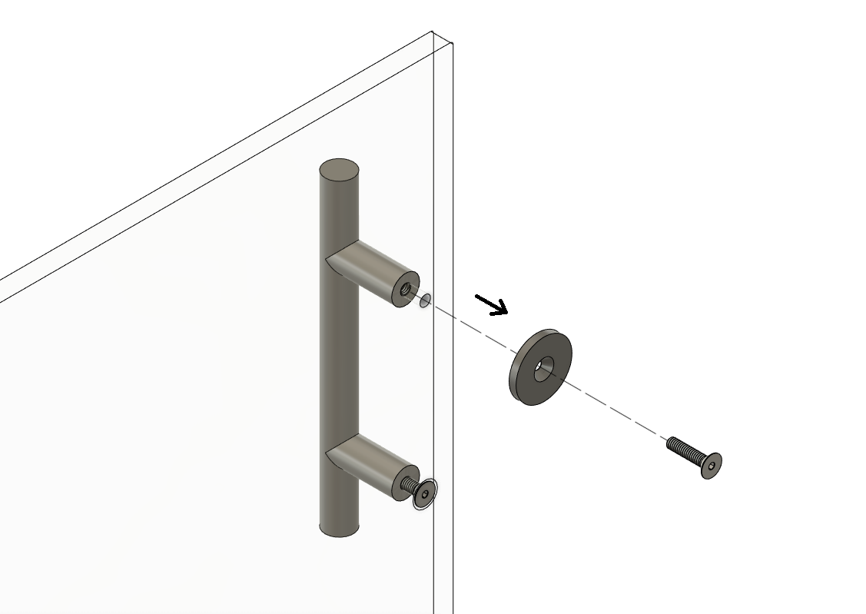

Reference Figure 1

* 1. Discard the old magnet (100739) and install the new magnet (101407) onto the door with screw (100738) in the same configuration as before.

* 1. Close the incubator door and ensure it fits into the unit.
  2. Repair is complete.