1. Purpose
   1. This work instruction describes the process to replace a power jack for the E8 Centrifuge.
   2. These instructions are valid for all versions of E8 Centrifuges.
2. Equipment/Software

|  |  |  |  |
| --- | --- | --- | --- |
| ITEM # | PART # | DESCRIPTION | QTY. |
| # | 100525 | Power Jack Cable Assembly; E8 | 1 |

2.2 #1 Philips Screwdriver

1. Instructions
   1. Confirm that all necessary components are present to complete the conversion.
   2. Ensure unit is both **unplugged** and **not powered on**. Unlock the lid latch and lift the lid to allow access to the rotor.
   3. Remove any test tubes inside the rotor, unscrew the rotor screw (100090), remove washer (100404), remove rotor (100094).

1 x Rotor (100094)

1 x Washer (100404)

1 x Screw (100090)

* 1. Remove 5 (100530) screws.

5 x Screw (100530)

* 1. Remove the base and motor assembly, taking care not to place any wires into tension. Opening the wire clamp may provide more room for the wires to move.

* 1. Remove the power jack by disconnecting all red and blue quick disconnects from the power switch. Remove the female terminal of the power jack wiring assembly in the 2-circuit housing of the power connector wiring assembly (100528).
  2. Install new power jack by pulling wires of the power jack wiring assembly (100525) through the larger hole on the back of the body assembly (100541), tightening the power jack to the body using the provides washer and nut.

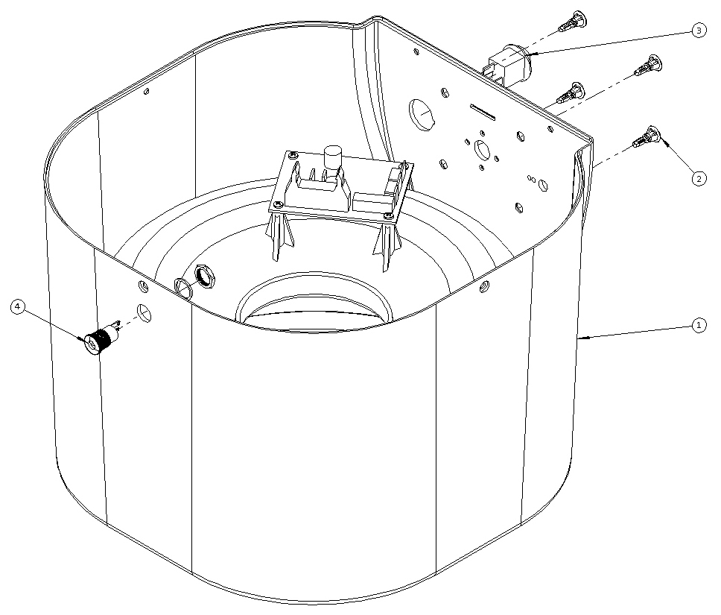

* 1. Place the female terminal of the power jack wiring assembly in the 2-circuit housing of the power connector wiring assembly (100528).
  2. Attach the red quick disconnect of the power connector wiring assembly (100528) to the lead of the power switch indicated in Figure 17.
  3. Attach the red and blue quick disconnect of the power jack wiring assembly to the leads of the power switch.

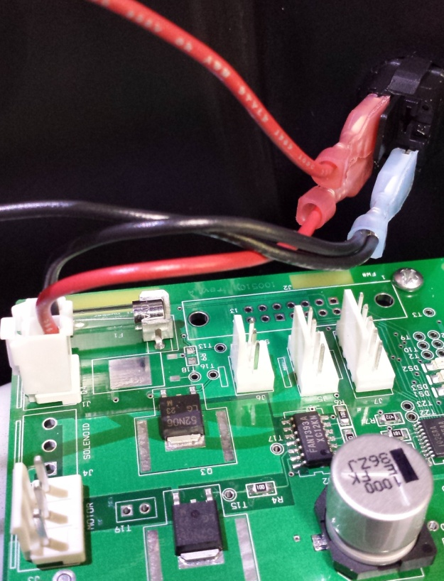

2-circuit housing of power connector

Power switch

Wires from power jack assembly (100528)

Wire from power connector assembly

* 1. Reassemble the unit: replace the base assembly with 5 screws (100530).
  2. Replace the rotor (100094), screw (100090), washer (100404). Close lid, repower.
  3. Close lid, repower, and test unit for normal laboratory operations.