- Purpose
  - This work instruction describes the process of replacing the Power Switch (100099) for both CytoPrep-5 and CytoPrep-10.

- Equipment/Software

ITEM # | PART # | DESCRIPTION | QTY.
1 | 100099 | Power Switch | 1

  - TOOLS NEEDED
- Hex-head screwdriver
- Instructions
  - Confirm that all necessary components are present to complete the conversion.
  - Use your hex-head screwdriver to loosen the 3 M4 Machine Screws (101044) on the side of the unit.
  - Remove the Acrylic Side Panel (101035) and 3 M4 machined screws (101044). Referencing to Figure 1.

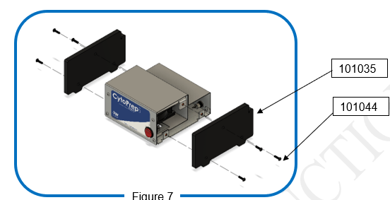
Figure 1

  - Carefully disconnect all 3 wires on the back of the Power Switch (100099).
  - Remove the old Power Switch (100099) from the unit.
  - Insert your new Power Switch (100099) into the corresponding hole, make sure it’s fully seated. Referencing Figure 2.

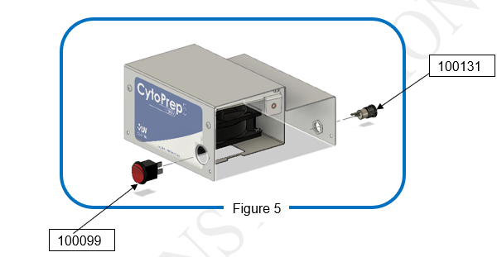
Figure 2
  - Connect the wires onto the new Power Switch (100099) referencing Figure 3.

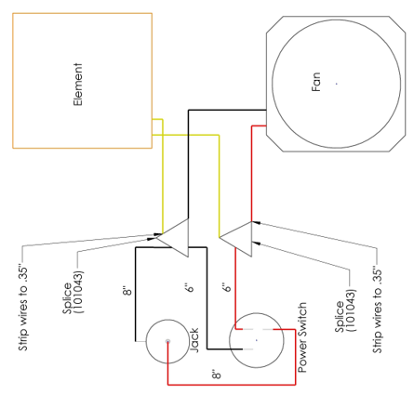Figure 3

  - Reinstall the Acrylic Side Pane (101035) with 3 M4 Machine Screws (101044).
  - Plug in the unit and ensure it function under normal laboratory condition.
  - This completes the repair.

