1. Purpose
   1. This work instruction describes the process of replacing the MX5 Fuse.
2. Equipment/Software

|  |  |  |  |
| --- | --- | --- | --- |
| ITEM # | PART # | DESCRIPTION | QTY. |
| 1 | 100054 | Fuse; 8 A; 125 V; Fast Acting; Glass; 5 mm x 20 mm | 2 |

1. Instructions
   1. Confirm that all necessary components are present to complete the conversion.
   2. Ensure that the unit is unplugged.
   3. Locate the fuse holder above the power switch in the back of the unit.

*Figure 1*

Fuse Holder

*Figure 1*

* 1. Remove the fuse holder. *Figure 2*

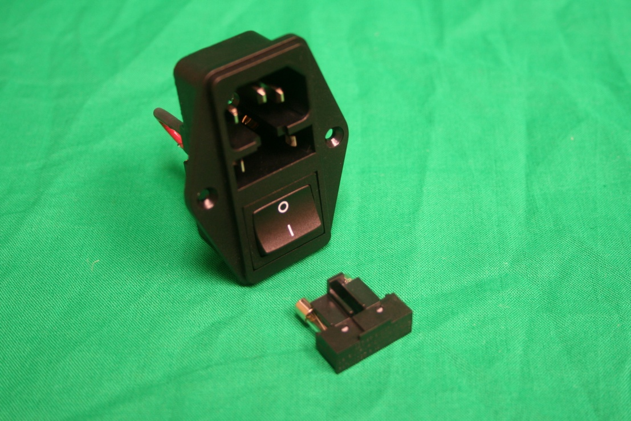

*Figure 2*

Fuse Holder

* 1. Replace the 2 fuses (100054) with 2 new fuses.
  2. Reinsert the fuse holder into the MX5.

Fuse 100054

Fuse Holder

* 1. Plug in and power on the MX5. Verify unit works under normal laboratory use.
  2. The repair is complete.