1. Purpose

1.1 This work instruction describes the process of replacing the Motor (100968-B or 100994-B) for the MX12 centrifuge.

1. Equipment/Software

|  |  |  |  |
| --- | --- | --- | --- |
| ITEM # | PART # | DESCRIPTION | QTY. |
| 1 | 100968-B  or  100994-B | Motor | 1 |

* 1. TOOLS NEEDED
  2. Philips-screwdriver
  3. 6 mm wrench

1. Instructions
   1. Confirm that all necessary components are present to complete the conversion.
   2. Turn on your MX12 unit, open the lid. Then disconnect the unit from power.
   3. Remove the rotor assembly by unscrewing the thumbscrew (101088), set them aside as you will need to put them back. Figure 1

Reference Figure 1

* 1. Remove 10 M4x0.7;10 mm screws (100090) with a Philips-screwdriver, set them aside as you will need them later. Figure 2

Reference Figure 2

* 1. Carefully remove the Base Plate (100952-E), keep the Base Plate (100952-E) close to the body as there is a wire still connected.
  2. Use the 6 mm wrench to remove the 3 M6x1.0 Nut (100057), be carefully while removing them from the screw as there is a washer (100067) on each of them. Figure 3
  3. Slowly remove the old motor (100968-B or 100994-B) from the base plate (100952-E). Figure 3

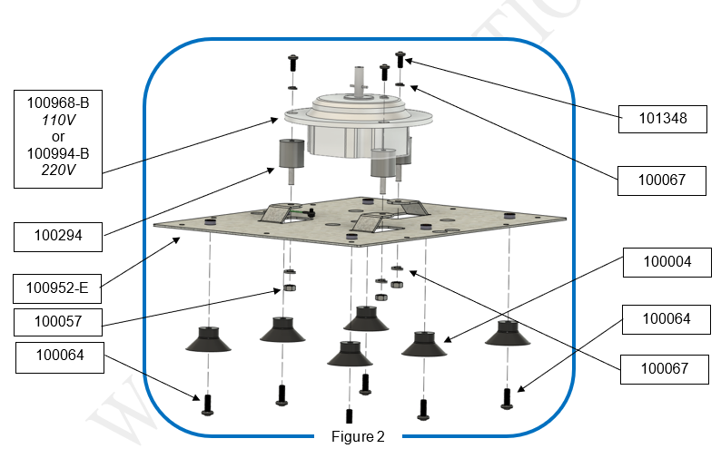

Figure 3

* 1. Use your Philips-screwdriver to remove the M3x8mm screw (100398) and the washer (100091) from the old motor (100968-B or 100994-B), remove the wire connector (101023). Figure 4

Figure 4

* 1. Disconnect the Motor Cable 6-pin and Motor Cable 5-pin from the Motor Control Board (100969-B). Figure 5

Figure 5

* 1. Remove 3 Vibration Absorbers (100294) from the old motor (100968-B or 100994-B) by unscrewing the M6x1.0 screws (101348) on top. Figure 3
  2. Install 3 Vibration Absorbers (100294) to the new motor (100968-B or 100994-B) by screwing the M6x1.0 screws (101348) on top.
  3. Alignment the wire connector (101023) to the hole on the bottom of the new motor (100968-B or 100994-B). Use a Philips-screwdriver to screw the M3x8mm screw (100398) and the washer (100091). Make sure it’s snug.
  4. Connect the Motor Cable 6-pin and Motor Cable 5-pin from new motor (100968-B or 100994-B) to the Motor Control Board (100969-B). Figure 5
  5. Set the new motor (100968-B or 100994-B) onto the Base Plate (100952-E),and secure it by tightening the 3 M6x1.0 Nut (100057) and 3 washer (100067).
  6. Reattach the Base Plate (100952-E) to the body the MX12 unit, screw the 10 M4x0.7;10 mm screws (100090) with a Philips-screwdriver.
  7. Reinstall the rotor assembly by screwing the thumbscrew (101088) till it’s snug.
  8. Close the lid. Run the MX12 unit at 12,000 RPM for 3 minutes to verify successful replacement of the motor (100968-B or 100994-B).
  9. This completes the repair.