1. Purpose
   1. This work instruction describes the process for repairing the Timer Knob of E8 Fixed Centrifuge and E8 Variable Centrifuge.
   2. These repair instructions are valid for Revision J of the E8 Fixed Centrifuge and Revision J of the E8 Variable Centrifuge. For previous revisions or clarification, please consult Product Development.
2. Equipment/Software

|  |  |  |  |
| --- | --- | --- | --- |
| ITEM # | PART # | DESCRIPTION | QTY. |
| 1 | 100203-B | Timer | 1 |

* 1. 10 mm socket
  2. #1 Philips screwdriver

1. Instructions
   1. Confirm that all necessary components are present to complete the conversion.
   2. Ensure the unit is unplugged and not powered on. Unlock the lid latch and lift the lid to allow access to the rotor.
   3. Remove any test tubes inside the rotor.
   4. Unscrew the rotor screw (100090) and remove the washer (100404). Set aside for reuse.

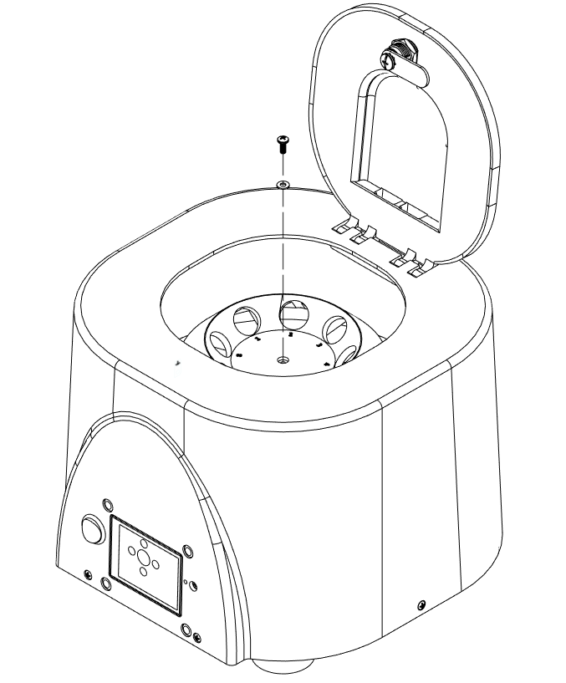

Remove 1 (100090) screw

Remove 1 (100404) washer

* 1. Remove the rotor (100094). Set aside for reuse.

Remove 1 (100094) rotor

* 1. Remove 5 (100530) screws. Set aside for reuse.

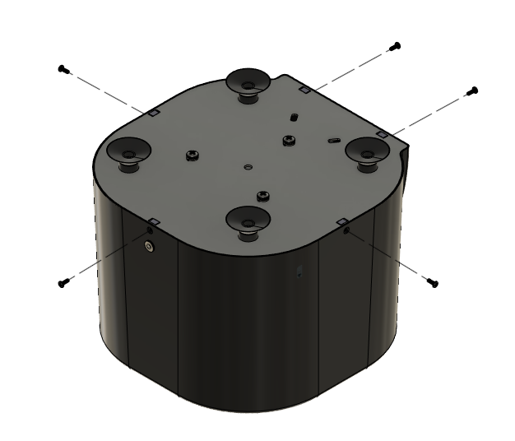

Remove 5 (100530) screws

* 1. Remove and set aside the base and motor assembly, taking care not to place any wires into excessive tension. Note that there is a wire clamp on one side of the unit. Opening the wire clamp will provide more room for the wires to move, allowing further access to the wiring.
  2. For variable units, remove the knob from the potentiometer. Set aside for reuse.
  3. Remove the timer knob and set aside for reuse.
  4. Carefully remove the label from the front of the unit. Set aside for reuse.

Remove timer knob

Remove potentiometer knobrews

* 1. Remove the quick disconnect of the timer cable assembly from the tab of the timer closest to the top of the body assembly.
  2. Remove the quick disconnect of the Power Connector cable assembly (100518-B) to the tab closest to the bottom of the body assembly.
  3. Unscrew 4 (100060) screws holding the Timer in place and set aside for reuse. Replace the timer with a new one and refasten using the 4 (100060) screws.

Unscrew 4 (100060)rews

* 1. Apply the label back onto the front of the unit. If the label has been damaged during removal, replace with a new one.
  2. For variable units, reattach the potentiometer knob to the potentiometer.
  3. Reattach the timer knob.
  4. Reattach the quick disconnect of the timer cable assembly from the tab of the timer closest to the top of the body assembly.
  5. Reattach the quick disconnect of the Power Connector cable assembly (100518-B) to the tab closest to the bottom of the body assembly.

From Power Connector Wiring Assembly

From Timer Cable Assembly

* 1. Replace the base and motor assembly and place the loose wires back into the wire clamp.
  2. Reassemble the unit by refastening the 5 (100530) screws and reattaching the rotor assembly.
  3. Close the unit lid and power on the unit. Verify all functionalities are present under normal laboratory conditions.