1. Purpose
   1. This work instruction describes the process of replacing the motor in an MX5
2. Equipment/Software

|  |  |  |  |
| --- | --- | --- | --- |
| ITEM # | PART # | DESCRIPTION | QTY. |
| 1 | 100917  Or  101073 | Motor w/ wiring harness; 110V  Or  Motor w/ wiring harness; 220V | 1 |

* 1. Phillips Screwdriver & Crescent Wrench.

1. Instructions
   1. Confirm that all necessary components are present to complete the conversion.
   2. Ensure that the unit is powered off and unplugged.
   3. Flip the unit over onto the lid.
   4. Remove the 8 M5 screws (100064) and feet (100586). *Figure 1*

M5 Screws

(100064)

Rubber Feet

(100586)

MX5 Base Plate

*Figure 1*

* 1. Carefully set the unit on the side. *Figure 2*

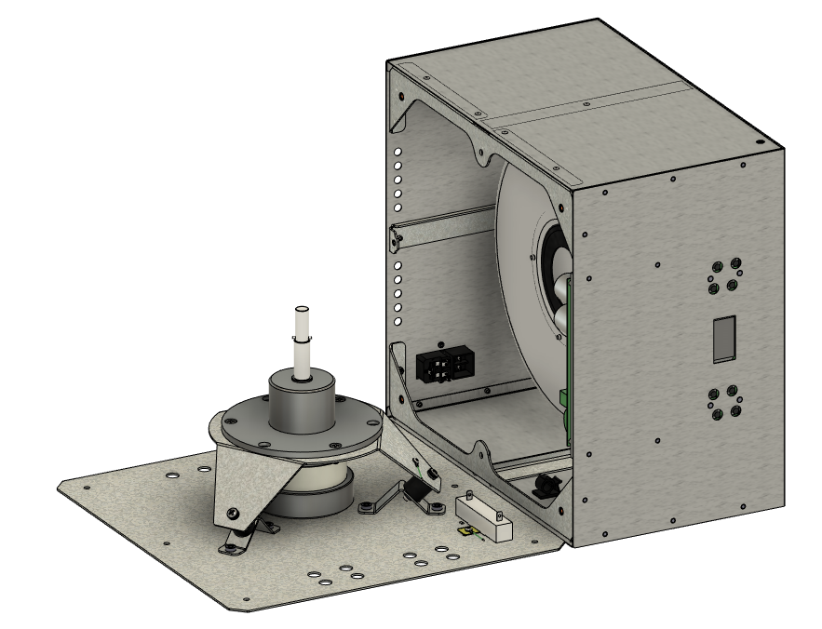

*Figure 2*

* 1. Unplug the Motor Cable 5-pin and the Motor Cable 6-pin from the Motor Control Board. *Figure 3*

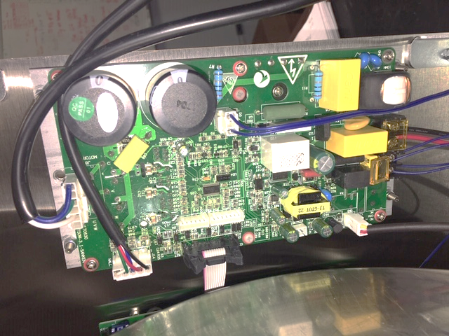

Motor Cable 5-pin

*Figure 3*

Motor Cable

6-pin

Motor Control Board

* 1. Unscrew the 3 M6 screws and nuts to remove the motor (100917) from the motor mount. NOTE: There are washers in-between the nuts and the motor mount. *Figure 4*

M6 Screws

(100064)

Motor

(100917)

Nuts & Washers

(100057 & 100067)

*Figure 4*

* 1. Replace the motor and refasten to the motor mount, ensuring that cables are fed through the wire clamp. *Figure 5*

Wire Clamp

*Figure 5*

* 1. Plug the motor into the specified slots on the motor control board. *Figure 6*



Motor Cable 5-pin

*Figure 6*

Motor Cable

6-pin

* 1. Carefully set the unit back on the lid.
  2. Reattach the feet and the base plate using the 8 M5 screws. *Figure 7*

*Figure 7*

* 1. Flip the unit onto the feet.
  2. Plug the unit in and power it on. Ensure the unit functions under normal laboratory use.
  3. Repair is complete.