- Purpose
  - This work instruction describes the process for replacing the label of the MX5 Centrifuge
  - These repair instructions are valid for Revision G of the MX5 Centrifuge (101072-G and 100900-G) as well as any previous revisions that are compatible with the label (100929).

- Equipment/Software

ITEM # | PART # | DESCRIPTION | QTY.
1 | 100929 | UI Label; raised button pads; blue & white; MX5 Centrifuge | 1

- Instructions
  - Confirm that all necessary components are present to complete the conversion.
  - Carefully remove the damaged front label from the unit.
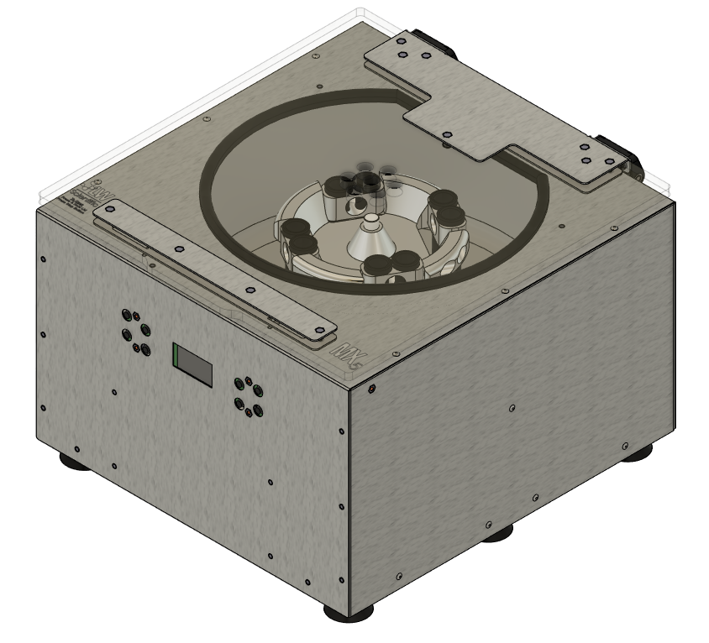

  - Replace the label with a new 100929 label.
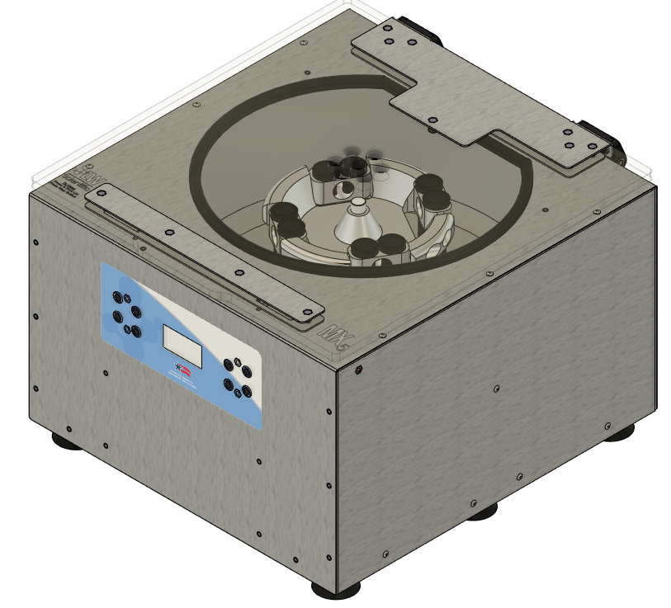

  - Turn on the unit and verify all buttons are functional with the new label.

