1. Purpose
   1. This work instruction describes the process for replacing the MXU Solenoid.
   2. These repair instructions are valid for revision C MXU Digital Centrifuges. For revisions older than C, please consult Product Development.
2. Equipment/Software

|  |  |  |  |
| --- | --- | --- | --- |
| ITEM # | PART # | DESCRIPTION | QTY. |
| 1 | 100079 | Solenoid; 12V | 1 |

* 1. Phillips head screwdriver
  2. #7 nut driver or #7 socket with socket wrench

1. Instructions
   1. Confirm that all necessary components are present to complete the conversion.
   2. Open the lid and remove the rotor and tube shields from the unit. *Figure 1*

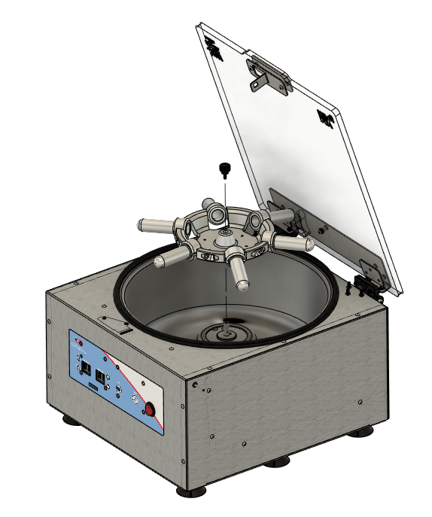

*Figure 1*

* 1. Turn the unit over onto its lid and remove the base plate. *Figure 2*

**NOTE: Avoid overextending****connected wires when removing the base plate.**

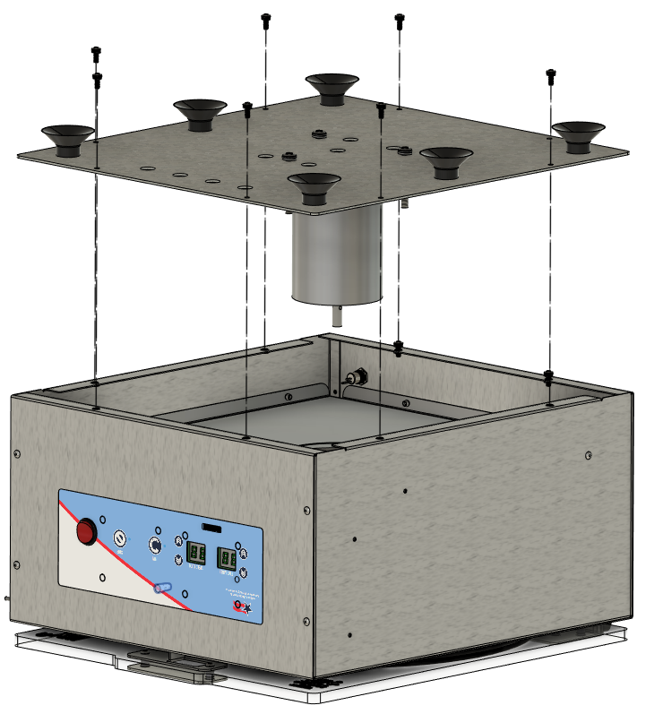

*Figure 2*

* 1. Disconnect the Motor (J3), the Speed IR Sensor (J5), and the Solenoid from the Motor Drive Board. *Figure 3*

Solenoid

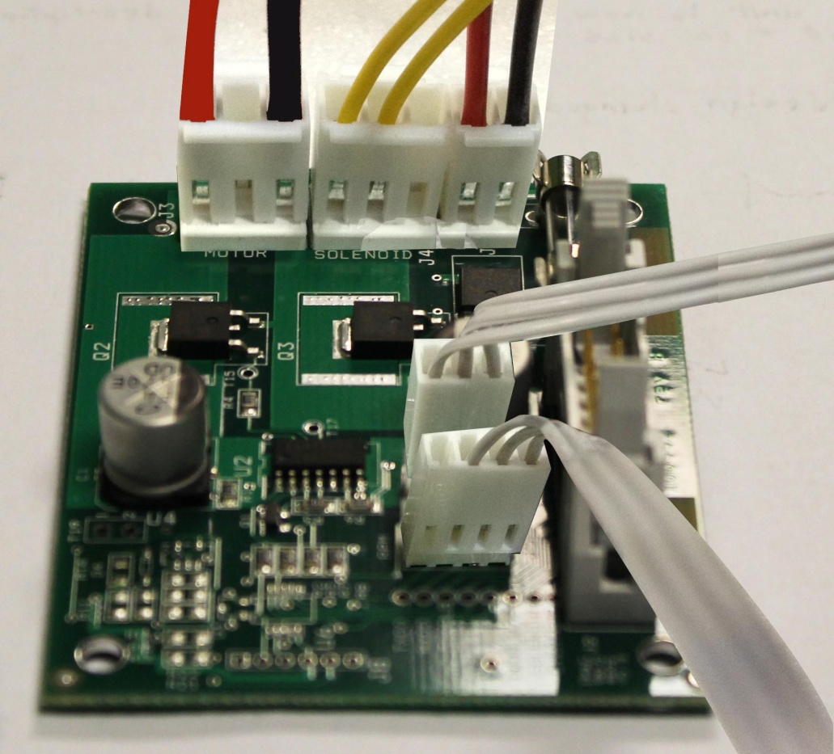

**J3**

**J5**

*Figure 3*

* 1. Using the #7 nut driver, locate and remove the two nuts (100922) holding the Solenoid IR Sensor Bracket (101110) in place. *Figure 4*

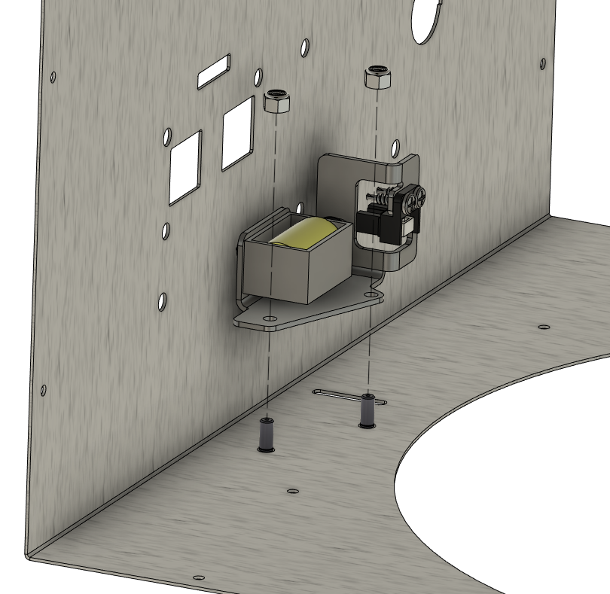

101110 – Solenoid IR Sensor Bracket

*Figure 4*

* 1. Using a Phillips head screwdriver, remove and replace the Solenoid (100079) from the Solenoid IR Sensor Bracket. *Figure 5*

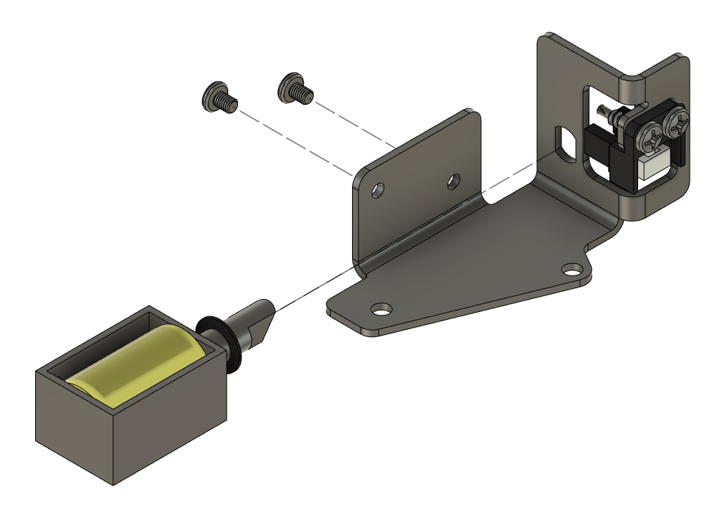

*Figure 5*

* 1. Re-attach the Solenoid IR Sensor Bracket to the body. *Figure 6*

*Figure 6*

* 1. Re-connect the Motor (J3), Speed IR Sensor (J5), and the Solenoid to the Motor Drive Board. *Figure 7*

Solenoid



**J3**

**J5**

*Figure 7*

* 1. Re-attach the Base Plate Assembly to the Body. *Figure 6*



*Figure 6*

* 1. Replace Rotor, close the lid, and verify the unit powers on and functions under normal laboratory use.

