1. Purpose
   1. This work instruction describes the process to replace the User Interface Board on the MX12 Centrifuges.
2. Equipment/Software

|  |  |  |  |
| --- | --- | --- | --- |
| ITEM # | PART # | DESCRIPTION | QTY. |
| 1 | 100976 | User Interface Board | 1 |

* 1. TOOLS NEEDED
  2. Philips-screwdriver
  3. 6 mm wrench

1. Instructions
   1. Confirm that all necessary components are present to complete the conversion.
   2. Turn on your MX12 unit, open the lid. Then disconnect the unit from power.
   3. Remove the rotor assembly by unscrewing the thumbscrew (101088), set them aside as you will need to put them back. Figure 1

Reference Figure 1

* 1. Remove 10 M4x0.7;10 mm screws (100090) with a Philips-screwdriver, set them aside as you will need them later. Figure 2

Reference Figure 2

* 1. Carefully remove the Base Plate (100952-E), keep the Base Plate (100952-E) close to the body as there is a wire still connected.
  2. Use the 6 mm wrench to remove the 3 M6x1.0 Nut (100057), be carefully while removing them from the screw as there is a washer (100067) on each of them.

Figure 3

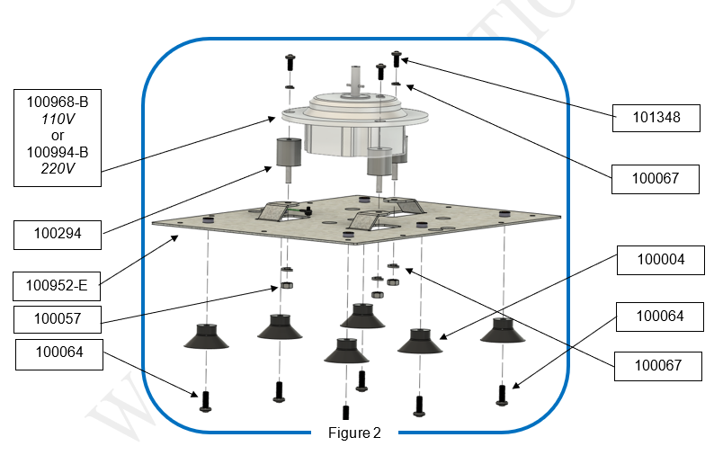

Figure 3

* 1. Unplug 2 wire connectors (101018 & 100978), and 1 wire connector (101020) from the old User Interface Board (100976). Figure 4
  2. Use your Philips-screwdriver to remove 4 M4x6mm screw (101084) from the corners of the old User Interface Board (100976). Figure 4

Figure 4

* 1. A diagram of a computer part

     Description automatically generatedRemove the old User Interface Board (100976) and 4 Washers (100066) from the unit. Figure 5

Figure 5

* 1. Install the new User Interface Board (100976) to the unit, make sure to place Washers (100066) between the board and the body. Figure 5
  2. Secure the new User Interface Board (100976) by screw-in the screws (101084). Tighten the screws with your Philips-screwdriver till snug.
  3. Set the motor (100968-B or 100994-B) back onto the Base Plate (100952-E),and secure it by tightening the 3 M6x1.0 Nut (100057) and 3 washer (100067).
  4. Reattach the Base Plate (100952-E) to the body the MX12 unit, screw the 10 M4x0.7;10 mm screws (100090) with a Philips-screwdriver.
  5. Reinstall the rotor assembly by screwing the thumbscrew (101088) till it’s snug.
  6. Turn on the MX12 centrifuge and check if all buttons are working properly to verify the replacement of the new User Interface Board (100976).
  7. This completes the repair.