1. Purpose
   1. This work instruction describes how to replace a power switch for the E8 centrifuge.
   2. These instructions are valid for all versions of the E8 Centrifuge.
2. Equipment/Software

|  |  |  |  |
| --- | --- | --- | --- |
| ITEM # | PART # | DESCRIPTION | QTY. |
| 1 | 100099 | Switch; power input; round body; illuminated red | 1 |

2.2 #1 Philips Screwdriver

1. Instructions
   1. Confirm that all necessary components are present to complete the conversion.
   2. Ensure unit is both **unplugged** and **not powered on**. Unlock the lid latch and lift the lid to allow access to the rotor.
   3. Remove any test tubes inside the rotor, unscrew the rotor screw (100090), remove washer (100404), remove rotor (100094).

1 x Rotor (100094)

1 x Washer (100404)

1 x Screw (100090)

* 1. Remove 5 (100530) screws.

5 x Screw (100530)

* 1. Remove the base and motor assembly, taking care not to place any wires into tension. Opening the wire clamp may provide more room for the wires to move.

* 1. Remove the power switch by disconnecting all red and blue quick disconnects from the power switch.

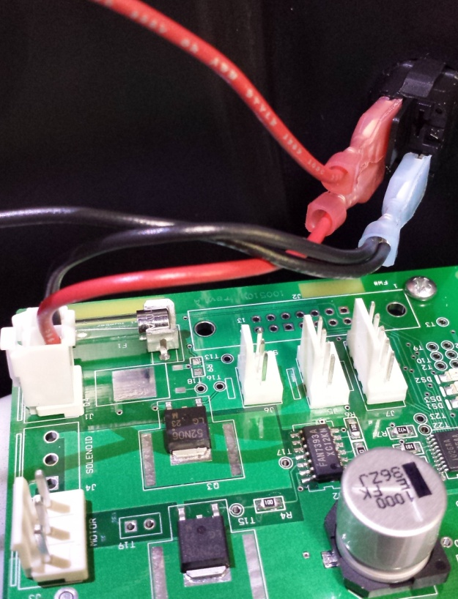

Reconnect these three wires to new power switch.

* 1. Replace the power switch, and reconnect the wires (that were disconnected from 3.6 as shown above).
  2. Reassemble the unit: replace the base assembly with 5 screws (100530).
  3. Replace the rotor (100094), screw (100090), washer (100404). Close lid, repower.
  4. Close lid, repower, and test unit for normal laboratory operations.