1. Purpose
   1. This work instruction describes the process of replacing the Power Switch (100099) on the Slide Warmer.
2. Equipment/Software

|  |  |  |  |
| --- | --- | --- | --- |
| ITEM # | PART # | DESCRIPTION | QTY. |
| 1 | 100099 | Power Switch | 1 |

* 1. TOOLS NEEDED
* Hex head screwdriver

1. Instructions
   1. Confirm that all necessary components are present to complete the conversion.
   2. Use your hex head screwdriver to loosen and remove all 10 screws (101071) from the lower assembly of the unit, referencing Figure 1.

Figure 1

* 1. Remove the lower assembly.
  2. Disconnect 3 wires on the back of the old Power Switch (100099).
  3. Remove the old Power Switch (100099) from body.
  4. Insert the new Power Switch (100099) into the corresponding hole and make sure it’s seated, referencing Figure 2.

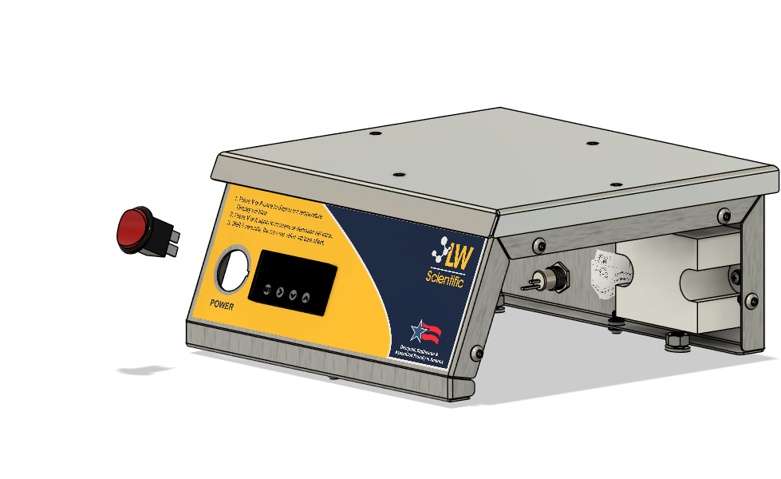

100099

Figure 2

* 1. Connect the wires onto the back of the new Power Switch (100099), referencing Figure 3.

Figure 3

* 1. Replace the lower assembly with 10 screws (101071), tighten screw and make sure they are snug.
  2. Plug in the unit and ensure it function under normal laboratory condition.
  3. This completes the repair.