1. Purpose
   1. This work instruction describes the process for replacing the motor drive board fuse in the E8 Digital Centrifuge.
   2. These repair instructions are valid for Revision J of the E8 Digital centrifuge. For previous revisions, please consult Product Development.
2. Equipment/Software

|  |  |  |  |
| --- | --- | --- | --- |
| ITEM # | PART # | DESCRIPTION | QTY. |
| 1 | 100054 | Fuse, 5mm x 20mm 8 A | 1 |

* 1. #1 Philips Screwdriver

1. Instructions
   1. Confirm that all necessary components are present to complete the conversion.
   2. Ensure the unit is unplugged and not powered on. Unlock the lid latch and lift the lid to allow access to the rotor.
   3. Remove any test tubes inside the rotor.
   4. Unscrew the rotor screw (100090) and remove the washer (100404). Set aside for reuse.

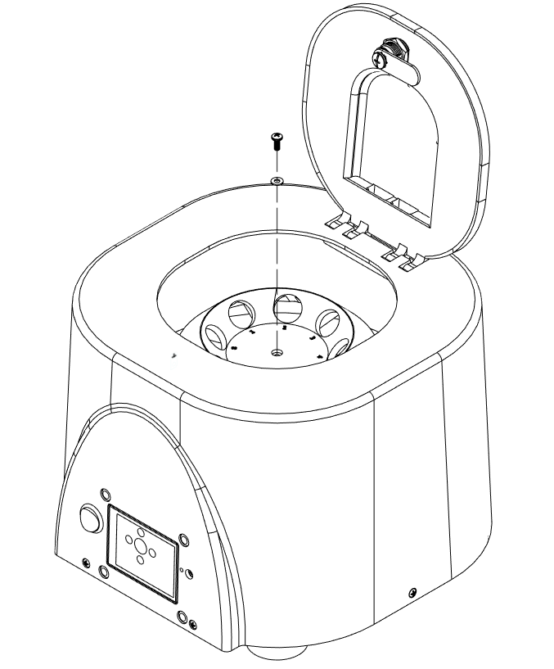

Remove 1 (100090) screw

Remove 1 (100404) washer

* 1. Remove the rotor (100094). Set aside for reuse.

Remove 1 (100094) rotor

* 1. Remove 5 (100530) screws. Set aside for reuse.

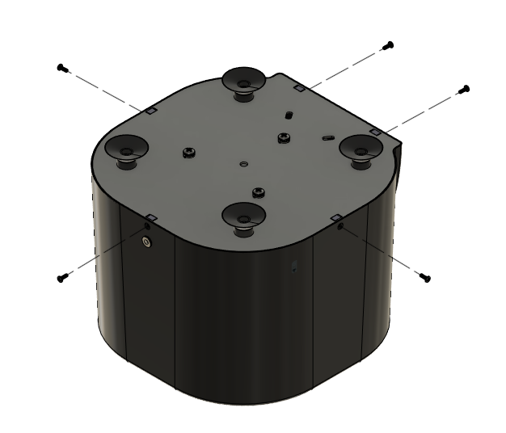

Remove 5 (100530) screws

* 1. Remove the base and motor assembly, taking care not to place any wires into excessive tension. Note that there is a wire clamp on one side of the unit. Opening the wire clamp will provide more room for the wires to move, allowing access to the motor drive board. Set aside for motor and base assembly.
  2. Remove the spent fuse from the fuse clips of the motor drive board as shown in the figure below. Place a new 5 mm x 20mm 8 A (100054) fuse in its place.

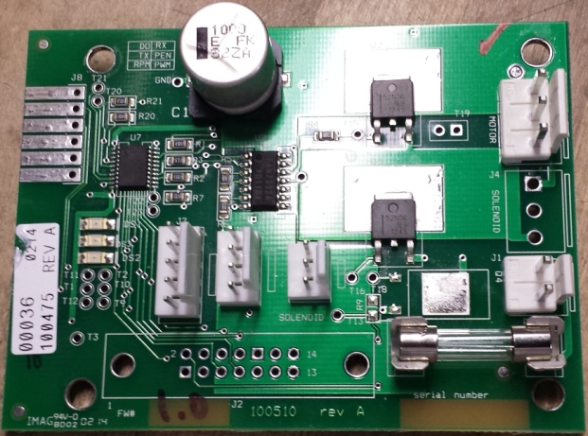

Replace this fuse

* 1. Begin reassembly by placing the motor and base assembly back onto the unit.

* 1. Refasten the 5 (100530) screws to the base assembly.



* 1. Reattach the rotor and motor assembly.
  2. Close the lid and power on the unit. Verify all functionalities are present under normal laboratory conditions.