1. Purpose
   1. This work instruction describes the process for replacing the lid of all E8 Centrifuges.
   2. These repair instructions are valid for all versions of all E8 Centrifuges.
2. Equipment/Software

|  |  |  |  |
| --- | --- | --- | --- |
| ITEM # | PART # | DESCRIPTION | QTY. |
| 1 | 100202 | E8 Lid; Plastic; Natural | 1 |
| 2 | 100291 | Cover Plate; Black Plastic | 1 |
| 3 | 100473 | Cam Latch; 1.5” | 1 |
| 4 | 100073 | Latch | 1 |

* 1. Loctite Blue 425 (Unnecessary for external repair)
  2. Loctite Blue 242 (Unnecessary for external repair)
  3. 4707 ABS Adhesive (Unnecessary for external repair)

1. Instructions
   1. Confirm that all necessary components are present to complete the conversion.
   2. The figures for this work instruction use Revision B of the E8 Touch Centrifuge as an example. Please note that method to replace the lid is universally applicable to all variations and revisions of the E8 Centrifuge.
   3. For external customers, lid repair will be sent as a complete assembly. If this is the case, please skip to step 3.11 and begin the repair using the complete assembly.
   4. Ensure the unit is unplugged and powered off.
   5. This work instruction details the repair and/or replacement of every component on the lid. As the extent of each repair may differ, determine which components may be reused and which require replacement.
   6. 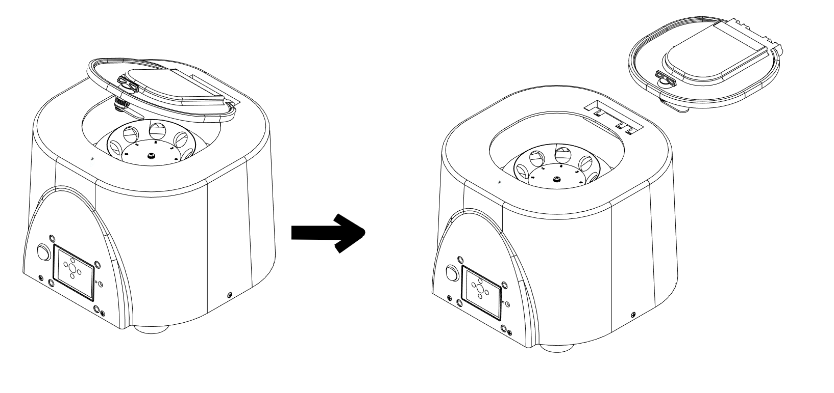Unlock the lid latch and slightly open the lid. Carefully position the unit so that the lid can be leveraged off the unit by applying horizontal force in the direction shown below. It is advised to hold the unit in place near the top where there is stronger support to provide structural support for this step.

Horizontal Force

* 1. Using a syringe and 4707 ABS Adhesive, attach the plastic cover on the lid with the smooth side facing upwards and ensure that the plastic cover sits flat.

* 1. Tighten the latch to the lid using Loc-Tite 425 and the provided latch nut, ensuring that the latch is at the open position (maximum counter clockwise rotation when viewing from the top) and can rotate approximately 90° clockwise to the lock position. Ensure the nut is fully seated against the lid.
  2. With the latch in the open position, tighten the cam lock (100473) to the latch, with the cam lock facing the right side of the lid, using Loc-Tite Blue 242 and the screw provided with the latch as shown in Figure 6. Right side is from the perspective of above and in front of the lid. Tighten to torque setting 3 using the Hils CL-6500 electric driver and a #3 Philips screwdriver bit.

* 1. With the latch in the open position, tighten the cam lock (100473) to the latch, with the cam lock facing the right side of the lid, using Loc-Tite Blue 242 and the screw provided with the latch as shown in Figure 6. Right side is from the perspective of above and in front of the lid. Tighten to torque setting 3 using the Hils CL-6500 electric driver and a #3 Philips screwdriver bit.
  2. Carefully position the unit so that the lid can be leveraged onto the unit by applying horizontal force in the direction shown below. It is advised to hold the unit in place near the top where there is stronger support to provide structural support for this step.

Horizontal Force

* 1. Close the unit lid and lock the lid latch. Power on the unit and verify all functionalities are present under normal laboratory conditions.