1. Purpose
   1. This work instruction describes the process to replace the Motor Control Board on the MX12 Centrifuges.
2. Equipment/Software

|  |  |  |  |
| --- | --- | --- | --- |
| ITEM # | PART # | DESCRIPTION | QTY. |
| 1 | 100969-B | Motor Control Board | 1 |

* 1. TOOLS NEEDED
  2. Philips-screwdriver
  3. 6 mm wrench

1. Instructions
   1. Confirm that all necessary components are present to complete the conversion.
   2. Turn on your MX12 unit, open the lid. Then disconnect the unit from power.
   3. Remove the rotor assembly by unscrewing the thumbscrew (101088), set them aside as you will need to put them back. Figure 1

Reference Figure 1

* 1. Remove 10 M4x0.7;10 mm screws (100090) with a Philips-screwdriver, set them aside as you will need them later. Figure 2

Reference Figure 2

* 1. Carefully remove the Base Plate (100952-E), keep the Base Plate (100952-E) close to the body as there is a wire still connected.
  2. Use the 6 mm wrench to remove the 3 M6x1.0 Nut (100057), be carefully while removing them from the screw as there is a washer (100067) on each of them.

Figure 3

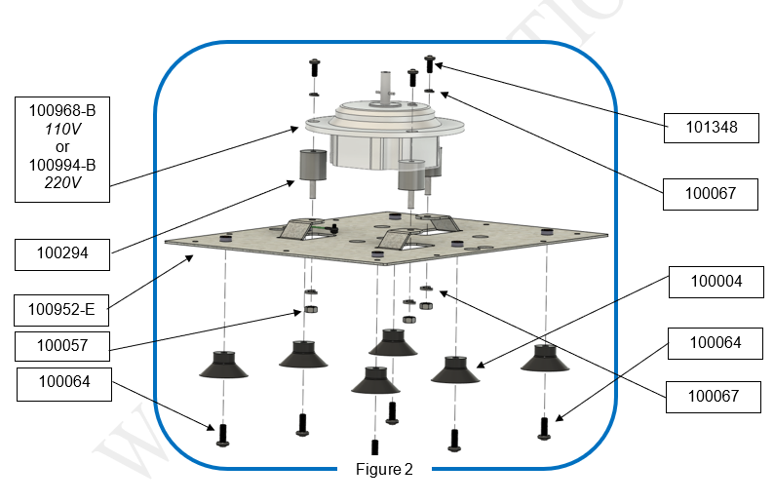

Figure 3

* 1. Unplug all wire connectors (100978, 101019, 101020) from the old Motor Control Board (100969-B). Figure 4
  2. Unplug Motor Cable 6-pin and Motor Cable 5-pin from the old Motor Control Board (100969-B). Figure 4
  3. Use your flat-head screwdriver to loosen the 2 Solenoid Cable from the green Terminal on the old Motor Control Board (100969-B). Figure 4
  4. Unplug the green wire (101023), red and black power cable from the Power Supply (100053). Figure 4

* 1. Use your Philips-screwdriver to remove 2 M4x10mm screws (100090) from the old Motor Control Board (100969-B). Figure 5
  2. A diagram of a computer part

     Description automatically generatedCarefully remove the old Motor Control Board (100969-B) from the unit and discard it. There might be resistance while removing as there are tape in the back.

Figure 5

* 1. Place the new Motor Control Board (100969-B) into the unit, using 2 M4x10mm screws (100090) and tighten with a Philips-screwdriver till snug. Figure 5
  2. Replace all the wires onto the new Motor Control Board (100969-B). Figure 4
  3. Set the motor (100968-B or 100994-B) back onto the Base Plate (100952-E),and secure it by tightening the 3 M6x1.0 Nut (100057) and 3 washer (100067).
  4. Reattach the Base Plate (100952-E) to the body the MX12 unit, screw the 10 M4x0.7;10 mm screws (100090) with a Philips-screwdriver.
  5. Reinstall the rotor assembly by screwing the thumbscrew (101088) till it’s snug.
  6. Close the lid. Run the MX12 unit at 12,000 RPM for 3 minutes to verify successful replacement of the Motor Control Board (100969-B).
  7. This completes the repair.