1. Purpose
   1. This work instruction describes the process for replacing the lid on the MX12 centrifuge unit.
2. Equipment/Software

|  |  |  |  |
| --- | --- | --- | --- |
| ITEM # | PART # | DESCRIPTION | QTY. |
| 1 | 100959-F | Lid | 1 |
| 2 | 100961-E | Lid Latch Top Plate | 1 |
| 3 | 101078-E | Solenoid Latch Catch | 1 |
| 4 | 100960-C | Hinge Plate | 1 |
| 5 | 101071 | Machined Screw M4x8mm BHCS SS | 7 |

* 1. **TOOLS NEEDED**
  2. 2.5mm hex driver or equivalent.

1. Instructions
   1. Confirm that all necessary components are present to complete the conversion.

Lid Latch Top Plate

Lid

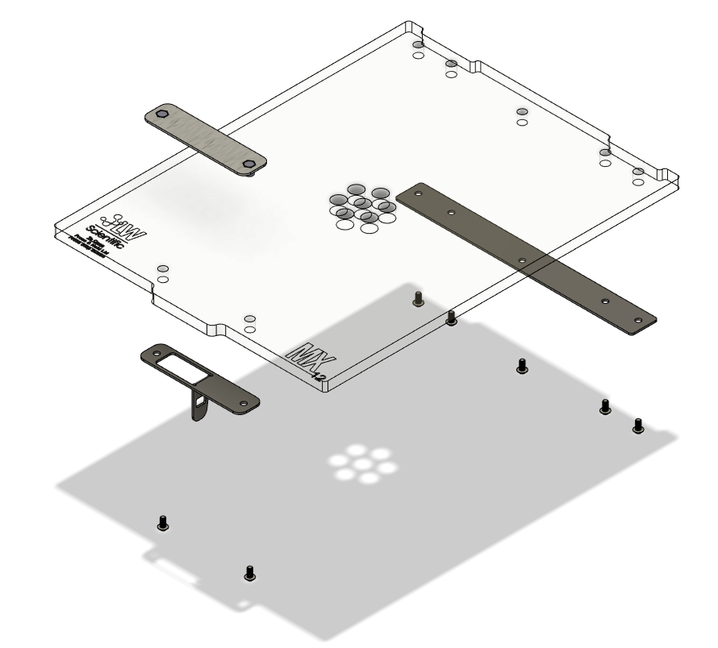

Hinge Plate

Solenoid Latch Catch

Machined Screw M4x8mm

Reference Figure 1

* 1. Power on your MX12 unit to unlatch the lid, open lid and shut off power to your unit. Make sure the lid stays in open position throughout this procedure.
  2. Using the 2.5mm hex driver to loosen and remove the two M4x8mm screws (101071) on the Solenoid Latch Catch (101078-E). Remove the Solenoid Latch Catch (101078-E) and Lid Latch Top Plate (100961-E) from the old lid (100959-F). See Reference Figure 2. Keep all parts, as you will need them later.

Reference Figure 2.

* 1. Using the 2.5mm hex driver to loosen and remove the five M4x8mm screws (101071) on the Hinge Plate (100960-C). Carefully remove the Hinge Plate (100960-C) and old lid (100959-F) from the Lid Hinge Bracket. See Reference Figure 3. Keep five M4x8mm screws (101071) and Hinge Plate (100960-C) as you will need them later, discard old lid (100959-F).

Reference Figure 3

* 1. Carefully replace your new Lid (100959-F) and old Hinge Plate (100960-C) onto the Lid Hinge Bracket and secure with five M4x8mm screws (101071), tighten screws with 2.5mm hex driver till snug then tighten them another ¼ turn to ensure they are fully seated.
  2. Replace your old Solenoid Latch Catch (101078-E) and Lid Latch Top Plate (100961-E) onto your new lid with two M4x8mm screws (101071). Tighten screws with 2.5mm hex driver till snug then tighten them another ¼ turn to ensure they are fully seated.
  3. Power your unit on again and close the lid. Open and close the lid a few more times to ensure the alignment and latching mechanism function properly.
  4. This completes the repair.