1. Purpose
   1. This work instruction describes how to replace the power jack for the Ready Warm.
   2. These instructions are valid for rev 6 of the Ready Warm.
2. Equipment/Software

|  |  |  |  |
| --- | --- | --- | --- |
| ITEM # | PART # | DESCRIPTION | QTY. |
| 1 | 100131-C | Power Jack Assembly | 1 |

* 1. Phillips head screw driver.

1. Instructions
   1. Confirm that all necessary components are present to complete the conversion.
   2. Ensure unit is both **unplugged** and **not powered on**.
   3. Turn the device around and remove the lower cover (100825-B) by removing necessary screwsA close-up of a machine

      Description automatically generated and washers.

100736

100735

100654

100734

* 1. Remove and replace the power jack (100131-C)

100131-C

* 1. Ensure that the wiring is correct, as depicted below. In the image, the red wire goes to the disk thermostat crimp in place. The black wire goes to the power switch crimp in place.

(to the power switch)

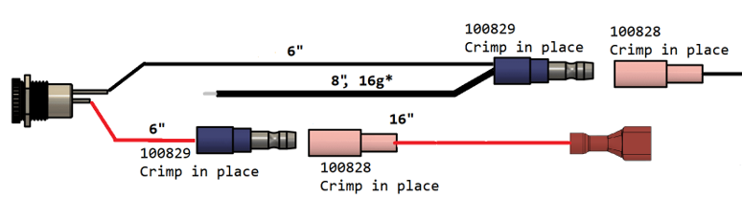

(to the disk thermostat)

The black wire circled above should securely screw into the PID Controller (100631) at position 2 circled below.

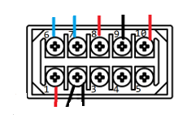

* 1. Reassemble the unit.
  2. Close lid, repower, and test unit for normal laboratory operations.