1. Purpose
   1. This work instruction describes the process for replacing the MXU Power Switch (100413).
   2. These repair instructions are valid for revision C MXU Digital Centrifuges. For revisions older than C, please consult Product Development.
2. Equipment/Software

|  |  |  |  |
| --- | --- | --- | --- |
| ITEM # | PART # | DESCRIPTION | QTY. |
| 1 | 100413 | Switch; Power Input | 1 |

* 1. Phillips Head Screwdriver

1. Instructions
   1. Confirm that all necessary components are present to complete the conversion.
   2. Open the lid and remove the rotor and tube shields from the unit. *Figure 1*

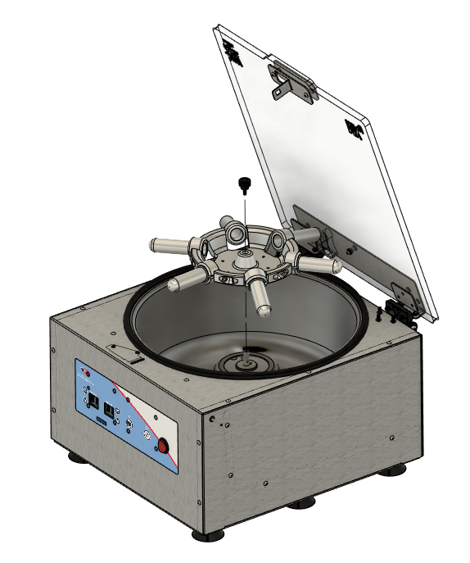

*Figure 1*

* 1. Turn the unit over onto its lid and remove the base plate. *Figure 2*

**NOTE: The motor wiring harnesses will be connected. Disconnect them or set the base close enough to the side to not overextend the wires.**

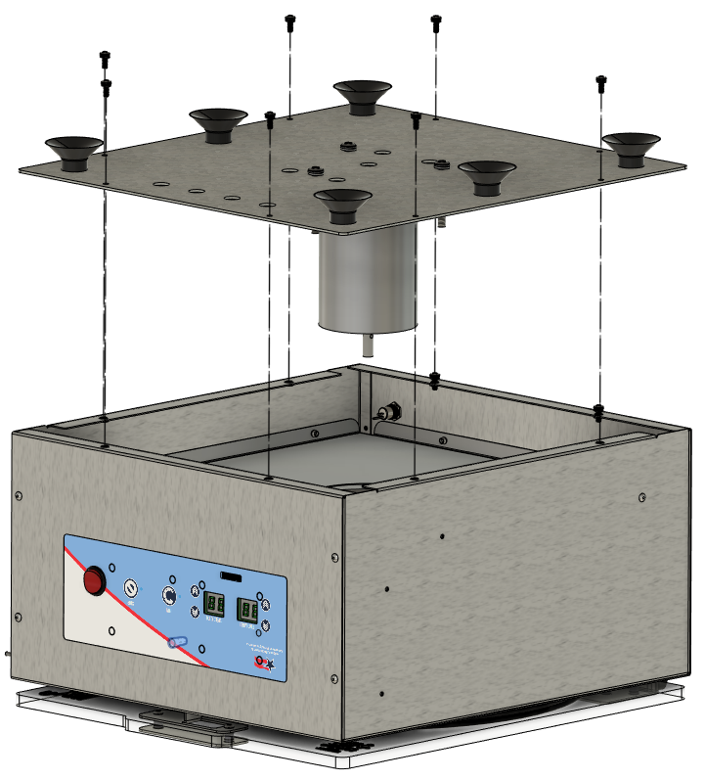

*Figure 2*

3.4 Locate Power Switch on the front face of the unit. *Figure 3*

*Figure 3*

* 1. Disconnect the 2 cables from the back of the Power Switch (100300-B & 100325-B). *figure 4*

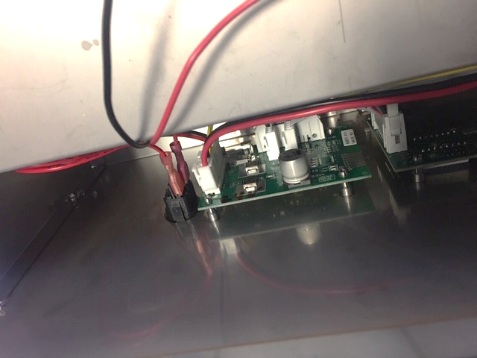

*Figure 4*

* 1. While pressing inwards on the top and bottom tabs of the Power Switch, push the switch out through the front face of the body. *Figure 5*

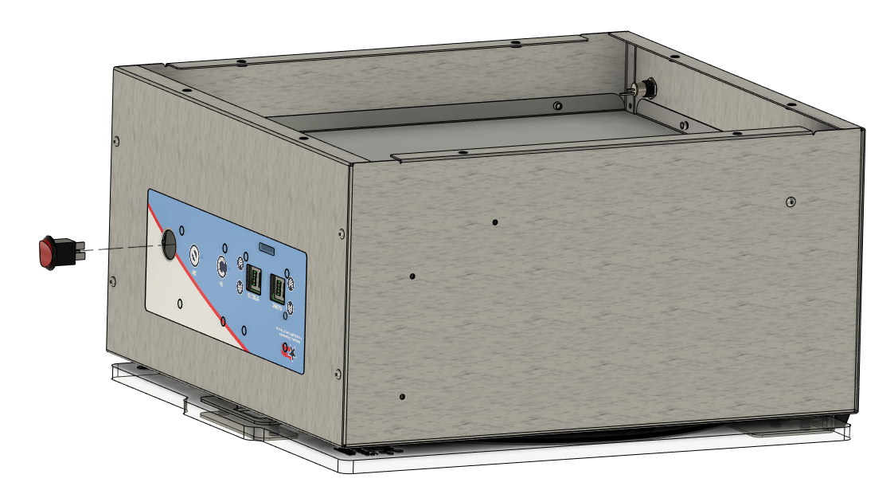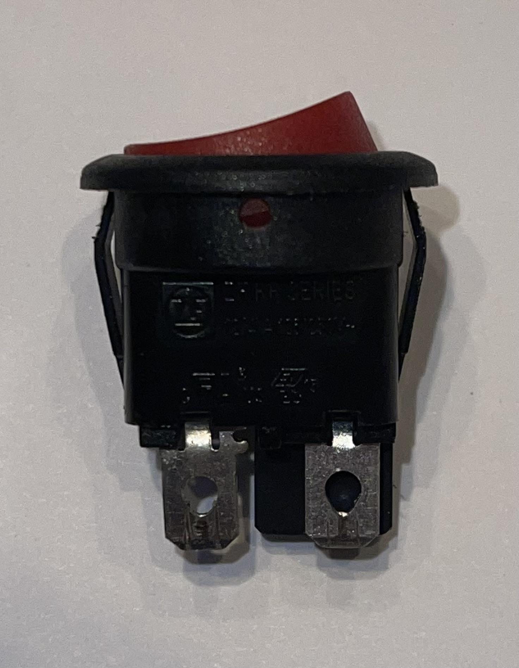

*Figure 5*

* 1. Insert new Power Switch, ensuring the “|” symbol faces up (towards the lid), and that the two tabs snap in place.
  2. Reconnect the 2 cables as shown. *Figure 6*



*Figure 6*

* 1. Re-attach the base plate. *Figure 7*



*Figure 7*

* 1. Replace Rotor, close the lid, and verify the unit powers on and functions under normal laboratory use. *Figure 8*



*Figure 8*