- Purpose
  - This work instruction describes the process for replacing the Lid Gasket of MX12 centrifuge units.

- Equipment/Software

ITEM # | PART # | DESCRIPTION | QTY.
1 | 100993 | Rubber Gasket | 1

- Instructions
  - Confirm that all necessary components are present to complete the conversion.

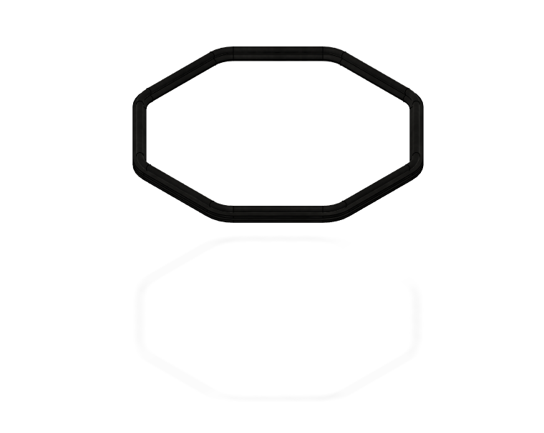
Replacement Lid Gasket
Reference Figure 1

  - Power on your MX12 unit and open the lid. Then turn off the power to your unit.
  - Remove the old Lid Gasket (100993) from your unit and discard it.
  - Carefully place your new replacement Lid Gasket (100993) onto the rim of the bowl opening, referencing Figure 2.
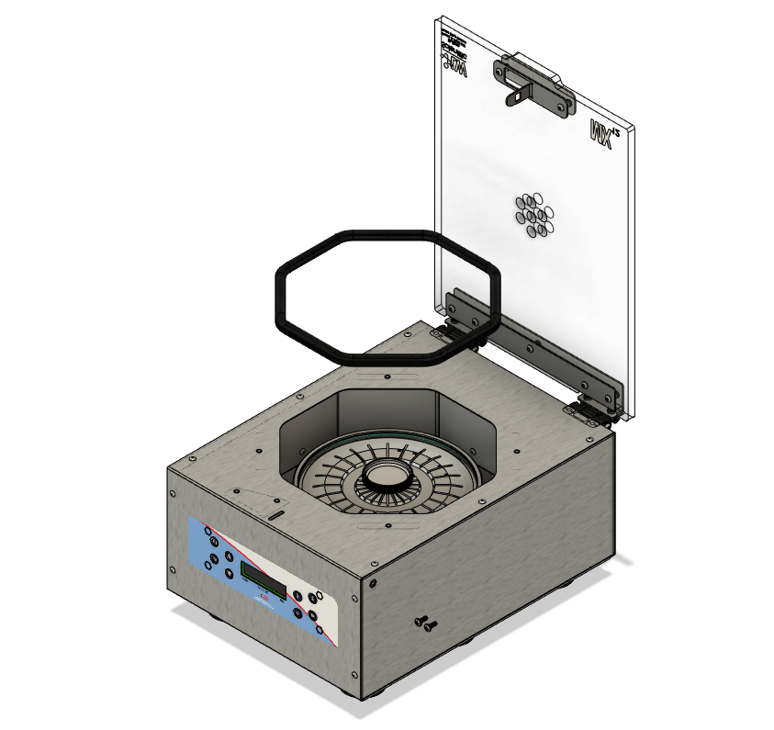
Reference Figure 2

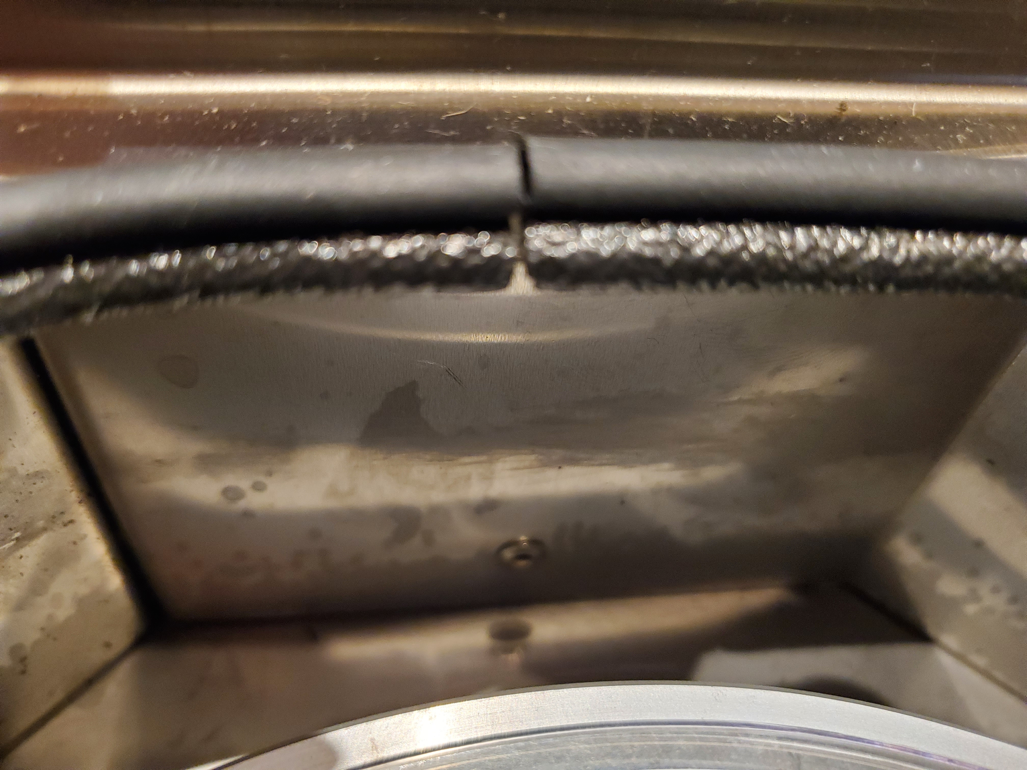
  - Firmly press Lid Gasket (100993) over the rim of the bowl opening, ensure that the cushioned side is facing upwards, referencing Figure 3.

Reference Figure 3

  - This completes the repair.

