1. Purpose
   1. This work instruction describes the process of replacing the MX5 lid latch.
2. Equipment/Software

|  |  |  |  |
| --- | --- | --- | --- |
| ITEM # | PART # | DESCRIPTION | QTY. |
| 1 | 100912-D | MX5 Lid Latch | 1 |

* 1. Tools Needed: 2.5mm Allen Wrench/Driver, Loctite Blue.

1. Instructions
   1. Confirm that all necessary components are present to complete the conversion.
   2. Ensure the unit is powered off and unplugged.
   3. Open the MX5 Lid. *Figure 1*

*Figure 1*

* 1. Using the 2.5 Allen Wrench/driver, remove the 4 M4 screws (101071). *Figure 2*

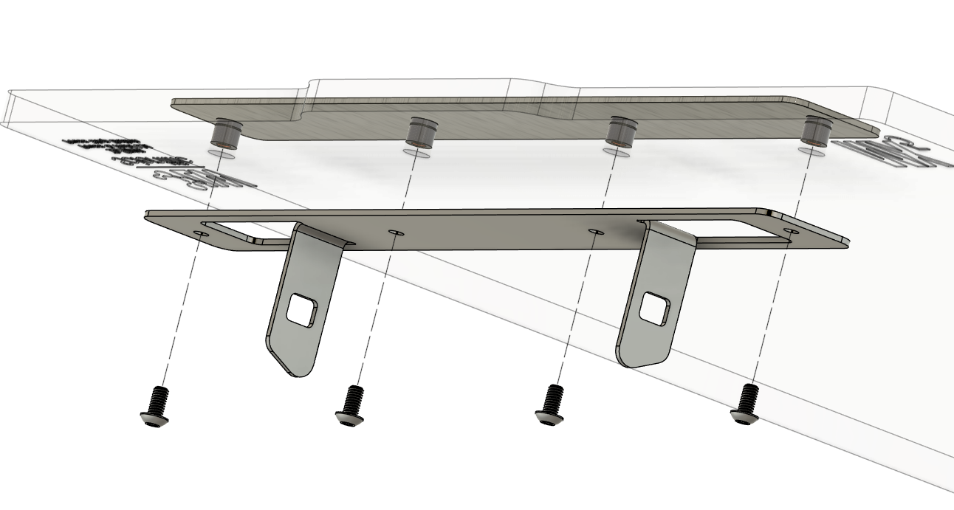

*Figure 2*

M4 Screws (101071)

MX5 Lid Latch (100912-D)

* 1. Apply a small amount of Loctite Blue to the 4 M4 screws (101071) and replace the MX5 Lid Latch (100912-D). *Figure 3*

*Figure 3*

* 1. Close the lid.
  2. Plug the MX5 in and power it on. Ensure unit functions under normal laboratory use.
  3. Repair is complete.