- Purpose
  - This work instruction describes the process of replacing the Fuse on the MX12 centrifuges.

- Equipment/Software

ITEM # | PART # | DESCRIPTION | QTY.
1 | 100185 | Fuse | 1

  - TOOLS NEEDED – N/A
- Instructions
  - Confirm that all necessary components are present to complete the conversion.
  - Turn off your MX12 unit and disconnect from power.
  - Unplug the old Fuse (100185) and discard it. Figure 1
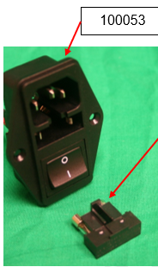
100185
100053
Reference Figure 1

  - Plug in the new Fuse (100185).
  - Close the lid. Run the MX12 unit at 12,000 RPM for 3 minutes to verify successful replacement of the new Fuse (100185).
  - This completes the repair.

