1. Purpose
   1. This work instruction describes the process for replacing the hinge on MX12 centrifuge units.
2. Equipment/Software

|  |  |  |  |
| --- | --- | --- | --- |
| ITEM # | PART # | DESCRIPTION | QTY. |
| 1 | 101323 | Black Plastic Hinge; adjustable friction | 2 |
| 2 | 100996 | Machine Screw; M4 X 0.7; 8mm; Black Oxide | 8 |

* 1. **TOOLS NEEDED**
  2. 2.5mm hex driver or equivalent

1. Instructions
   1. Confirm that all necessary components are present to complete the conversion.

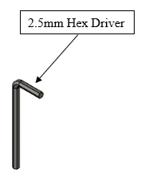p

Replacement Hinges

Attachment Screws

Reference Figure 1

* 1. Close the lid and turn off the power on your MX12 unit.
  2. Using the included 2.5mm hex driver tool or equivalent, remove the eight screws from the back of the hinges, referencing Figure 2.

Reference Figure 2

* 1. Remove the old Hinges (101323) from your unit and discard them. Do not discard the Screws (100996) as you will need them for the next step.
  2. Hold the new Hinges (101323) in place and make sure all screw holes line up with both the lid and the body.
  3. Secure the new Hinges (101323) to your unit by using the Screws (100996). Tighten the screw with your 2.5mm hex driver till they are snug, then another ¼ turn to ensure they are fully seated.
  4. Power on your unit, open and close the lid a few times to make sure the hinges are functioning properly.
  5. This completes the repair.